

InFluxPC, LLC - Advanced v5.2

User’s Guide

Version 5.2.5.0
Mar 2008
InFluxPC, LLC - Advanced v5.2

User’s Guide

Copyright Notice

The use and copying of this product is subject to a license agreement. Any other use is prohibited. No part of this publication may be reproduced, transmitted, transcribed, stored in a retrieval system or translated into any language in any form by any means without the prior written consent of us. Information in this manual is subject to change without notice and does not represent a commitment on the part of the vendor. We do not warrant that this document is error free. If you find any errors in this document, please report to us in writing.

This product includes software developed by the Apache Software Foundation (http://www.apache.org/).

Trademarks

Microsoft, Windows, Microsoft Exchange Server and Microsoft SQL Server are registered trademarks of Microsoft Corporation.
Sun, Solaris, SPARC, Java and Java Runtime Environment are registered trademarks of Sun Microsystems Inc.
Oracle, Oracle 8i, Oracle 9i are registered trademarks of Oracle Corporation.
Lotus, Domino, Notes are registered trademark of IBM Corporation.
Red Hat is registered trademark of Red Hat, Inc.
Linux is registered trademark of Linus Torvalds.
Apple and Mac OS X are registered trademarks of Apple Computer, Inc.
All other product names are registered trademarks of their respective owners.
Table of Content

1 Overview 5
1.1 Benefits 5
1.2 Features 5
1.3 Security 6
1.4 System Requirements 6
2 Installing OBM 7
2.1 Installing OBM for Windows 7
2.2 Installing OBM for Mac OS X 8
2.3 Installing OBM for Linux 9
2.4 Installing OBM for Netware 10
2.5 Installing OBM for Sun Solaris 11
3 Uninstalling OBM 12
3.1 Uninstalling OBM for Windows 12
3.2 Uninstalling OBM for Mac OS X 12
3.3 Uninstalling OBM for Linux 12
3.4 Uninstalling OBM for Netware 12
3.5 Uninstalling OBM for Solaris 13
4 Using OBM 14
4.1 System Tray Launcher (Windows Only) 14
4.2 Logon Dialog 14
4.3 Language Selection 15
4.4 User Profile 16
4.5 Backup Logs 17
5 Setting Up Backup Sets 18
5.1 Backup Set Type 18
5.2 Backup Source 19
5.3 Mapped Network Drive 20
5.4 Backup Schedule 22
5.5 Backup Filter 22
5.6 Pre/Post-Backup Command 24
5.7 Temporary directory 26
5.8 Transfer Block Size 26
5.9 Follow Symbolic Link (Linux/Unix/Mac only) 26
5.10 Microsoft’s Volume Shadow Copy Service (VSS) 27
5.11 Encryption 27
5.12 Retention Policy 28
5.13 Extra Backup (Off-line backup, Logout Reminder) 30
5.14 In-File Delta 31
5.15 Local Copy 31
5.16 Using One Backup Account for Multiple Computers 34
6 Backing Up Files 36
6.1 How files are backed up 36
6.2 Backup files directly to the backup server 37
6.3 Backup files to removable hard disk (seed loading) 39
7 Restoring Files 41
7.1 Restore backup files directly from backup server 41
7.2 Restore backup files from removable hard disk 46
7.3 IP addresses Restriction for Online Restore 50
8 In-File Delta Technology 51
8.1 Overview 51
8.2 Block Size 53
8.3 Minimum File Size 53
8.4 Uploading full file again 53
8.5 Advanced In-file delta type 53
9 Backup/Restore Oracle 8i/9i 55
9.1 Requirements 55
9.2 Overview 56
9.3 How to backup an Oracle Database 57
9.4 How to restore an Oracle Database 60
10 Backup/Restore Microsoft SQL Server 7.0 / 2000 62
10.1 Requirements 62
10.2 Overview 62
10.3 How to backup Microsoft SQL Server database(s) 63
10.4 How to restore Microsoft SQL Server database(s) 65
11 Backup/Restore Lotus Domino / Notes 70
11.1 Requirements 70
11.2 Overview 71
11.3 How to backup Lotus Domino / Notes database(s) / file(s) on Windows 72
11.4 How to restore Lotus Domino / Notes database(s) / file(s) on Windows 75
11.5 How to backup Lotus Domino / Notes database(s) / file(s) on Linux 77
11.6 How to restore Lotus Domino / Notes database(s) / file(s) on Linux 80
12 Backup/Restore Microsoft Exchange Server 83
12.1 Requirements 83
12.2 Overview 83
12.3 How to backup Microsoft Exchange Server 85
12.4 How to restore Microsoft Exchange Server 87
13 Backup/Restore Windows System State 91
13.1 Requirements 91
13.2 Overview 91
13.3 How to backup Windows System State 92
13.4 How to restore Windows System State 95
14 Backup/Restore Individual Brick Level Backup for Microsoft Exchange Server 96
14.1 Requirements 96
14.2 Overview 96
14.3 Granting Privileges 96
14.4 How to backup Individual Brick Level Backup 98
14.5 How to restore Individual Brick Level Backup 102
15 Backup/Restore MySQL Server 105
15.1 Requirements 105
15.2 Overview 105
15.3 How to backup MySQL server on Windows 106
15.4 How to backup MySQL server on Linux (command line mode) 109
15.5 How to restore MySQL server 110
16 Email Reporting 111
16.1 New User Report 111
16.2 Forgot Password Report 112
16.3 Backup Job Report 113
16.4 Setting Change Report 115
16.5 Inactive User Reminder 116
17 Web Features 117
17.1 Install OBM 117
17.2 Update User Profile 117
17.3 Request Forgotten Password 118
17.4 Restore/Delete/Undelete Backup Files 118
17.5 Review Backup Jobs 119
17.6 Review Storage Statistics 120
18 Further Information 122
18.1 FAQs 122
18.2 Contact Us 122

Overview

Benefits
- Easy Backup of
  - Microsoft Exchange Server 2000 / 2003
  - Microsoft SQL Server 7.0 / 2000
  - Lotus Domino/Notes 5.0 or above
  - Oracle 8i or above
  - MySQL 3.2.4 or above
  - Windows System State
  - Outlook and Outlook Express (i.e. *.pst, *.dbx and *.wab)
  - Important personal settings, e.g. Desktop, Favorite, My Documents and History etc
  - Other common files (e.g. *.doc, *.xls)
- Support backing up only changes within a file (using in-file delta technology)
- Support backing up of open files on Windows XP/2003 (Volume Shadow Copy)
- Support backing up of Windows NTFS access privileges, Linux access privileges and modes, Mac OS X metadata and resource forks
- Easy to use, deploy and maintain

Features
- (New in 5.2) Full support of Microsoft Exchange individual email, contacts, calendars, tasks etc.
- (New in 5.2) Choose whether to restore “file permissions” during restore.
- (New in 5.2) For “Local Copy” backup, ability to choose whether to perform a local copy backup only and skip the offsite backup.
- (New in 5.2) Lotus Notes/Domino agent for Linux.
- (New in 5.2) Auto Upgrade Agent to automatically upgrade the client software.
- User configurable incremental / differential in-file delta backup mode (i.e. backing up only changes within a file since the last incremental or full backup according to each user’s preference).
- Allow in-file delta backup mode to be overridden by each user individually according to backup time (e.g. enforcing full (or incremental or differential) backup of all files every Sunday or the 1st day of every month).
- Volume Shadow Copy backup (i.e. backing up files even when they are exclusively open, e.g. Outlook.pst).
- In-File Delta backup (i.e. backing up only changes within files).
- Off-line backup mode and logout backup reminder.
- Customizable backup schedule allows backups to be scheduled at any time.
- Compress and encrypt data automatically before sending them to the server (server stores only encrypted data).
- Increment backup strategy ensures that only new or updated files are sent to the backup server.
- Support both full backup (database backup) and incremental backup (transaction log backup) for Microsoft SQL Server 7.0/2000, Microsoft Exchange Server 2000/2003, Lotus Domino/Notes 5.0 and Oracle 8i or above.
- Can integrate with external “Open File Manager” to provide open file backup support to all open files.
- Access backup data anytime, anywhere by using a web browser.
- Comprehensive backup report lists all files backed up. Backup report delivered automatically via email.
- Backup data are CRC validated before they are stored on server.
- Fully user customizable data retention policy allows users to have access to deleted files using the least possible storage space on the backup server.
- Can select source backup files easily by using a backup filter, e.g. selecting all *.doc and *.xls in your computer in a single operation.
- Run any custom OS commands before/after a backup job.
- Run on Windows, Mac OS X, Linux, NetWare, Unix and all other platforms supporting a Java2 Runtime Environment.
- Periodic backup files validation on backup server ensures backup files are 100% valid and fully restorable when needed.

Security
- 128-bit point-to-point SSL communication between server and client
- Support HTTP/HTTPS Proxy and Socks v4/v5 firewall
- Data are 128-bit encrypted when stored on the backup server
- Choice of different encryption algorithms, e.g. Twofish, Triple DES, Advanced Encryption Standard (AES)
- Choice of different encryption modes, e.g. Electronic Cook Book (ECB) and Cipher Block Chaining (CBC)
- An random initializing vector, salt and iteration count will be generated by the software automatically for each file when encrypting your data
- Each backup user can restrict online access to his files to his pre-defined list of IP addresses

System Requirements

Server-side applications
 | Supported Platforms | Hardware Requirements
OBS   | - Windows 2000 / XP / 2003 (server recommended)  - Linux kernel 2.4 or above  - Solaris 2.x or above  - AIX  - HP-UX  - FreeBSD  - Mac OS X 10.2 or above  - All other operating systems that supports Java2 Runtime Environment 1.4.2 or above | - Memory:  - 512MB (minimum)  - 1GB (recommended)  - Disk Space:  - 300MB  - Network Protocol:  - TCP/IP (http/https)
RPS   | - Windows 2000 / XP / 2003 (server recommended)  - Linux kernel 2.4 or above  - Solaris 2.x or above  - AIX  - HP-UX  - FreeBSD  - Mac OS X 10.2 or above  - All other operating systems that supports Java2 Runtime Environment 1.4.2 or above | - Memory:  - 128MB (minimum)  - 512MB (recommended)  - Disk Space:  - 100MB  - Network Protocol:  - TCP/IP (http/https)

* The use of Windows 2000 WorkStation and XP Professional is only recommended for backup system with less than 20 users. For 20 or more users, please use Windows 2000 or 2003 Server instead.

Client-side applications
 | Supported Platforms | Application Compatibilities | Hardware Requirements
OBM   | - Windows 95 / 98 / ME / NT / 2000 / XP / 2003 / Vista  - Linux kernel 2.4 or above  - NetWare 5.1 or above  - Solaris 2.x or above  - AIX  - HP-UX  - FreeBSD  - Mac OS X 10.2 or above  - All other operating systems that supports Java2 Runtime Environment 1.3.1 or above | - Microsoft Exchange Server 2000 / 2003 / 2007  - Microsoft SQL Server 7.0 / 2000 / 2005  - Lotus Domino / Lotus Notes 5.0 or above  - Oracle 8i or above  - MySQL 3.2.4 or above  - Outlook / Outlook Express i.e. *.pst, *.dbx and *.wab  - Other common files e.g. *.doc, *.xls  - Also supports backing up of:  - Windows System State (all platforms except Vista)  - Windows NTFS access privileges  - Linux access privileges and modes  - Mac OS X metadata and resource forks | - Memory:  - 128MB (minimum)  - 256MB (recommended)  - Disk Space:  - 110MB  - Network Protocol:  - TCP/IP (http/https)
ACB   | - Windows 95 / 98 / ME / NT / 2000 / XP / 2003 / Vista  - Mac OS X 10.2 or above | - Outlook / Outlook Express i.e. *.pst, *.dbx and *.wab  - Other common files e.g. *.doc, *.xls  - Also supports backing up of:  - Windows NTFS access privileges | - Memory:  - 128MB (minimum)  - 256MB (recommended)  - Disk Space:  - 110MB  - Network Protocol:  - TCP/IP (http/https)

Installing OBM
Before you can start backing up data to the Offsite Backup Server, you need to install the Online Backup Manager (OBM) client onto your computer.

Installing OBM for Windows
- Download the Online Backup Manager installer (obm-win.exe) from the website.
- Double click the icon to run the installer.
- Follow on screen instructions.
- After installation, OBM will start automatically.

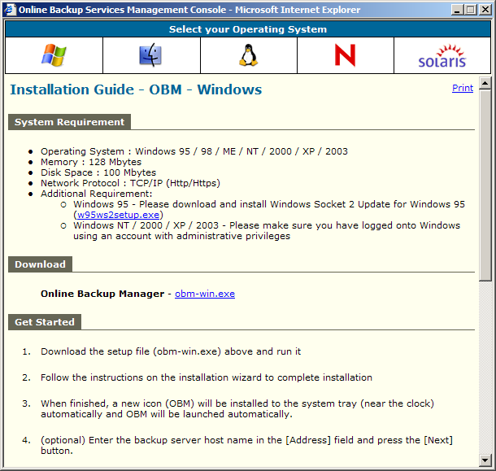

Installing OBM for Mac OS X
- Download the Online Backup Manager installer (obm-mac.zip) from the website.
- Expand the zip file.
- Double click the pkg file icon to run the installer.
- Follow on screen instructions.
- After installation, the installer will need to restart your computer.
- After restarting your computer, click the newly added OBM icon on your desktop. You can manually drag the icon to your dock bar if you wish.

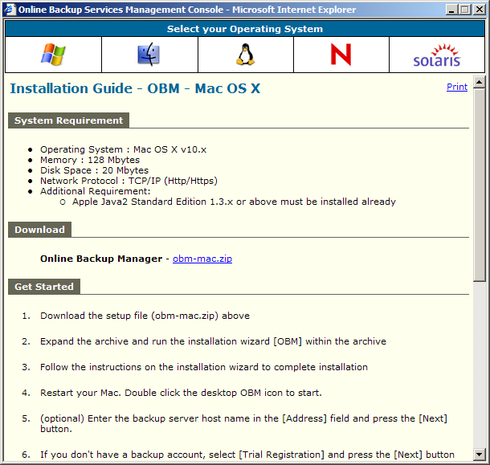

Installing OBM for Linux
- Download the Online Backup Manager tarball release (obm-linux.tar.gz) from the website.
- Set the OBM_HOME environment variable
# export OBM_HOME=/usr/local/obm
- Expand the client software to $OBM_HOME
# mkdir $OBM_HOME
# tar –x –C $OBM_HOME -zvf obm-linux.tar.gz
- Install OBM
# cd $OBM_HOME
# ./bin/install.sh
- Start Auto Upgrade Agent
# /etc/init.d/auaobm start
- Start backup scheduler
# /etc/init.d/obm-scheduler start
- Set the DISPLAY environment variable
# export DISPLAY=IP_ADDRESS_OF_XTERMINAL[:0.0]
- Run OBM
# sh $OBM_HOME/bin/BackupManager.sh &

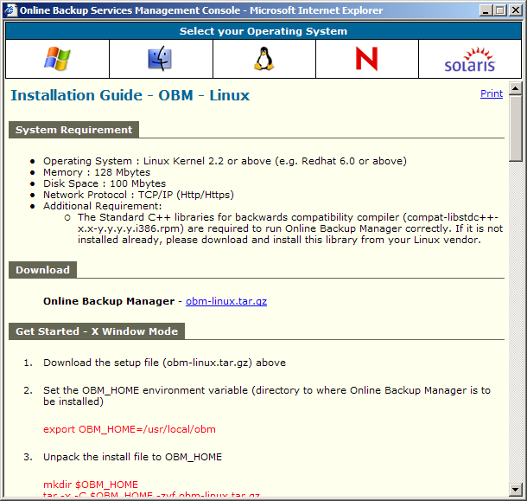

Installing OBM for Netware
- Download the Online Backup Manager zip release (obm-netware.zip) from the website.
- Expand the zip file to SYS:\OBM
- Install OBM
SYS:\> SYS:\OBM\aua\bin\install-aua.ncf
- Start Auto Upgrade Agent
SYS:\> SYS:\OBM\aua\bin\startup.ncf
- Start backup scheduler
SYS:\> SYS:\OBM\bin\Scheduler.ncf
- Run OBM
SYS:\> SYS:\OBM\bin\RunBackupManager.ncf

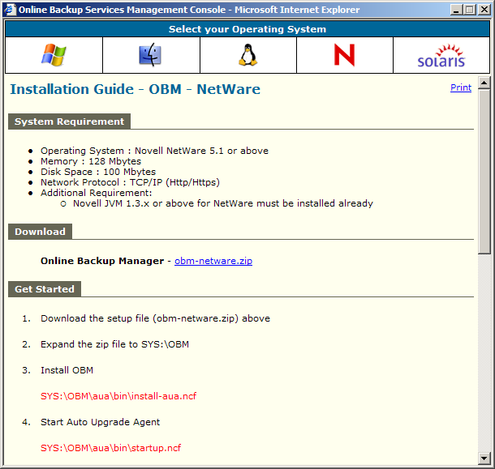

Installing OBM for Sun Solaris
- Download the Online Backup Manager tarball release (obm-solaris.tar.gz) from the website.
- Set the OBM_HOME environment variable
# export OBM_HOME=/usr/local/obm; export OBM_HOME
- Set the JAVA_HOME environment variable to the directory where J2SE Java Runtime Environment (JRE) 1.4.x has been installed
# export JAVA_HOME=/usr/java/j2re1.4.x; export JAVA_HOME
- Expand the client software to $OBM_HOME
# mkdir $OBM_HOME
# cd $OBM_HOME
# gunzip -c obm-solaris.tar.gz | tar –xf -
- Install OBM
# ./bin/install.sh
- Start Auto Upgrade Agent
# /etc/init.d/auaobm start
- Start backup scheduler
# /etc/init.d/obm-scheduler start
- Set the DISPLAY environment variable
# export DISPLAY=IP_ADDRESS_OF_XTERMINAL[:0.0]
- Run OBM
# sh $OBM_HOME/bin/BackupManager.sh &
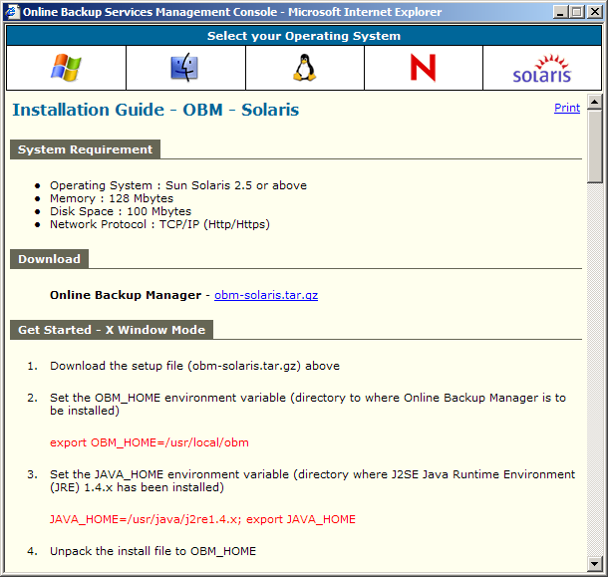

Uninstalling OBM
This section describes the steps required to uninstall OBM from your computer.

Uninstalling OBM for Windows
- Open [Start] -> [Control Panel] -> [Add/Remove Programs]
- Select [OBM] from the list and press the [Remove] button

Uninstalling OBM for Mac OS X
- Remove all program files by running
# cd $OBM_HOME/bin
# sudo ./uninstall.sh
- Remove all backup setting by removing ~/.obm
# rm –rf ~/.obm
- Restart your computer

Uninstalling OBM for Linux
- Change user to “root” or equivalent
- Remove all program files by running
# cd $OBM_HOME/bin
# ./uninstall.sh
- Remove all backup setting by removing ~/.obm
# rm –rf ~/.obm

Uninstalling OBM for Netware
- Stop the running backup scheduler by running
SYS:\> touch SYS:\OBM\ipc\Scheduler\stop
- Stop the running auto upgrade agent by running
SYS:\> SYS:\OBM\aua\bin\shutdown.ncf
- Remove all program files by removing the directory SYS:\OBM
- Remove all backup settings by removing the directory SYS:\.OBM

Uninstalling OBM for Solaris
- Change user to “root” or equivalent
- Set the OBM_HOME environment variable
# export OBM_HOME=/usr/local/obm; export OBM_HOME
- Set the JAVA_HOME environment variable to the directory where J2SE Java Runtime Environment (JRE) 1.4.x has been installed
# export JAVA_HOME=/usr/java/j2re1.4.x; export JAVA_HOME
- Remove all program files by running
# cd $OBM_HOME/bin
# ./uninstall.sh
- Remove all backup setting by removing ~/.obm
# rm –rf ~/.obm

Using OBM
This chapter will describe all the features available in OBM and outline how you can use OBM to meet various backup needs.

System Tray Launcher (Windows Only)
After you have successfully installed OBM onto your computer, an OBM icon will be added to the system tray area (next to your system clock) automatically.
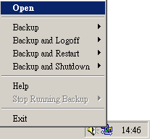
This icon is the entry point to OBM. Right clicking the icon will show a menu that provides the following functions:
Menu Item | What it does
Open | Run OBM.
Backup | Runs a specific backup set (or all backup sets) chosen from the sub-menu in silent background mode.
Backup and Logoff | Runs a specific backup set (or all backup sets) chosen from the sub-menu in silent background mode and then logoff from Windows when finished.
Backup and Restart | Runs a specific backup set (or all backup sets) chosen from the sub-menu in silent background mode and restart Windows when finished.
Backup and Shutdown | Runs a specific backup set (or all backup sets) chosen from the sub-menu in silent background mode and shutdown the computer when finished.
Help | Shows a help dialog
Stop running backup | Interrupts a running backup set (or all backup sets) chosen from the sub-menu.
Exit | Close this system tray launcher application.

Logon Dialog
Before you can use OBM, you have to be authenticated by the Offsite Backup Server first. The logon dialog shown below will check if you have the right to access OBM by submitting the username and password you provided to the backup server.
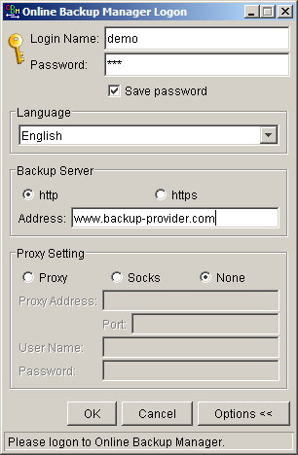
For secure communication, you can choose to communicate with Offsite Backup Server in SSL (Secure Socket Layer) by selecting the [https] option.
The [Address] field shows the Offsite Backup Server to which OBM will connect to authenticate your username and password. You can use either a resolvable host name (e.g. backup.your-domain.com) or an IP address (e.g. 192.168.1.1).
If the Offsite Backup Server is not accepting connection from the standard ports (Port 80 and 443 for http and https respectively), you can append a semi-colon “:” and the custom port number to the host name of the [Address] field (e.g. www.backup-provider.com:8080) to connect to the server using the custom port number (port 8080 in this case).
If you need to connect to the server through proxy, just enter your proxy setting in the [Proxy Setting] section. For [SOCKS] proxy, both v4 and v5 without user authentication are supported.

Language Selection
You can switch the language of the OBM user interface by choosing the desired language available from the [Language] drop down list. The languages available includes English, Czech, Danish, Dutch, French, Spanish, Portuguese, Icelandic, Norwegian, Finnish, Italian, German, Swedish, Chinese (Traditional and Simplified), Japanese, Lithuanian and Slovenian.
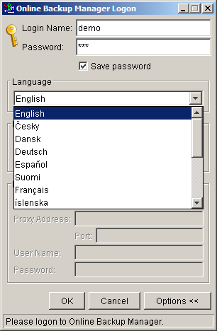

User Profile
After the backup server authenticates you successfully, the OBM main window appears. You can then use OBM to update your user profile.
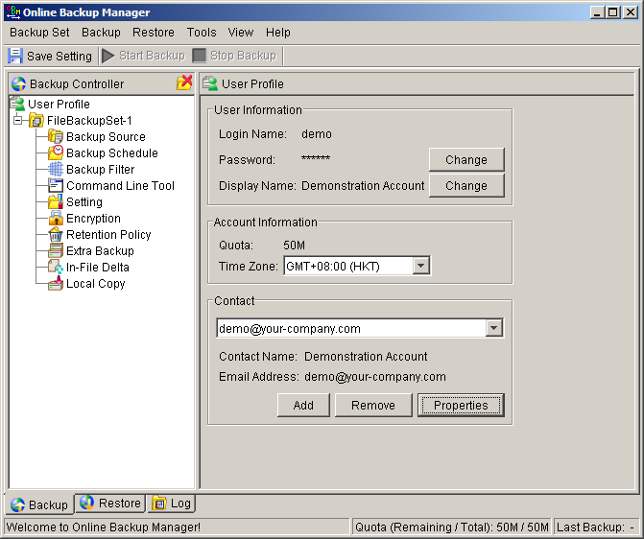
You can perform the following update to your user profile.
To change your [Password], press the [Change] button next to the password field. A Change Password dialog will appear. Enter your original password and new password into the text field of this dialog and press [OK].
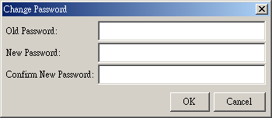
To change your [Display Name], press the [Change] button next to the display name field. A Change Display Name dialog will appear. Enter the new display name and press [OK].
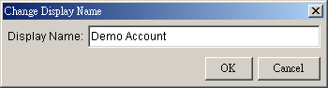
To change your [Time Zone], just select your time zone from the drop down list next to the time zone entry.
To add a new contact email to this account, press the [Add] button in the [Contact] section. A [Add New Contact] dialog will appear. Enter a name and an email address in the text field provided and then press the [OK] button.
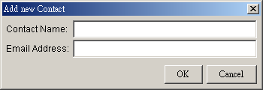
To remove a contact email, select the email that is to be removed from the email list and press the [Remove] button. Press [OK] to confirm the removal.
To update a contact email, select the email that is to be updated from the email list and press the [Properties] button. A [Update Contact Property] dialog will appear. After you have made the changes that you want, press the [OK] button.
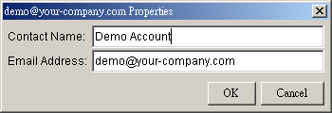

Backup Logs
All backup activities are logged to backup activity log files. They are available for reviewing from OBM.

How to review backup activities?
You can review all your backup Jobs by
- Select the [Log] tab available at the bottom of OBM
- Select the Backup Job you want to review on the [Log Controller] panel
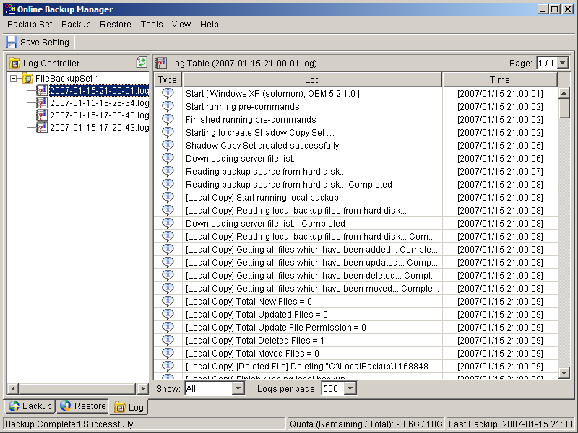

Setting Up Backup Sets
A backup set contains all backup settings of a backup operation. This section will describe all features available within a backup set and explain how you can use each of them to achieve various tasks.
Each backup account can have multiple backup sets. Each backup set is an individual and independent entity. For example, if you want one directory to be backed up during the day and another directory to be backed up during the night, you can create two backup sets, each with a different backup schedule and backup source, to serve this need.
To create a new backup set, simply click [Backup Set] -> [New] and choose a backup set type. For example, let’s create a “File Backup Set” for the rest of this chapter.
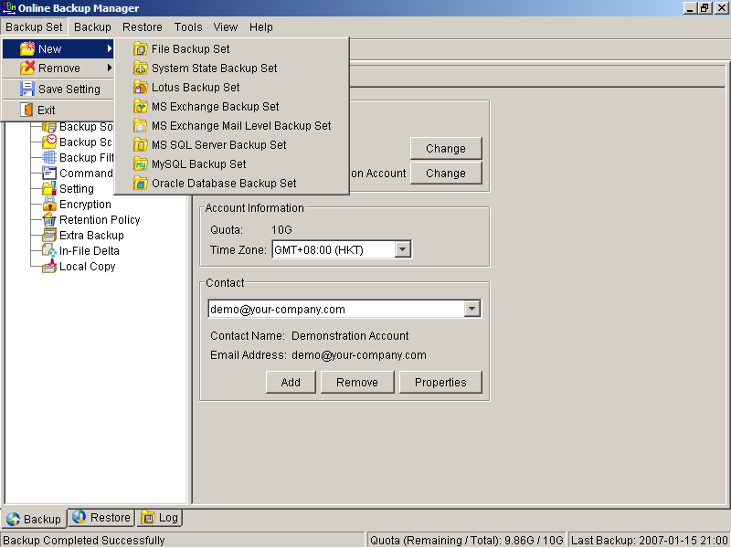

Backup Set Type
A backup set can be of one of the following types:
Backup Type | Description
File | Backup set type to backup common files/directories
Microsoft SQL Server | Backup set type to backup Microsoft SQL Server 7.0/2000
Oracle Database Server | Backup set type to backup Oracle 8i/9i database
Lotus Domino/Notes | Backup set type to backup Lotus Domino/Notes
Microsoft Exchange Server | Backup set type to backup Microsoft Exchange Server 2000 / 2003
MySQL | Backup set type to backup MySQL Server
System State | Backup set type to backup Microsoft Window’s System State
Microsoft Exchange Mail (MAPI) | Backup set type to backup individual emails, contacts, calendars, tasks etceteras from Microsoft Exchange Server 2000 / 2003

Backup set type is defined at backup set creation and cannot be modified. If you want to change the backup set type, you have to create another backup set in the new backup set type.

Backup Source
A “Backup Source” defines the files/directories that are to be included in a backup set. There are two types of backup source: Selected and Deselected. Selected backup source defines files/directories that are to be included in a backup set while deselected backup source defines files/directories that are to be excluded from a backup set. Online Backup Manager will generate appropriate backup source setting for you automatically when you make your backup source selection on OBM.
Please note that for Windows operating systems, if the “Hide protected operating files (Recommended)” setting is enabled for the file explorer, system folders/files will not be shown in the backup source. By selecting the parent folders however, all subfolders (including system folders/files) will be included in the backup set. Thus if you want to exclude system folders (e.g. recycle bin) from the backup, please select the desired folders/files directly rather than selecting the parent folder. Alternatively, you can enter the corresponding system path to the [Exclude List] of the backup set using the web interface.

From the [Standard] node available at the top of the [Backup Source] tree, you can easily select the following common folders to be backed up:
- “My Documents” folder
- “Outlook” and “Outlook Express” mail store folder
- “Favorites” folder
- “Desktop” folder
From the [Options] node available below the [Standard] node, you can easily select other common folders to be backed up as well. They include the “Application Data” folder, the “Start Menu” folder, the “Templates” folder, the “All Users’ Documents” folder, the “Temporary Internet Files” folder, the “Cookies” folder, the “Font” folder, the “History” folder, the “Applications Data” folder, the “Nethood” folder, the “Printhood” folder, the “Recent” folder and the “Send to” folder.
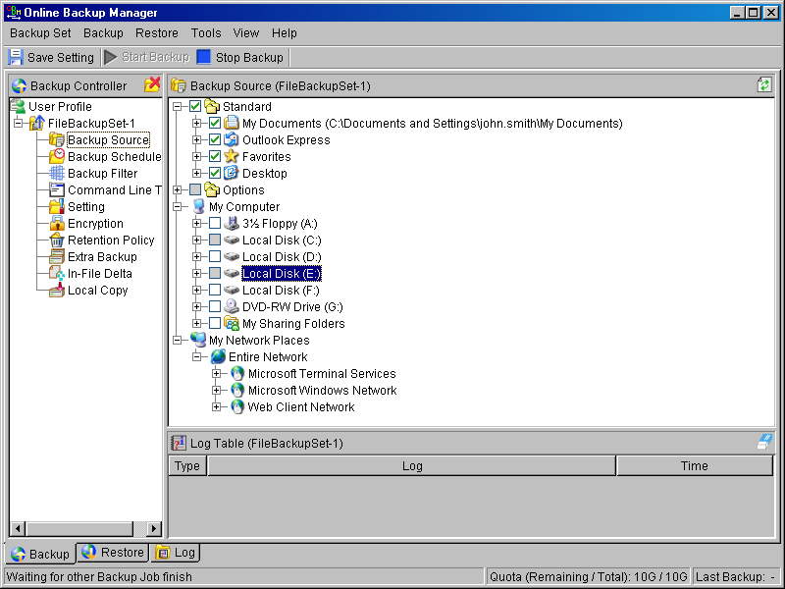

The checkbox next to the files/directories shown above can be in one of the following mode:
Mode | Description
 | All files/directories (recursively) under this directory will be backed up
 | All files/directories (recursively), except those explicitly excluded, under this directory will be backed up. If you add files/directories to this directory in the future, they will be backed up as well.
 | Only the checked files/directories under this directory will be backed up. If you add files/directories to this directory in the future, they will NOT be backed up.
 | Nothing under this directory will be backed up.

Mapped Network Drive
If you need to backup a mapped network drive on Windows (it will only work in Windows NT/2000/XP/2003), you must enter your Window’s domain, username and password into the [Network Resources Authentication for Windows] section as shown below. It is required because scheduled backups will always run under the context of Window’s “Local System” account (which does not have the privileges required to access network resources) by default. OBM needs to collect your Windows username, password and domain name to authenticate itself to the windows domain controller to acquire the required access privileges to the network files to be backed up. If you don’t supply a username and password, OBM will have problems accessing network resources in its scheduled backup Jobs.
If you need to backup network mapped drive in scheduled backup, please do this:
- Select the backup set from the left panel and press the [Properties] button
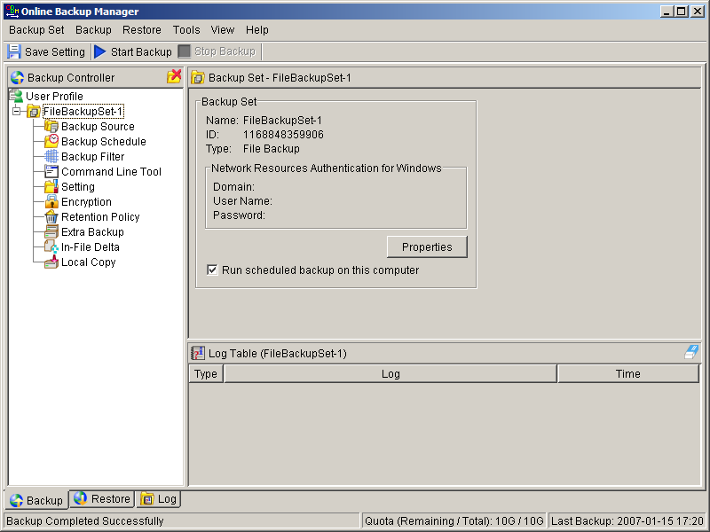
- Enter your Windows domain, username and password into the dialog shown below and press [OK]
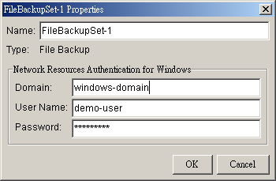
- Press the [Save Setting] button on the toolbar
The steps above apply only to computers running in a Windows domain. If you don’t have a windows domain with your network and you are using a workgroup or using a NetWare server, please use the “net use” command to authenticate the running backup process against the computer hosting the mapped drive. Otherwise, you will get “Access Denied” error from the backup report.
For example, if you want to backup \\SERVER\SHARE that is located on a NetWare server (or another computer in a windows workgroup) and you are getting "Network drive is not accessible" error message, please try adding the following command as a [Pre-backup command]
net use \\SERVER\SHARE [PASSWORD] /USER:[DOMAIN | MACHINE_NAME]\[USERNAME]
E.g.
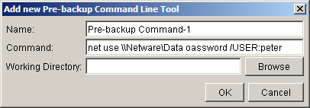
Enter one of the following commands directly into the Pre-Backup Command:
net use \\Netware\Data password /USER:peter
net use \\WorkgroupComputer1\Data password /USER:WorkgroupComputer1\peter
This will authenticate the current process with the NetWare server (or another computer in a windows workgroup) and backup will then run correctly.

Backup Schedule
A “Backup Schedule” defines the frequency and the time that backups should run automatically.
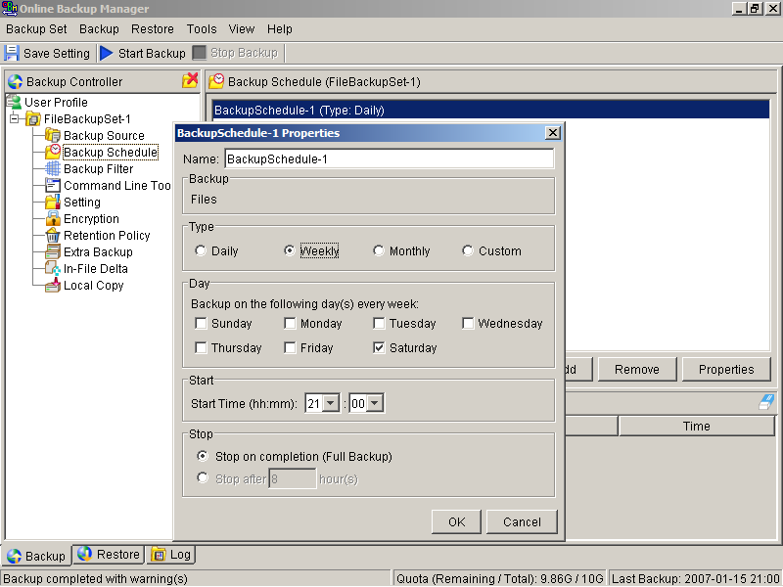
Backup schedule can be in one of the following types:
Type | Description
Daily | Backup Jobs will run everyday
Weekly | Backup Jobs will run on the specified day(s) of every week
Monthly | Backup Jobs will run on the specified day or on a day with a given criteria (e.g. first weekend, last weekday) of every month
Custom | Backup job will run once on any particular date
For each schedule type above, backup will run at the scheduled time for a maximum of the duration specified (or until all data are backed up if [Stop on backup completion] option is chosen). If a backup job does not finish within the maximum duration specified, it will be interrupted.
Please note that you can have more than one schedule within a backup set. For example, you can have a daily backup schedule that runs at 13:00 at noon and another daily backup schedule that runs at 00:00 at midnight. The combination of these schedules effectively creates a backup schedule that runs daily at 00:00 and 13:00 everyday.

Backup Filter
A “Backup Filter” defines the file selection rules that allow user to easily include/exclude files into/from the backup set by applying user defined criteria(s) to the file names or directory names.
There are some basic rules regarding backup filters:
- Filters are checked in creation order. Once inclusion/exclusion has been identified, the remaining filters won't be checked.
- Inclusion/Exclusion made by filter always takes precedence over backup source selections
- If all filters do not apply to a particular file, this file is then checked for inclusion/exclusion backup source selections
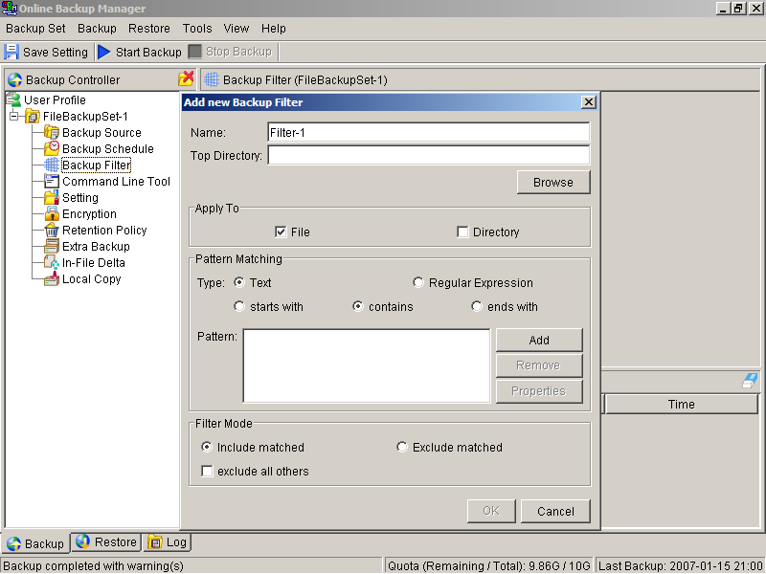
Key | Description
Name | The name of a filter
Top Directory | The top directory to which this filter is applied. Filtering rules will be applied to all files and/or directories under this directory.
Apply To | Define whether to apply the filtering rule to files and/or directories
Pattern Matching | It defines the filtering rules of a filter. A filtering rule can be of one of the following types:  [Starts With] Include/Exclude all files/directories with name starting with a certain pattern.  For example: You can use B* to match all files with name starting with a ‘B’ character  [Contains] Include/Exclude all files/directories with name containing a certain pattern.  For example: You can use *B* to match all files with name containing with a ‘B’ character  [Ends With] Include/Exclude all files/directories with name ending with a certain pattern.  For example: You can use *.doc to match all files with name ending with ‘.doc’ (all Word documents)  [Regular Expression] Include/Exclude all files/directories with name matching a regular expression.
Filter Mode | Defines whether you want to include or exclude matched files into/from the backup set. Also, for those unmatched files, you can choose to exclude (if include filter type) or include (if exclude filter type) them into/from the backup set.
Example 1:
If you want to backup only Word, Excel and PowerPoint documents in your document directory (e.g. C:\My Documents), you should setup your backup filter as follows.
Top Directory = C:\My Documents
Apply To = File (true)
Matching Type = End With
Matching Patterns = *.doc, *.xls, *.ppt
Filter Mode = Include
Exclude all others = True
Example 2:
If you want to backup all files, excluding all *.exe, *.dll and *.tmp, in C:\Applications, you should setup your backup filter as follows.
Top Directory = C:\Applications
Apply To = File (true)
Matching Type = End With
Matching Patterns = *.exe,*.dll, *.tmp
Filter Mode = Exclude
Include all others = True
Example 3:
If you have made your selection of files (all under C:\) from the backup source setting but you want exclude all images (e.g. *.jpg and *.gif) from your selection, you should setup your backup filter as follows.
Top Directory = C:\
Apply To = File (true)
Matching Type = End With
Matching Patterns = *.jpg, *.gif
Filter Mode = Exclude
Include all others = false
Please note that the [Include all others] setting is not enabled because you don’t want to include all other files (NOT *.jpg, *.gif) under C:\ into the backup set.
Example 4: (advanced)
If you want to include everything, except the “log” directory, under C:\Applications into a backup set, you should setup your backup filter as follows.
Top Directory = C:\Applications
Apply To = Directory (true)
Matching Type = Regular Expression
Matching Patterns = ^log$
Filter Mode = Exclude
Include all others = True
Example 5: (advanced)
If you want to include all directories named “log” from the backup set files with file name starting with “B” and ending with “*.doc” under C:\My Documents into the backup set, you can use a regular expression of “^B.*\.doc$” to do your selection. The filter backup can then be setup as follows.
Top Directory = C:\My Documents
Apply To = File (true)
Matching Type = Regular Expression
Matching Patterns = ^B.*\.doc$
Filter Mode = Include
Exclude all others = True

Pre/Post-Backup Command
The “Command Line Tool” feature has two major components, the [Pre-Backup] command and the [Post-Backup] command. You can use the [Pre-Backup] or [Post-Backup] commands to run any native OS (operating system) commands before or after running a backup job.
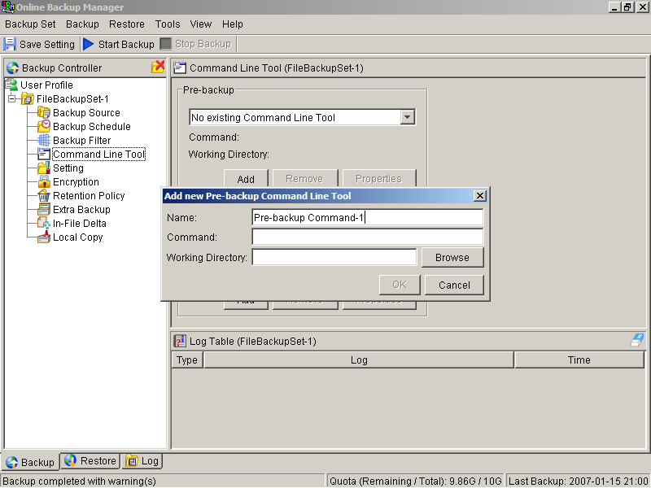
Both [Pre-Backup] and [Post-Backup] commands comprise of the following parameters:
Key | Description
Name | Name of this Command
Command | The command to be run  (e.g. C:\My Documents\Application.exe or C:\My Documents\BatchJob.bat)
Working Directory | The directory at which this command will run
The backup set type affects the time at which [Pre-Backup] and [Post-Backup] commands run. The following table outlines when [Pre-Backup] and [Post-Backup] commands will run in different types of backup set.
Backup Set Type | When Pre-Backup Commands run? | When Post-Commands run?
File | Before uploading backup files | After uploading all backup files
Non-File Backup Sets (e.g. Microsoft SQL Server) | Before spooling backup files to temporary directory | After spooling backup files to temporary directory (i.e. before the first backup file is uploaded)
Note: You should never backup an application while it is running as this can result in inconsistent and unusable files getting backed up. Please use the “Volume Shadow Copy” feature if you’re running Windows XP/2003 or make use of the Pre-Backup Command feature to shutdown your application before running a backup job and use the Post-Backup Command feature to restart your application after the backup job has completed.
For Example
You want to stop Microsoft Outlook using the Pre-Backup Command and restart it after backup using the Post-Backup Command, create the two following text files and assigned the files to Pre-Backup and Post-Backup Command.
- Create a text file named “OutlookClose.vbs” using notepad with the following two lines:
Set objOLK = createObject("Outlook.Application")
objOLK.quit
- Create a text file named “OutlookStart.bat” using notepad with the following line:
"C:\Program Files\Microsoft Office\OFFICE11\OUTLOOK.EXE"

Temporary directory
If you are running a file backup job with in-file delta enabled or a database type backup job, OBM will generate temporary files and the directory that will be used to store all these files are defined by [Setting] -> [Temporary directory for storing backup files]. Please set this to a non-system disk partition that has enough free space to avoid problems.
You can set the [Temporary directory for storing backup files] to a mapped network drive. If you choose to do this, please use a UNC path (e.g. \\SERVER\SHARE) and don’t forget to configure the [Backup Set] -> [Network Resources Authentication for Windows] setting.
To conserve the use of disk space, you can set the [Remove temporary files after backup] option to delete the temporary files automatically after a backup job has finished.

Transfer Block Size
Transfer block size defines the block size OBM will use to transfer your backup blocks. Generally, backup jobs using a larger block size will have better performance, because of the smaller number of connections involved.
However, some firewalls or proxy servers may block out-going network traffic (HTTP/HTTPS POST method) with large block size for security reasons. If you are in a network with this type of restriction, please lower the transfer size value and try again.
To change the transfer block size of any backup set, please select the [Setting] node on the left panel to invoke the [Setting] panel on the right. You can then make changes to the [Transfer Block Size]. After you have made your changes, just press the [Save Setting] button on the toolbar.
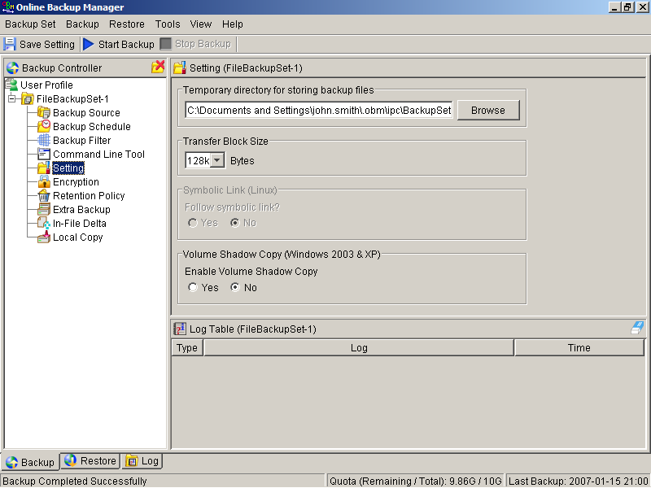

Follow Symbolic Link (Linux/Unix/Mac only)
Under Unix/Linux/Mac, users can create a symbolic link to link a file/directory from another directory. This setting defines whether you want OBM to traverse any symbolic links encountered on your backup path.
To change the follow symbolic link of any backup set, please select the [Setting] node on the left panel to invoke the [Setting] panel on the right. You can then make changes to the [Follow Symbolic Link]. After you have made your changes, just press the [Save Setting] button on the toolbar.

Microsoft’s Volume Shadow Copy Service (VSS)
Microsoft Volume Shadow Copy Service (VSS) allows you to backup files that are exclusively opened. Without VSS, you will get the error message “The process cannot access the file because another process has locked a portion of the file” if you are trying to backup a file that is exclusively opened (e.g. Outlook PST file).
Please note that VSS is only available on Windows XP / 2003 and you must have administrative privileges to start the VSS service on a computer. Also VSS will only work if at least one of your partitions is formatted using NTFS.
If you are running Windows 2003, please install the Windows 2003 VSS hot fix available in http://support.microsoft.com/default.aspx?scid=kb;en-us;887827 before running VSS.
If you are running into problems with VSS running on Windows XP / 2003, Microsoft's recommendation is to try re-registering the Volume Shadow Copy Service again. Simply run the script [OBM Home]\bin\RegisterVSS.bat to do so.
For more information, please take a look at the following page for a technical introduction to Volume Shadow Copy Services (VSS):
http://technet2.microsoft.com/windowsserver/en/library/2b0d2457-b7d8-42c3-b6c9-59c145b7765f1033.mspx

Encryption
Before your files are sent to the Offsite Backup Server, all your files are compressed and encrypted using your choice of encryption algorithm, mode and key. The following table explains all encryption parameters available within a backup set.
Note:
Encryption settings are set at backup set creation time and cannot be modified. You need to create a new backup set if you want to change your encryption settings for a backup set.
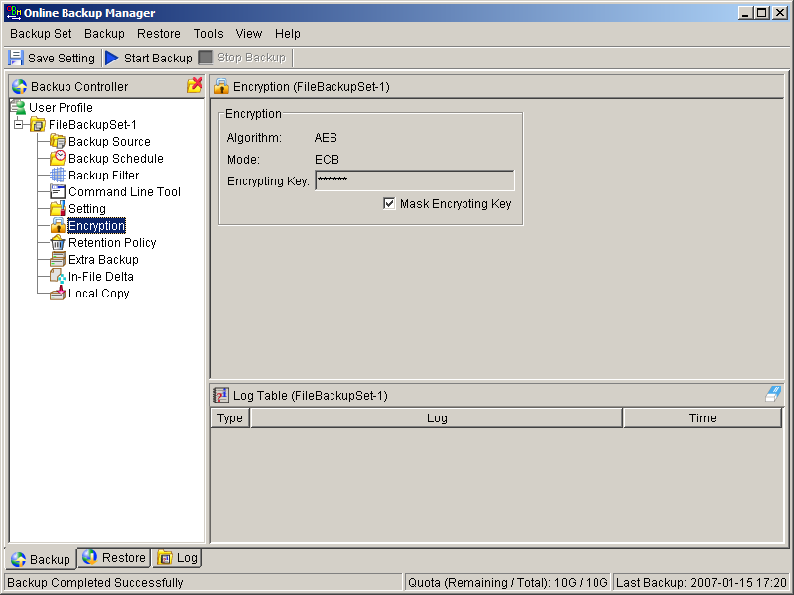
Parameter | Description
Encryption Algorithm | It defines the encrypting algorithm used to encrypt your backup files. There are three encryption algorithms available:  [AES] Advanced Encryption Standard algorithm  [DESede] Triple DES algorithm  [Twofish] Twofish algorithm  We recommend the use of AES as it has been chosen as the encryption standard for commercial use. Please refer to references on Cryptography for more information about encryption algorithms.
Encryption Mode | It defines the encrypting mode used to encrypt your backup files. There are two encryption modes available:  [ECB] Electronic Cook Book Mode  [CBC] Cipher Block Chaining Mode  We recommend the use of CBC mode as it offers better security. Please refer to references on Cryptography for more information about encryption modes.
Encrypting Key | The key used to encrypt all files within a backup set. Please write it down on paper and keep it in a safe place. If the key is lost, you will not be able to recover your files from the encrypted backup files.

Retention Policy
During backup, if OBM finds that you have deleted a file (or updated a file) on your computer, it will put the corresponding deleted (or updated) file already backed up on the backup server into a retention area. The retention policy setting defines how long files inside the retention area will be kept on the backup server before they are deleted automatically from the server.
Retention policy will only affect “retained” file (i.e. files that have already been deleted or updated on your computer and thus are moved to the retention area of the backup server). For those files that have not been updated on your computer, the backup of these files is kept in the data area on the backup server and won’t be affected by the setting of retention policy. These backup files of unchanged files will stay on the backup server forever until the original files are removed (or updated) from your computer.

Standard Retention Policy
The [Standard] retention policy allows you to delete retained files automatically after a user defined number of days or after a user defined number of backup Jobs. To change the retention policy setting of any backup set, please select the [Retention Policy] node on the left panel. You can then make changes to your retention policy under the [Retention Policy] section. After you have made your changes, just press the [Save Setting] button on the toolbar.
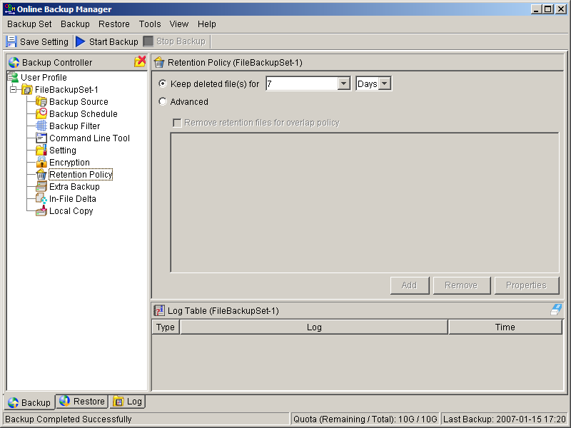

Advanced Retention Policy
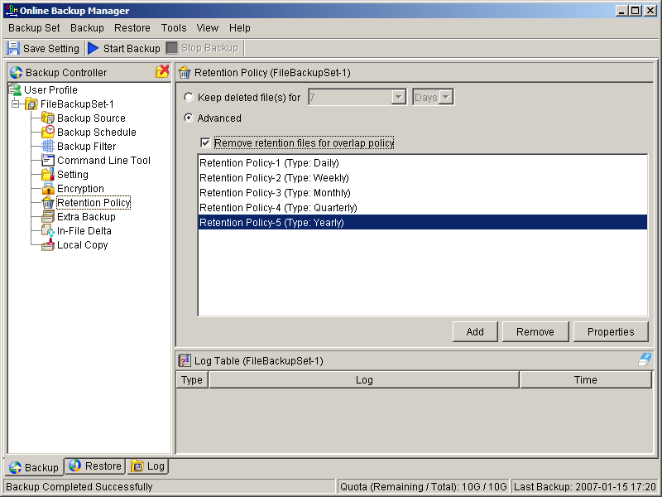

The [Advanced] retention policy allows you to configure a more flexible retention policy. It allows you to keep a set of snapshots of all backup files based on the time of the backup Jobs. For example, you can configure the advanced retention policy to keep the following sets of backup files to mimic the retention policy of the old days when you were still doing tape rotations:
      - All files available within the last 7 days
      - All files available on the last 4 Saturdays within the last 28 days
      - All files available on the 1st day of each month within the last 3 months
      - All files available on the 1st day of each quarter within the last 12 months
      - All files available on the 1st day of each year within the last 7 years
To do so, you need to setup your advanced retention policy as follows:
      - Type = Daily; Number of copy to keep = 7
      - Type = Weekly; Frequency = Saturday; Number of copy to keep = 4
      - Type = Monthly; Frequency = Day 1; Number of copy to keep = 3
      - Type = Quarterly; Frequency = Day 1 of Jan, Apr, Jul, Oct; Number of copy to keep = 4
      - Type = Yearly; Frequency = Date 01-01; Number of copy to keep = 7
Assuming today is 17-Jan-2006, if [Remove retention files for overlap policy] is NOT enabled, a total of 22 snapshots (provided you have run backups daily for more than 7 years) will be kept on the server accordingly, i.e.:
Daily | Weekly | Monthly | Quarterly | Yearly
16-Jan-2006 | 14-Jan-2006 | 01-Jan-2006 | 01-Jan-2006 | 01-Jan-2006
15-Jan-2006 | 07-Jan-2006 | 01-Dec-2005 | 01-Oct-2005 | 01-Jan-2005
14-Jan-2006 | 31-Dec-2005 | 01-Nov-2005 | 01-Jul-2005 | 01-Jan-2004
13-Jan-2006 | 24-Dec-2005 |  | 01-Apr-2005 | 01-Jan-2003
12-Jan-2006 |  |  |  | 01-Jan-2002
11-Jan-2006 |  |  |  | 01-Jan-2001
10-Jan-2006 |  |  |  | 01-Jan-2000

If [Remove retention files for overlap policy] is enabled, only the following snapshots are kept:
Daily | Weekly | Monthly | Quarterly | Yearly
16-Jan-2006 | 14-Jan-2006 | 01-Jan-2006 | 01-Jan-2006 | 01-Jan-2006
15-Jan-2006 | 07-Jan-2006 | 01-Dec-2005 | 01-Oct-2005 | 01-Jan-2005
14-Jan-2006 | 31-Dec-2005 | 01-Nov-2005 | 01-Jul-2005 | 01-Jan-2004
13-Jan-2006 | 24-Dec-2005 |  | 01-Apr-2005 | 01-Jan-2003
12-Jan-2006 |  |  |  | 01-Jan-2002
11-Jan-2006 |  |  |  | 01-Jan-2001
10-Jan-2006 |  |  |  | 01-Jan-2000

The weekly policy overrides the daily policy so the snapshots of 10-Jan-2006, 11-Jan-2006, 12-Jan-2006, 13-Jan-2006 and 14-Jan-2006 are removed. The monthly policy overrides the weekly policy so the snapshots of 24-Dec-2005 and 31-Dec-2005 are removed. The same applies to the monthly, quarterly and yearly policy giving a total of 11 snapshots.

Extra Backup (Off-line backup, Logout Reminder)
Off-line backup is basically designed for notebook users who are off-line most of the time and cannot rely on the backup schedule to backup regularly. The "Backup Interval" allows notebook users to specify the interval that they would like their data to backup. When the machine is online and this interval has elapsed, backup will run automatically. If “Backup Alert” is enabled, a popup message box will ask the user to confirm starting the backup.
The "Email Notification" setting is the number of days since the last backup that triggers the backup server to send email notification to the client to remind him to run an off-line backup.
When the “Logout Reminder” setting is enabled, a popup message box will ask the user to start a backup before logging out / shutting down Windows.
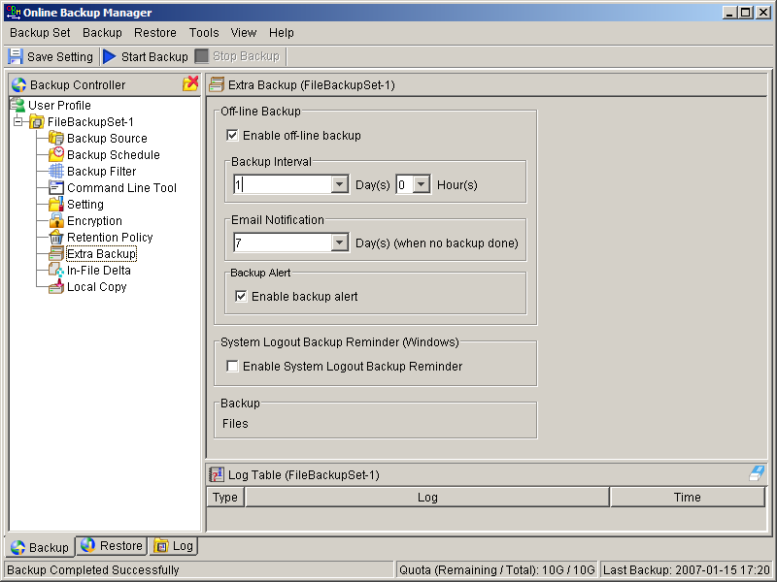

In-File Delta
Please refer to the in-file delta section for more information on this topic.

Local Copy
If you want to save an extra copy of backup data on your local hard disk (in addition to a copy of backup data stored on the backup server) to minimize file-restoring time and/or to provide an extra safety precaution, you can do the following:
- Open OBM from the System Tray (see previous sections for details)
- Setup your backup set (see previous sections for details)
- Select [Local Copy] under your backup set from the left panel
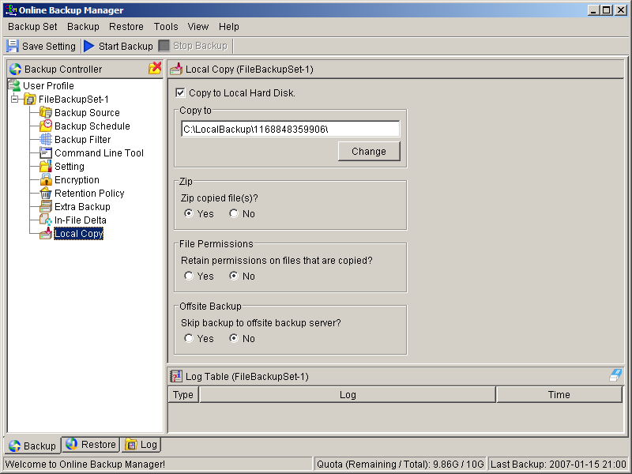
- Check the [Copy to Local Hard Disk] checkbox
- Enter a directory to where you want an extra copy of your backup files to be stored in the [Copy to] field provided (preferably a directory under another hard disk)
- (Optional) Select the [Yes] radio button if you want to store your backup files in compressed form to conserve free space usage
- An extra copy of backup will be saved in the [Copy to] directory when you run your backup job
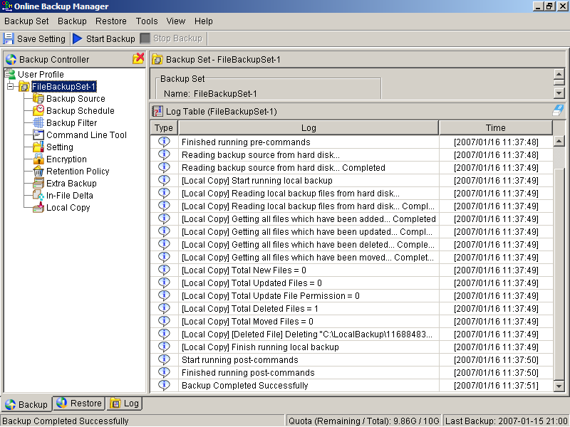
If you want to make local copy to a directory located on a NetWare server (or another computer is a windows workgroup) and you are getting "Network drive is not accessible" error message, please try adding the following command as a [Pre-backup command]
net use \\SERVER\SHARE [PASSWORD] /USER:[DOMAIN | MACHINE_NAME]\[USERNAME]
E.g.
C:\> net use \\Netware\Data password /USER:peter
C:\> net use \\WorkgroupComputer1\Data password /USER:WorkgroupComputer1\peter
This will authenticate the current process with the NetWare server (or another computer is a windows workgroup). Backup will then be allowed to run correctly.

How to restore “Local Copy” files
“Local Copy” files are stored in the [Copy to] directory (under [Local Copy] setting). To restore backup files, please do the followings:
- Choose [Tools] -> [Unzip Local Copy]
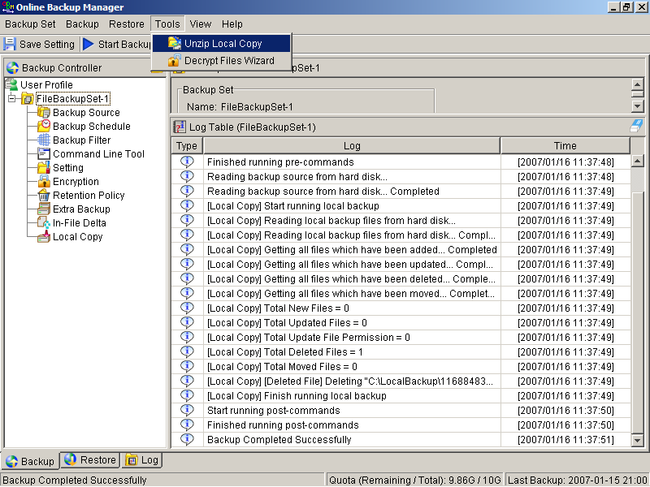
- Select the required [Backup Set] from the drop down list
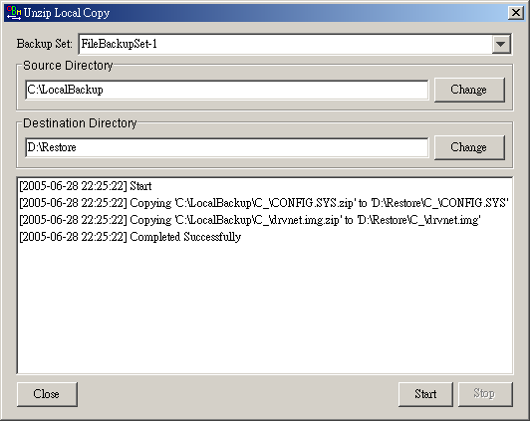
- Fill in the [Source Directory] (directory where “Local Copy” files are stored) and [Destination Directory] (directory to where you want “Local Copy” files to be restored)
- Click [Start]

Using One Backup Account for Multiple Computers
OBM allows you to backup multiple computers using a single backup account. To backup multiple computers, you need to create a different backup set to backup each individual computer and to configure the [Run scheduled backup on this computer] checkbox.
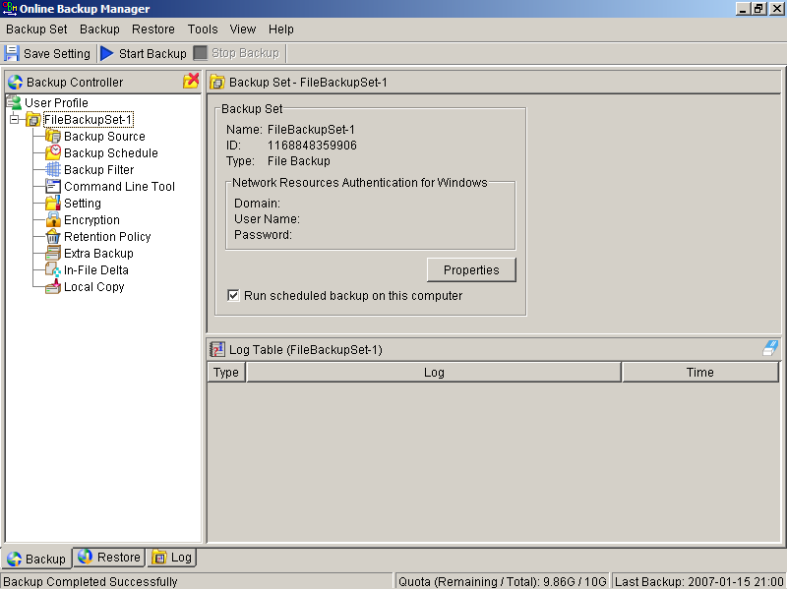

For version 5.2
Since the computer that created the backup set will have its computer name associated with the backup set. The backup scheduler running on each computer will only run backup sets with the same computer name as itself. Thus, you just need to make sure that all your computer names using a single backup account are unique.

For version 5.1 or Earlier
You must configure OBM on each computer that it only runs scheduled backup for the intended backup sets only. If this is not setup properly, scheduled backup job of the same backup set from different computers will both be started. This will result in lots of checksum errors and files being deleted on the backup server.
To allow multiple computers to be backed up under a single backup account, you are required to do the following for each computer that has installed OBM under the same backup account:
- Logon to one of the computers that has OBM installed under the same backup account.
- Open OBM and select a backup set that is not intended to run on this computer from the left panel.
- Make sure that the [Run scheduled backup on this computer] checkbox on the right panel is not checked.
- Repeat the previous step for the rest of the backup sets that are not intended to run on this computer.
- Repeat steps ii to iv for each computer that has OBM installed under the same backup account.
IMPORTANT If you create a new backup set or want to backup another computer using the same backup account at a later date (this implies that you need to create an additional backup set under this backup account for the new computer), please make sure to repeat the procedure above (i.e. uncheck the [Run scheduled backup on this computer] checkbox for the added backup set) for each computer.

Backing Up Files
This chapter describes how files are backed up by OBM to the backup server

How files are backed up
The diagram below describes how OBM backup your files.
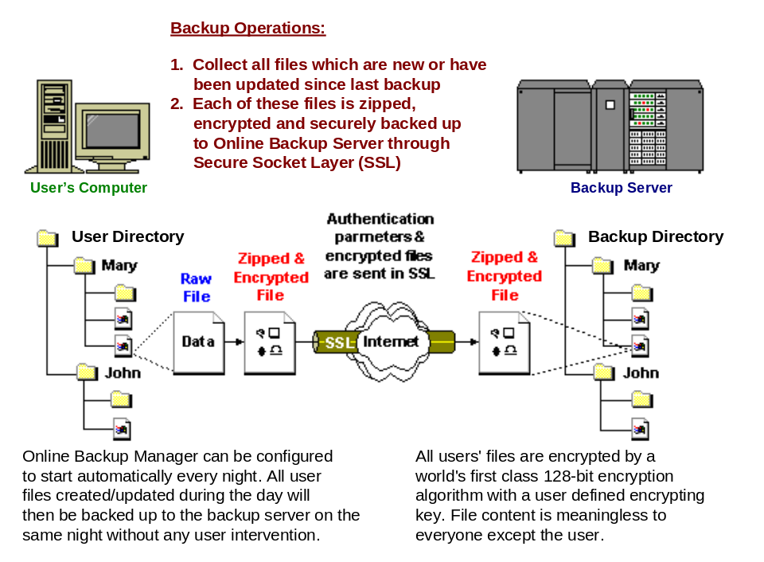

Run backup at scheduled time automatically
Once you set your backup scheduled, a backup job will be started automatically to perform backup operation for you at your absence. You can have backup running at your scheduled time as often as you want (e.g. twice a day or hourly during office hour) without requiring doing any extra work.

Incremental Backup
Unchanged files are already backed up to server and need not to be backed up again. OBM will pick the new or updated files from your backup set files and upload only these files to the server. It significantly reduces the time required to perform the backup operation since most users update less than 5% of their total data each day.

Compress and encrypt data automatically
Data are compressed and encrypted before they are uploaded to the server. Not only does it reduce the storage space to keep you backup files, it also ensures the privacy of your data.

File Retention Policy
The built-in file retention policy allows you to access multiple versions of the same file or even deleted files from your backup set. Backup files are put into a retention area before they are removed from the server. If you want to get back a deleted file (or you want to get back the previous versions of an updated files) within the retention period, these files will always be available in the retention area. This feature is particularly useful when you have accidentally deleted a file or incorrectly updated a file within the file retention period (file retention period is user customizable).

Backup files directly to the backup server
You can backup your data to an Offsite Backup Server by following instructions below.
- Open OBM
- Right click OBM icon available in the system tray and choose [Open]
  - Create a backup set
  - From the Menu, Choose [Backup Set] -> [New] -> [File Backup Set]
  - Enter a name for your backup set
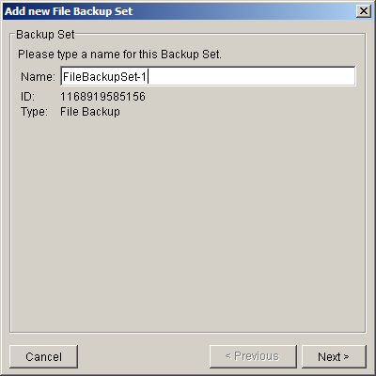
  - Select the files/directories you want to backup
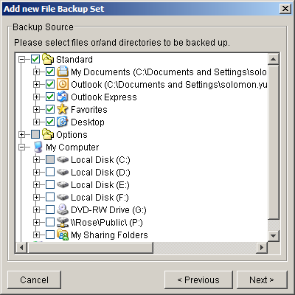
  - Set the backup schedule (Note: You can have more than one schedule in a backup set)
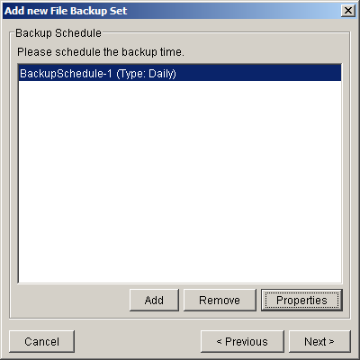
  - Set the encryption algorithm, encryption mode and encrypting key for this backup set
(Hint: For the sake of simplicity, just select the [Default] radio button (your encrypting key is set to be the same as your backup account password)
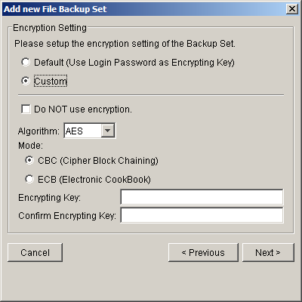
- Run Backup
  - Select the backup set you want to run on the left panel and press the [Start Backup] button (►) on the toolbar
  - Select [Off-site Backup Server] to start backing up your files to an Offsite Backup Server.
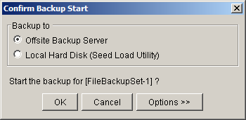
Note:
1. | You can have more than one backup set in a backup account.
2. | Please write the encrypting key down on paper and keep it in a safe place. If you lose your encrypting key, you will not be able to restore your backup files.

Backup files to removable hard disk (seed loading)
If you have a lot of data (e.g. 300GB) to backup to the backup server, it would take a considerable amount of time to perform the first full backup through the Internet. If you run into this problem, you can use the Seed Loading Utility to backup your backup set to local hard disk (instead of directly to the backup server) and then transport the backup data, using removable hard disk, to the offsite backup server. The administrator can then load all your backup files from your removable hard disk into your backup account. This could then save you days (even weeks) of performing your first full backup. Since subsequent backup will be incremental backup (only new or updated files will be uploaded to the server) you should have no problems uploading your backup data afterwards.
To perform seeding loading, please do the following:
- Open OBM from the System Tray (see previous sections for details)
- Setup your backup set (see previous sections for details)
- Select the backup set you want to run on the left panel and press the [Start Backup] button (►) on the toolbar
- Select [Local Hard Disk (Seed Load Utility)] to start backing up your files to local hard disk and press the [OK] button
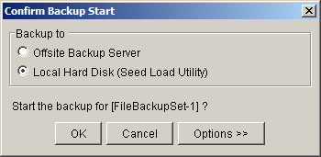
- Enter a directory where you want all backup files to be stored in the [Destination Directory] field and press the [Start] button.
Please make sure you have enough free space in the directory specified. If you are going to transport a removable hard disk to the offsite backup server, please enter a directory under your removable hard disk here.
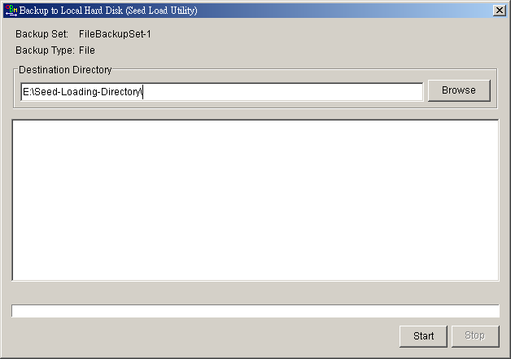
- You should get the message “Backup Completed Successfully” as shown below after all backup files are spooled to the directory you specified.
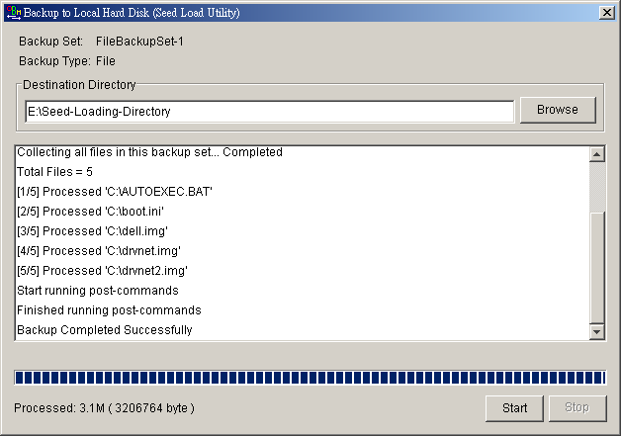
- Transport the data specified in the [Destination Directory] field to the offsite backup server

Restoring Files
This chapter describes different ways files can be restored from to the backup server
It is very important to write down your encrypting key on paper and keep it in a safe place because there will be no way to restore your backup files if you lose your encrypting key.

Restore backup files directly from backup server
You can use either OBM or the web restorer to restore backup files from the backup server.

Using OBM
You can restore your data from the backup server by following instructions below.
- Open OBM from the System Tray (see previous sections for details)
- Select the [Restore] tab at the bottom part of OBM
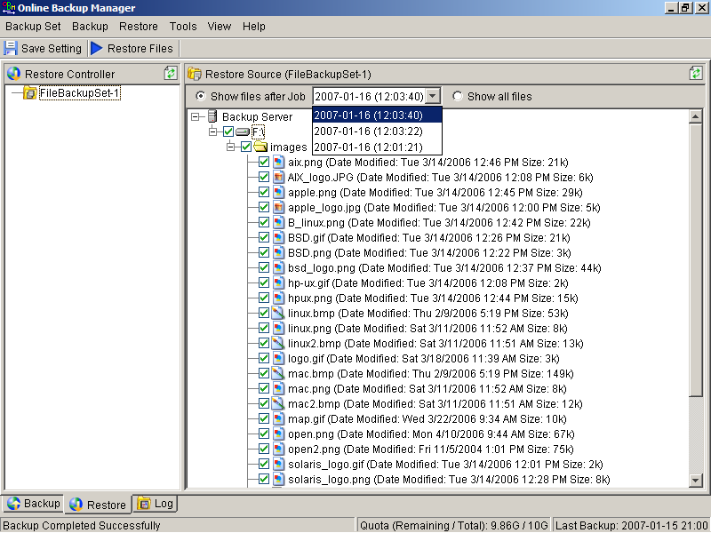
- Select the backup set from which you would like files to be restored from the left panel
- Select the snapshot of your backup files that you would like to restore from the backup server by using [Show files after Job] drop down list
- Select the files that you would like to restore and press the [Restore Files] button on the toolbar
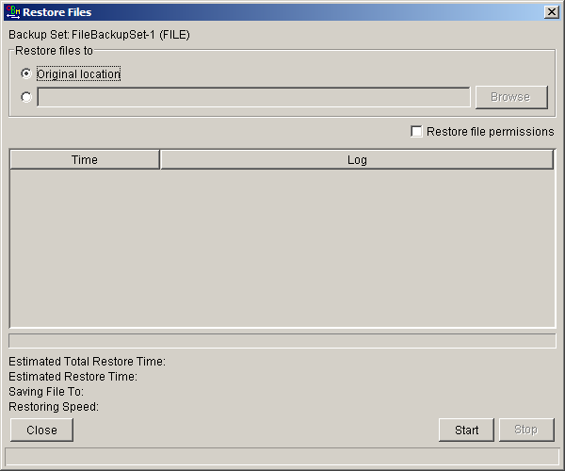
- Use the [Browse] button to select the directory to where you want files to be restored (or simply select [Original location] to restore files to their original path)
- Files will be restored automatically as shown below (a file won’t be downloaded from the backup server again if an identical file exists on local path already)
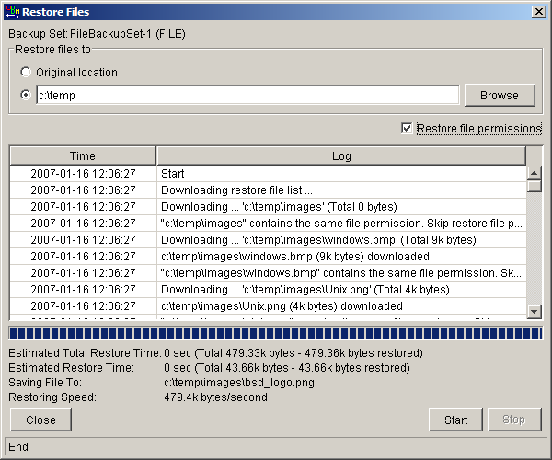

Using the web interface
You can restore your data from an Offsite Backup Server by following instructions below.
- Logon to the Offsite Backup Server web interface
- From the top menu, click [File Explorer]
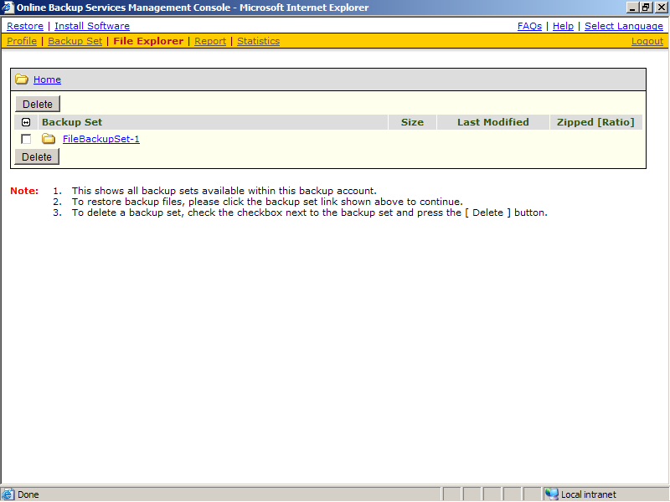
- Click the [Backup Set] link that contains the files that you want to restore
- Select the snapshot of your backup files that you would like to restore from the backup server by using [Show files after Job] drop down list
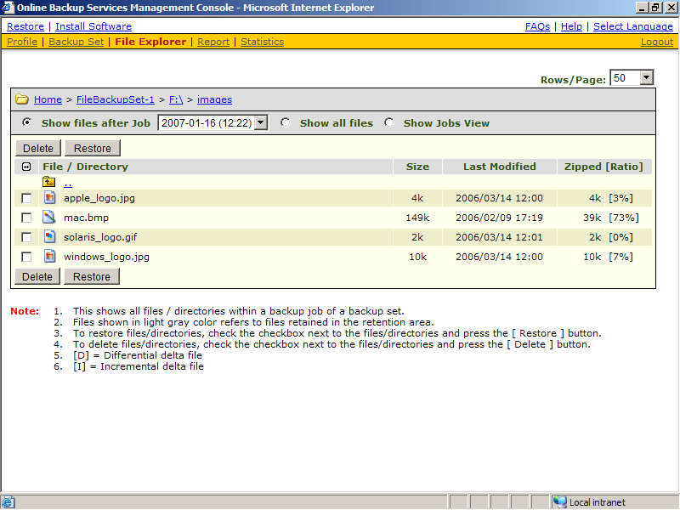
- If you want to see all the different versions of all files (shown as gray below), just choose the [Show all files] radio button on the [File Explorer] page.
Files, which are shown in gray below (e.g. AIX_logo.JPG) are being stored in the retention area on the backup server but you can still restore these files from the backup server.
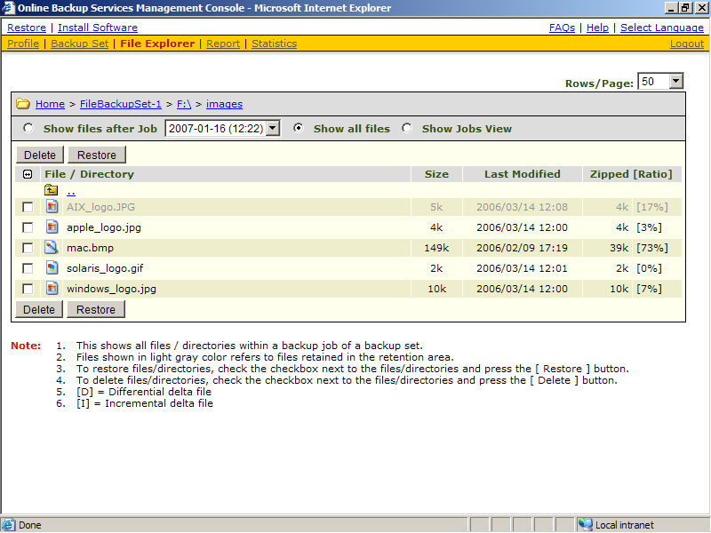
- Select the files that you would like to restore and press the [Restore] button on the toolbar
- A dialog shown below would appear
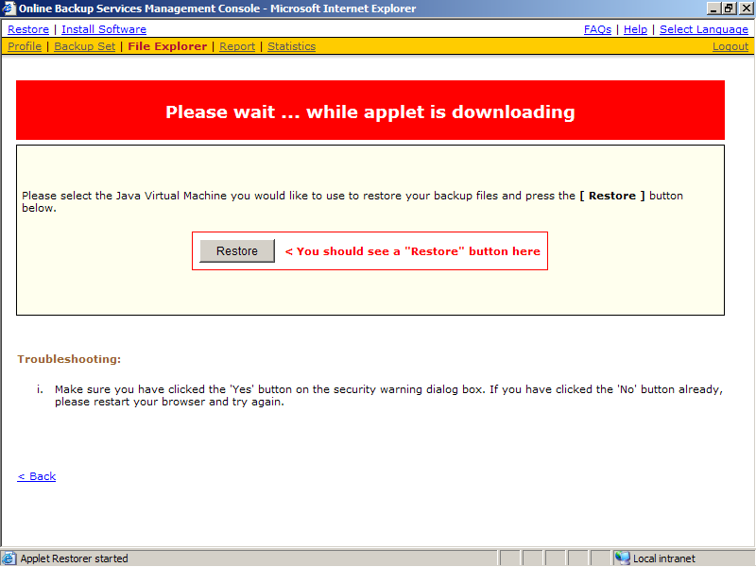
  - Press the [Restore] button
  - Enter the directory to which backup files should be restored to in the [Restore files to] textbox
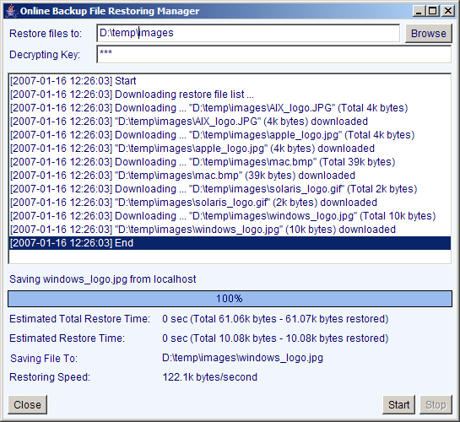
  - Enter the encrypting key which will be used to decrypt your backup files upon restoring your backup files
  - Press the [Start] button

Restore backup files from removable hard disk
If you want to restore lots of backup files from the backup server and you find it too slow to restore all your backup files from the backup server through the internet. You can ask your backup services provider to send you all your backup files in removable hard disk (or CD/DVD). However, all backup files stored on backup server are in encrypted format. You need to decrypt them back to their original format before you can use them. To decrypt your backup files from removable media, please do the followings:
- Open OBM from the System Tray
- Select the [Tools] -> [Decrypt Files Wizard] from the menu
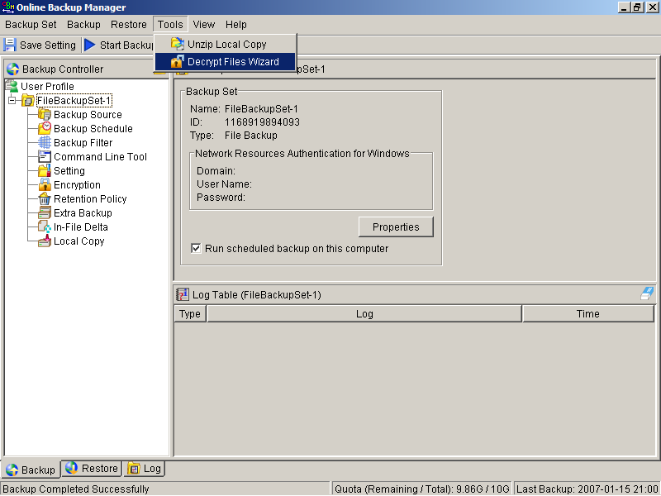
- Use the [Browse] button to locate the “files” directory (provided by your backup provider in removable hard disk or DVD) which contains the backup files that you want to decrypt
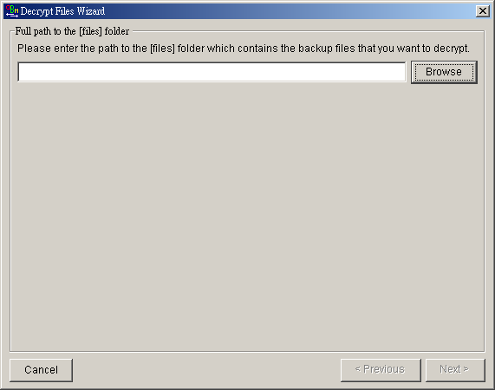
- If you have more than one backup set under the “files” directory, select the [Backup Set] which contains the backup files that you want to decrypt
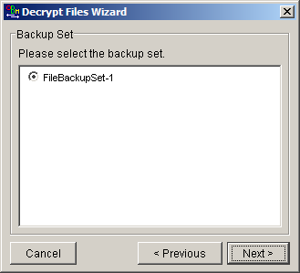
- Select the snapshot of your backup files that you would like to restore from the removable media by using [Show files after Job] drop down list
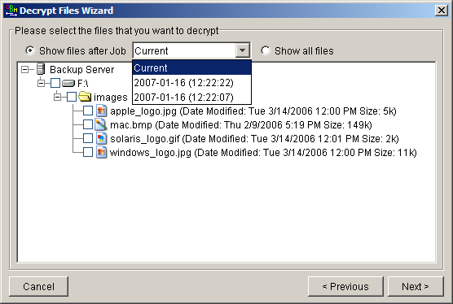
- If you want to see all the different versions of all files (shown as gray below), just choose the [Show all files] radio button on the [Decrypt Files Wizard] dialog.
Files, which are shown in gray below (e.g. AIX_logo.JPG) are being stored in the retention area on the removable media (but you can still restore these files).
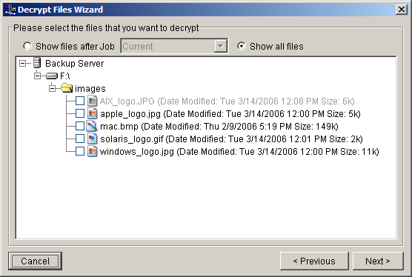
- Enter the directory to which you want the backup files to be restored to in the [Decrypt files to] section and enter the [Decrypting Key] (the same as the encrypting key of this backup set)
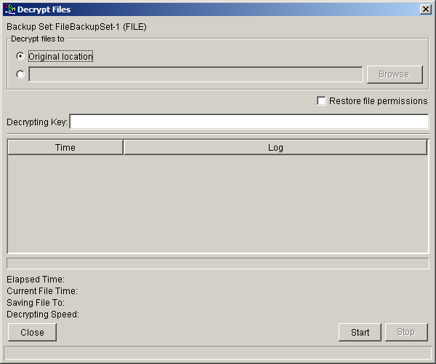
- Press the [Start] button
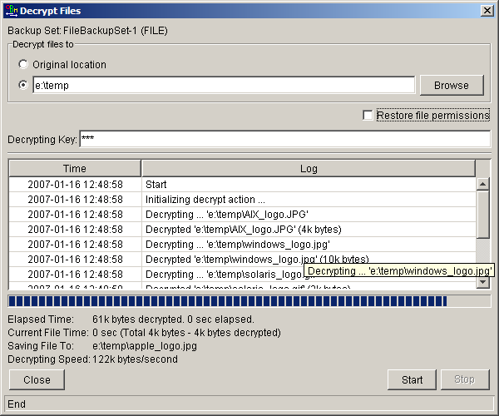

IP addresses Restriction for Online Restore
Online file restore operation can be restricted by IP addresses. You can ask your backup service provider to restrict online file restoration for your backup sets by IP addresses to only allow people from authorized IP addresses to restore files from the backup server. To check if online file restore of any backup set is restricted this way, please take a look at the web interface of OBS, [Online Backup Services Management Console] -> [Backup Set] -> [Online Restore IP restriction] (shown below).
Users are not allowed to update the [Online Restore IP restriction] directly. Please ask your backup services provider to do the changes for you.
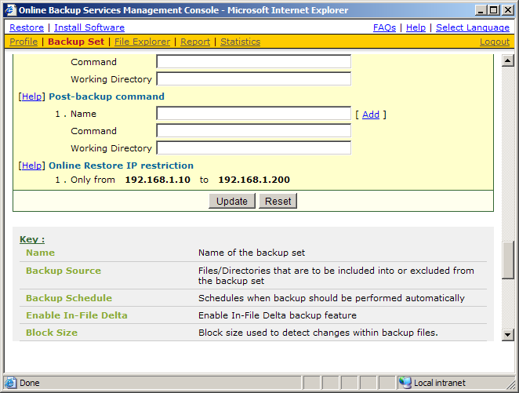

In-File Delta Technology
The chapter describes what in-file delta technology is and how in-file delta can be used to backup large database files (e.g. a 10GB Outlook.pst file) without uploading the whole database file everyday.

Overview
In-file delta technology is an advanced data block matching algorithm which has the intelligence to pick up changes (delta) of file content between two files. Using this algorithm, daily backing up of large files (e.g. a 10GB Outlook.pst file) over low-speed internet connection is made possible because it requires only the changes of information (should be marginal) since the last backup to be sent over a low-speed internet connection to complete the backup of a large file (here we assume that the full backup of the file has been saved on the backup server already).
This is what will happen in the backup of a 10GB Outlook.pst file when it is backed up by OBM with in-file delta technology.
- The whole files (10GB), along with its checksum file, are backed up to the backup server. This can be done directly through the internet or indirectly using the seed loading utility on a removable hard disk.
- When backup runs again later (normally the next day), OBM will download a checksum listing of all data blocks of the full backup file (or last incremental backup file) from the backup server and use it to pick up all changes that have been made to the current Outlook.pst file.
- Changes detected are then saved in a delta file which is uploaded to the backup server. A new checksum file is generated and is also uploaded. (This delta file is assumed to be small because the content of PST files doesn’t change a lot during daily usage)
- Subsequent backups of this 10GB Outlook.pst file will go through step ii and step iii again. As explained, only a small delta file and checksum file will be uploaded to the backup server.
- With in-file delta technology, daily backing up of large file over low-speed internet connection is now possible

Incremental in-file delta type
Incremental Delta will facilitate ease of backup. The delta is generated by comparing with the latest uploaded full or delta file. The delta file generated is the smallest possible and uses the least bandwidth during backup. For restoration, the full file and all delta files up to the required point-in-time is required to restore the file to a specific point-in-time.
Example: If you are adding around 100MB changes to a 10G Outlook.pst everyday.
After the first full backup job, OBM will continue to generate and upload delta files instead of uploading the full file until either one of the following two rules are true:
- Number of deltas generated since the last full backup is greater than the [Number of Delta] setting.
- The delta ratio (the ratio of the delta file size against the full file size) is greater than the [Delta Ratio] setting
Using incremental delta, the delta generated by comparing the current file with the latest uploaded full or delta file is around 100MB.
Since the delta file size is around 100MB daily, the delta ratio (around 1%) will not trigger a full file upload. Instead OBM will continue to generate and upload delta files until day 102 (assuming the full file was uploaded on day 1) when the number of deltas generated exceeds the [Number of Delta] setting and triggers the upload of the full Outlook.pst file. You can disable the [Number of Delta] and [Delta Ratio] if you don’t want to upload the full file.
All delta files are generated with respect to changes made since the last incremental or full backup. This means that the last full backup file and ALL incremental delta backup files are required to restore the latest snapshot of a backup file.

Differential in-file delta type
Differential Delta will facilitate ease of restore. The delta is generated by comparing with the latest uploaded full file. The delta file generated grows daily and uses more bandwidth during backup. For restoration, the full file and a single delta file is required to restore the file to a specific point-in-time.
Example: If you are adding around 100MB changes to a 10G Outlook.pst everyday.
After the first full backup job, OBM will continue to generate and upload delta files instead of uploading the full file until either one of the following two rules are true:
- Number of deltas generated since the last full backup is greater than the [Number of Delta] setting.
- The delta ratio (the ratio of the delta file size against the full file size) is greater than the [Delta Ratio] setting
Using differential delta, the delta generated by comparing the current file with the latest uploaded full file is around 100MB for the 1st delta, 200MB for the 2nd delta, 300MB for the 3rd delta and so on.
Since the delta file grows by 100MB daily, the delta ratio for day 52 (delta file size is approximately 51x100= 5.1GB, assuming the full file was uploaded on day 1) being over 50% exceeds the [Delta Ratio] setting and triggers the upload of the full Outlook.pst file. You can disable the [Number of Delta] and [Delta Ratio] if you don’t want to upload the full file.
All delta files are generated with respect to changes made since the last full backup file (i.e. differential backup). This means that only last full backup file and the last delta file are required to restore the latest snapshot of a backup file. This means that other intermediate delta files are only required if you want to restore other snapshots of a backup file.
Differential in-file delta backup has the benefits that a corrupted delta file would only make one particular version of a backup file non-recoverable and all other backups created by other delta files of the same file would still be intact.

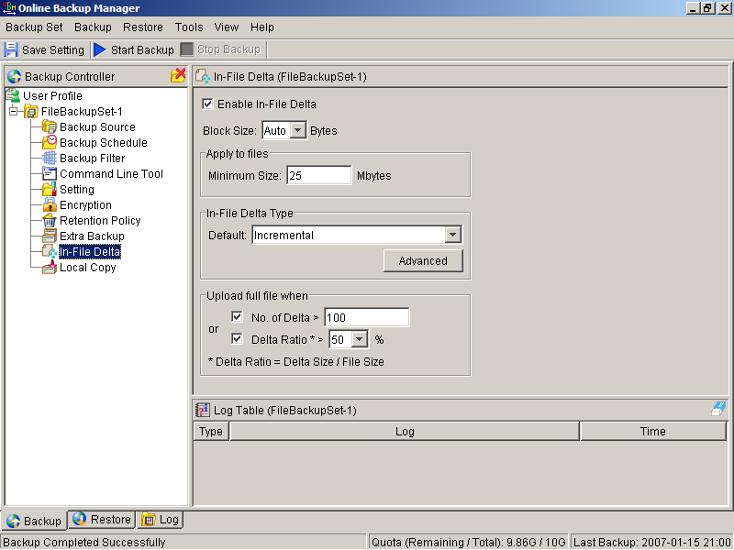

Block Size
The block size defines the size of data block being used to detect the changes between the last full or delta backup file and the file sitting on the local computer right now. In general, the smaller the block size, the more likely a matched data block can be found between the last backup file and the file on local computer. It, therefore, produces a smaller delta file but it would require more processing power to detect these changes. On the other hand, in-file delta backup running with larger block size will run faster but this will generally produce a larger delta file.
In most case, the default setting [Auto] will choose the optimal block size for each file (depending on the size of the file) for you.

Minimum File Size
The [Minimum File Size] setting defines the smallest file size a file must have before the use and application of in-file delta backup technology.
If the size of a file that is being backed up is smaller than the [Minimum File Size] setting, in-file delta backup technology won’t be applied to this file and the whole file, instead of just the delta file, will be uploaded to the backup server. It is not necessary to perform in-file delta backup on small files because backing up the whole file doesn’t take too long anyway. Backing up the whole file instead reduces the time required to restore a backup file.

Uploading full file again

No. of Delta
The [No. of delta] setting defines the maximum number of delta files from the same full backup file to be generated and backed up to the backup server before a full backup (the whole file) of this file is uploaded to the backup server instead.
For example, if you have created 100 delta files from the full backup file already and the [No. of delta] setting is set to 100, the next backup will upload a full backup file (the whole file) instead of just the delta file. However, if the [No. of delta] rule is disabled, it will keep generating delta files and uploading these delta files to the backup server until the other delta rule forces a full backup (i.e. delta ratio exceeded). This setting is here to make sure that there will always be a full backup file after a certain number of delta files have been generated.

Delta Ratio
The [Delta Ratio] setting is defined to be the size of a delta file divided by the size of its full backup file (i.e. the percentage of changes detected between the last full backup file and the current file).
If the delta ratio calculated from the size of the generated delta file and the size of the full backup file is greater than the [Delta Ratio] setting, the whole file, instead of just the delta file, will be backed up to the backup server. It is done this way because the difference between backing up the whole file and the delta file is not significant and it is better to upload the whole file instead to reduce the time required to restore the file.
The default setting of [Delta Ratio] is 50%. This means that if a file changes by more than 50%, the whole file, instead of just the delta file, will be backed up and uploaded to the backup server.

Advanced In-file delta type
The [In-file delta] -> [Advanced] setting allows users to override default in-file delta type when on a certain number of days (e.g. all Sundays or the 1st day of each month). This is useful if you want all in-file delta backups to be incremental but you want to do a differential in-file delta backup on Saturdays as well as the full file backups on the 1st day of every month. If you want to do this, simply configure [In-file delta] -> [Advanced] -> [Advanced In-file Delta Type Setting] to what is shown below.
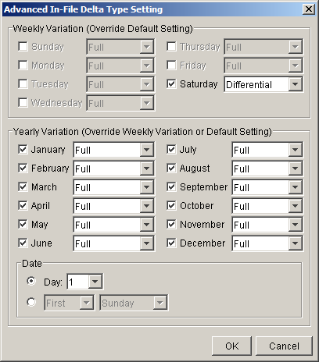
With this setting, all backup Jobs on Saturdays will be differential in-file delta backups, backups for the 1st day of each month will run a full backup. This ensures that all backup files will be backed up in full at a regular interval. One benefit of this is that restore time will run faster because of less delta merging. Another benefit is that the risk of a corrupted incremental delta file resulting in data loss is much lower because a full backup is always available periodically.

Backup/Restore Oracle 8i/9i/10g
This chapter will describe in details how OBM backup your Oracle 10g and how you can restore an Oracle 10g database using the backup files.

Requirements
- OBM must be installed onto the computer that can connect to your Oracle 10g server using TCP/IP protocol.
- Data from Oracle 10g database will be backed up to a temporary directory before they are sent to Offsite Backup Server. Please make sure you have sufficient space on your computer to store these data when you run the backup job.
- Database must be in archived log mode
To switch database to archived log mode, please do the following:
  - Set the parameters below in the PFILE to enable automatic archiving
LOG_ARCHIVE_DEST = [directory where archive redo logs will be stored]
LOG_ARCHIVE_FORMAT = 'log%t_%s_%r.arc'
LOG_ARCHIVE_START = TRUE
  - Set ORACLE_SID to your database’s System Identifier (SID)
export ORACLE_SID=GDB1 (assuming your database’s SID is GDB1)
  - Run SQL Plus and connect to database as SYSDBA
For Oracle 9i/10g
sqlplus "/ as sysdba"
For Oracle 8i
connect internal;
  - Shutdown database
shutdown immediate
  - Start and mount database
startup mount
  - Switch database to archived log mode
alter database archivelog;
  - Open database
alter database open;
Oracle 10g Example:
$ export ORACLE_SID=GDB1

$ sqlplus "/ as sysdba"

SQL*Plus: Release 10.2.0.1.0 - Production on Thu Nov 8 15:08:57 2007

Copyright (c) 1982, 2005, Oracle. All rights reserved.

Connected to:
Oracle Database 10g Enterprise Edition Release 10.2.0.1.0 - Production
With the Partitioning, OLAP and Data Mining options

SQL> shutdown immediate
Database closed.
Database dismounted.
ORACLE instance shut down.

SQL> startup mount
ORACLE instance started.

Total System Global Area 285212672 bytes
Fixed Size 1218992 bytes
Variable Size 96470608 bytes
Database Buffers 184549376 bytes
Redo Buffers 2973696 bytes
Database mounted.

SQL> alter database archivelog;

Database altered.

SQL> alter database open;

Database altered.

- JAVASYSPRIV role is granted to system account
You can grant this role to system account by executing:
  - Grant permission to system account
For Oracle 9i/10g
SQL> grant javasyspriv to system;
For Oracle 8i
SVRMGRL> connect internal
SVRMGRL> @?/javavm/install/initjvm.sql;
SVRMGRL> @?/rdbms/admin/catalog.sql;
SVRMGRL> @?/rdbms/admin/catproc.sql;
SVRMGRL> @?/javavm/install/initdbj.sql;
SQL> grant javasyspriv to system;
Oracle 9i/10g Example:
SQL> grant javasyspriv to system;

Grant succeeded.

Overview
OBM will backup your Oracle database by taking the following steps.
- Connect to the Oracle database using SQL*NET over TCP/IP
- Run all Pre-Commands of this backup set
- If the backup type to run is [Database Backup type],
  - all data files in each of the tablespace(s) selected are copied to the temporary directory specified by this backup set
  - if there are temporary files in the database, the script to re-create the temporary files are generated to a file located in the temporary directory specified by this backup set
  - all non-default initialization parameters will be spooled to an initializing file located in the temporary directory specified by this backup set
  - all control files will be copied to the temporary directory specified by this backup set
  - all archived log files will be copied to the temporary directory specified by this backup set
- If the backup type to run is [Archived Log Backup type],
  - all archived log files will be copied to the temporary directory specified by this backup set
- Run all Post-Commands of this backup set
- Upload all files copied to the temporary directory to the Offsite Backup Server
- Remove temporary files from the temporary directory if [Setting] -> [Temporary Directory for storing backup files] is enabled
Note:
If your Oracle database is running on Windows, please install OBM onto the company running the Oracle database if OBM is to backup this Oracle database. This would shorten the time required to backup the Oracle database.

How to backup an Oracle Database (Physical Backup)
Please follow the instructions below to backup your Oracle database to the Offsite Backup Server.
- Install OBM onto your computer
- Open OBM
Right click OBM icon available in the system tray and choose [Open]
- Create a backup set
  - From the Menu, Choose [Backup Set] -> [New] -> [Oracle Database Backup Set]
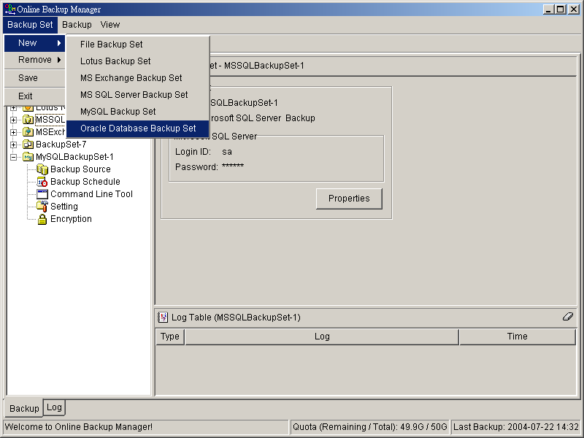
  - Enter a name for your backup set
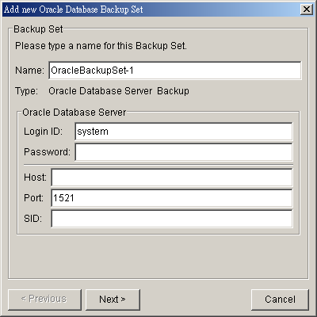
  - Enter the system password, the Oracle Database Server Host Name, TNS Port and SID
  - Select the tablespace(s) you want to backup
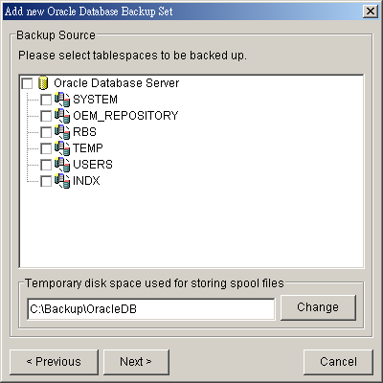
  - Enter a temporary location to store the database file(s) before they are sent to an Offsite Backup Server
  - Set the backup schedule for database backup and archived log backup
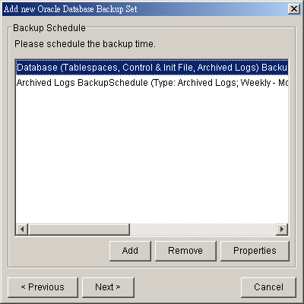
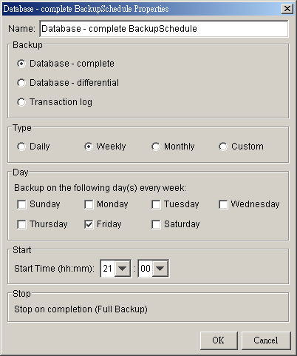
Note: You can have more than one schedule in a backup set, i.e. you can perform intra-day transaction log backup by adding more than one daily transaction log backup schedule to your backup set.
  - Set the encryption algorithm, encryption mode and encrypting key for this backup set
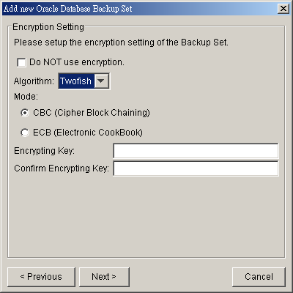
Hint: For maximum security, please select AES (Advanced Encryption Standard) Algorithm, CBC (Cipher Block Chaining) mode and use an encrypting key with more than 8 characters.
- Run Backup
  - Select the backup set you want to run on the left panel and press the [Start Backup] button (►)
  - Select the backup type (e.g. Database Backup, Archived Log Backup) you would like to perform
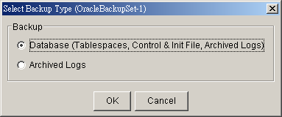
  - Select [Off-site Backup Server] to start backing up your files to an Offsite Backup Server.
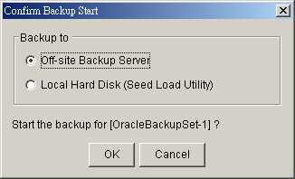
  - When the backup finished, you should see Backup Completed Successfully in the log table.
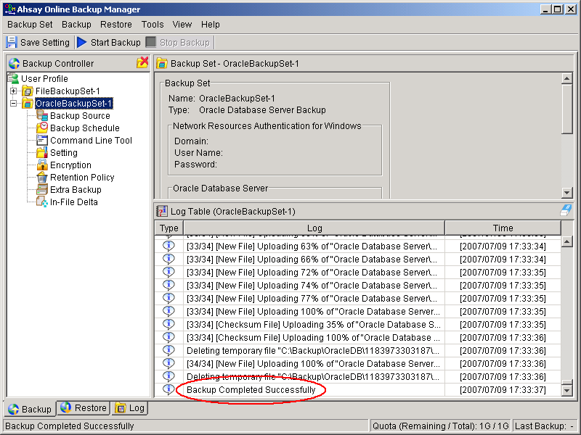

How to restore an Oracle Database
Please follow the instructions below to restore your Oracle 9i/10g databases from an Offsite Backup Server.
- Download the backup files from Offsite Backup Server
Please refer to the [Quick Start - Backup File] section for information on how to download backup files from Offsite Backup Server.
- For restore an existing database
Shutdown the database
To shutdown the database, please do the following:
  - Set ORACLE_SID to your database’s System Identifier (SID)
$ export ORACLE_SID=GDB1 (assuming your database’s SID is GDB1)
  - Run SQL Plus and connect to database as SYSDBA
$ sqlplus "/ as sysdba"
  - Shutdown database
SQL> shutdown immediate
Oracle 9i/10g Example:
$ export ORACLE_SID=GDB1

$ sqlplus "/ as sysdba"

SQL*Plus: Release 10.2.0.1.0 - Production on Thu Nov 8 17:04:57 2007

Copyright (c) 1982, 2005, Oracle. All rights reserved.

Connected to:
Oracle Database 10g Enterprise Edition Release 10.2.0.1.0 - Production
With the Partitioning, OLAP and Data Mining options

SQL> shutdown immediate
Database closed.
Database dismounted.
ORACLE instance shut down.

For recover a database that currently does not exist
Create a password file
$ orapwd file=$ORACLE_HOME/dbs/orapwGDB1 password=pwd123
(assuming your database’s SID is GDB1, and password is pwd123)
Oracle 9i/10g Example:
$ orapwd file=/oracle/OraHome1/dbs/orapwGDB1 password=pwd123

- Put all downloaded backup files in place
Control files, data files and archived logs are stored on Offsite Backup Server along with their full path information. You just need to put all these files back to their original locations when performing a database restore.
For example:
/obm_restore/Oracle Database Server/oracle/product/10.2.0/db_1/admin/GDB1/
/obm_restore/Oracle Database Server/oracle/product/10.2.0/db_1/dbs/initGDB1.ora
/obm_restore/Oracle Database Server/oracle/product/10.2.0/db_1/dbs/spfileGDB1.ora
/obm_restore/Oracle Database Server/oracle/product/10.2.0/db_1/flash_recovery_area/GDB1/
/obm_restore/Oracle Database Server/oracle/product/10.2.0/db_1/oradata/GDB1/
Move to
/oracle/product/10.2.0/db_1/admin/GDB1/
/oracle/product/10.2.0/db_1/dbs/initGDB1.ora
/oracle/product/10.2.0/db_1/dbs/spfileGDB1.ora
/oracle/product/10.2.0/db_1/flash_recovery_area/GDB1/
/oracle/product/10.2.0/db_1/oradata/GDB1/
- Rename database files (Only for restoring database to a new location)
Rename your database files by doing the following:
  - Modify the PFILE to update file path
Open the PFILE ($ORACLE_HOME/dbs/initGDB1.ora), change every file path to the new location, and then save it
For example:
background_dump_dest = /oracle/OraHome1/admin/GDB2/bdump
control_files = (/oracle/OraHome1/oradata/GDB2/control01.ctl,
/oracle/OraHome1/oradata/GDB2/control02.ctl,
/oracle/OraHome1/oradata/GDB2/control03.ctl)
core_dump_dest = /oracle/OraHome1/admin/GDB2/cdump
user_dump_dest = /oracle/OraHome1/admin/GDB2/udump
Change to
background_dump_dest = /new_db_location/OraHome1/admin/GDB2/bdump
control_files = (/new_db_location/OraHome1/oradata/GDB2/control01.ctl,
/new_db_location/OraHome1/oradata/GDB2/control02.ctl,
/new_db_location/OraHome1/oradata/GDB2/control03.ctl)
core_dump_dest = /new_db_location/OraHome1/admin/GDB2/cdump
user_dump_dest = /new_db_location/OraHome1/admin/GDB2/udump
  - You may need to quote the values of dispatchers as a single argument.
Add double quotation marks
dispatchers = "(PROTOCOL=TCP) (SERVICE=GDB1XDB)"
  - Delete the SPFILE
Delete the SPFILE ($ORACLE_HOME/dbs/spfileGDB1.ora)
  - Set ORACLE_SID to your database’s System Identifier (SID)
$ export ORACLE_SID=GDB1 (assuming your database’s SID is GDB1)
  - Run SQL Plus and connect to database as SYSDBA
$ sqlplus "/ as sysdba"
  - Start and mount database
SQL> startup mount
  - Create a backup of the control file to trace file
SQL> alter database backup controlfile to trace as '/New_DB_Location/control.trc' reuse; (assuming you create a trace file to /New_DB_Location/)
  - Rename each of data file, log file and tempfile
Open the trace file that just created, and then check for the filename of each datafile, log file and tempfile.
Please do the following to rename each of the files:
SQL> ALTER DATABASE RENAME FILE 'xxx' TO 'yyy';
where xxx is the old filename found in the trace file, and yyy is the new filename with updated path
For example:
SQL> ALTER DATABASE RENAME FILE '/oracle/product/10.2.0/db_1/oradata/GDB1/system01.dbf' TO '/new_db_location/oradata/GDB1/system01.dbf';
SQL> ALTER DATABASE RENAME FILE '/oracle/product/10.2.0/db_1/oradata/GDB1/undotbs01.dbf' TO '/new_db_location/oradata/GDB1/undotbs01.dbf';
SQL> ALTER DATABASE RENAME FILE '/oracle/product/10.2.0/db_1/oradata/GDB1/sysaux01.dbf' TO '/new_db_location/oradata/GDB1/sysaux01.dbf';
SQL> ALTER DATABASE RENAME FILE '/oracle/product/10.2.0/db_1/oradata/GDB1/users01.dbf' TO '/new_db_location/oradata/GDB1/users01.dbf';
SQL> ALTER DATABASE RENAME FILE '/oracle/product/10.2.0/db_1/oradata/GDB1/TS1' TO '/new_db_location/oradata/GDB1/TS1';
SQL> ALTER DATABASE RENAME FILE '/oracle/product/10.2.0/db_1/oradata/GDB1/redo01.log' TO '/new_db_location/oradata/GDB1/redo01.log';
SQL> ALTER DATABASE RENAME FILE '/oracle/product/10.2.0/db_1/oradata/GDB1/redo02.log' TO '/new_db_location/oradata/GDB1/redo02.log';
SQL> ALTER DATABASE RENAME FILE '/oracle/product/10.2.0/db_1/oradata/GDB1/redo03.log' TO '/new_db_location/oradata/GDB1/redo03.log';
SQL> ALTER DATABASE RENAME FILE '/oracle/product/10.2.0/db_1/oradata/GDB1/temp01.dbf' TO '/new_db_location/oradata/GDB1/temp01.dbf';
Oracle 9i/10g Example:
$ export ORACLE_SID=GDB1

$ sqlplus "/ as sysdba"

SQL*Plus: Release 10.2.0.1.0 - Production on Fri Nov 9 17:50:30 2007

Copyright (c) 1982, 2005, Oracle. All rights reserved.

Connected to an idle instance.

SQL> startup mount
ORACLE instance started.

Total System Global Area 285212672 bytes
Fixed Size 1218992 bytes
Variable Size 92276304 bytes
Database Buffers 188743680 bytes
Redo Buffers 2973696 bytes
Database mounted.
SQL> alter database backup controlfile to trace as '/new_db_location/control.trc' reuse;

Database altered.
SQL> ALTER DATABASE RENAME FILE '/oracle/product/10.2.0/db_1/oradata/GDB1/system01.dbf' TO '/new_db_location/oradata/GDB1/system01.dbf';

Database altered.

SQL> ALTER DATABASE RENAME FILE '/oracle/product/10.2.0/db_1/oradata/GDB1/undotbs01.dbf' TO '/new_db_location/oradata/GDB1/undotbs01.dbf';

Database altered.

SQL> ALTER DATABASE RENAME FILE '/oracle/product/10.2.0/db_1/oradata/GDB1/sysaux01.dbf' TO '/new_db_location/oradata/GDB1/sysaux01.dbf';

Database altered.

SQL> ALTER DATABASE RENAME FILE '/oracle/product/10.2.0/db_1/oradata/GDB1/users01.dbf' TO '/new_db_location/oradata/GDB1/users01.dbf';

Database altered.

SQL> ALTER DATABASE RENAME FILE '/oracle/product/10.2.0/db_1/oradata/GDB1/TS1' TO '/new_db_location/oradata/GDB1/TS1';

Database altered.

SQL> ALTER DATABASE RENAME FILE '/oracle/product/10.2.0/db_1/oradata/GDB1/redo01.log' TO '/new_db_location/oradata/GDB1/redo01.log';

Database altered.

SQL> ALTER DATABASE RENAME FILE '/oracle/product/10.2.0/db_1/oradata/GDB1/redo02.log' TO '/new_db_location/oradata/GDB1/redo02.log';

Database altered.

SQL> ALTER DATABASE RENAME FILE '/oracle/product/10.2.0/db_1/oradata/GDB1/redo03.log' TO '/new_db_location/oradata/GDB1/redo03.log';

Database altered.

SQL> ALTER DATABASE RENAME FILE '/oracle/product/10.2.0/db_1/oradata/GDB1/temp01.dbf' TO '/new_db_location/oradata/GDB1/temp01.dbf';

Database altered.

- Restore Database
Use Recovery Manager to restore your database by doing the following:
For Oracle 9i/10g
  - Set ORACLE_SID to your database’s System Identifier (SID)
$ export ORACLE_SID=GDB1 (assuming your database’s SID is GDB1)
  - Run Oracle Recovery Manager (rman) and connect to the target database
$ rman target /
  - Start and mount database
RMAN> startup mount
  - Reapply all transactions from the archived log files to the last sequence
RMAN> recover database until sequence=4 thread=1; (assuming the sequence number of your last archived redo log is 3)
Sequence number are named on the filename of archived redo log
e.g. /oracle/OraHome1/dbs/o1_mf_1_2_3m5h1svs_.arc
/oracle/OraHome1/dbs/o1_mf_1_3_3m5h1yby_.arc
in this case, the sequence number of archived redo log is 4.
  - Open database
RMAN> alter database open resetlogs;
Oracle 9i/10g Example:
$ export ORACLE_SID=GDB1

$ rman target /

Recovery Manager: Release 10.2.0.1.0 - Production on Thu Nov 8 17:46:27 2007

Copyright (c) 1982, 2005, Oracle. All rights reserved.

connected to target database (not started)

RMAN> startup mount

Oracle instance started
database mounted

Total System Global Area 285212672 bytes

Fixed Size 1218992 bytes
Variable Size 113247824 bytes
Database Buffers 167772160 bytes
Redo Buffers 2973696 bytes

RMAN> recover database until sequence=4 thread=1;

Starting recover at 08-NOV-07
Starting implicit crosscheck backup at 08-NOV-07
using target database control file instead of recovery catalog
allocated channel: ORA_DISK_1
channel ORA_DISK_1: sid=157 devtype=DISK
Finished implicit crosscheck backup at 08-NOV-07

Starting implicit crosscheck copy at 08-NOV-07
using channel ORA_DISK_1
Finished implicit crosscheck copy at 08-NOV-07

searching for all files in the recovery area
cataloging files...
cataloging done

List of Cataloged Files
=======================
File Name: /oracle/product/10.2.0/db_1/flash_recovery_area/GDB1/archivelog/2007_11_08/o1_mf_1_3_3m5h1yby_.arc

using channel ORA_DISK_1

starting media recovery

archive log thread 1 sequence 2 is already on disk as file /oracle/product/10.2.0/db_1/flash_recovery_area/GDB1/archivelog/2007_11_08/o1_mf_1_2_3m5h1svs_.arc
archive log thread 1 sequence 3 is already on disk as file /oracle/product/10.2.0/db_1/flash_recovery_area/GDB1/archivelog/2007_11_08/o1_mf_1_3_3m5h1yby_.arc
archive log filename=/oracle/product/10.2.0/db_1/flash_recovery_area/GDB1/archivelog/2007_11_08/o1_mf_1_2_3m5h1svs_.arc thread=1 sequence=2
archive log filename=/oracle/product/10.2.0/db_1/flash_recovery_area/GDB1/archivelog/2007_11_08/o1_mf_1_3_3m5h1yby_.arc thread=1 sequence=3
media recovery complete, elapsed time: 00:00:01
Finished recover at 08-NOV-07

RMAN> alter database open resetlogs;

database opened

For Oracle 8i
  - Set ORACLE_SID to your database’s System Identifier (SID)
$ export ORACLE_SID=GDB1 (assuming your database’s SID is GDB1)
  - Run Oracle Server Manager (svrmgrl)
$ svrmgrl
  - Connect to the target database
SVRMGRL> connect internal
  - Start and mount database
SVRMGRL> start mount;
  - Reapply all transactions from the archived log files
RMAN> recover database using backup controlfile
  - Open database
RMAN> ALTER DATABASE OPEN RESETLOGS;
Oracle 8i Example:
$ svrmgrl

SVRMGRL> connect internal

SVRMGR> startup mount;
ORACLE instance started.
Total System Global Area 95874448 bytes
Fixed Size 64912 bytes
Variable Size 52744192 bytes
Database Buffers 40960000 bytes
Redo Buffers 2105344 bytes
Database mounted.
SVRMGRL> recover database using backup controlfile
ORA-00279: change 419671 generated at 06/14/03 02:51:49 needed for thread 1
ORA-00289: suggestion : /data/ora815/vin/archive/ARCH0000000225.LOG
ORA-00280: change 419671 for thread 1 is in sequence #225
ORA-00278: log file '/data/ora815/vin/archive/ARCH0000000224.LOG' no longer needed for this recovery
Specify log: {<RET>=suggested | filename | AUTO | CANCEL}

AUTO
Log applied.
. . . . . . . . . . .
ORA-00279: change 547222 generated at 06/18/03 19:58:26 needed for thread 1
ORA-00289: suggestion : /data/ora815/vin/archive/ARCH0000000384.LOG
ORA-00280: change 547222 for thread 1 is in sequence #384
ORA-00278: log file '/data/ora815/vin/archive/ARCH0000000383.LOG' no longer needed for this recovery
ORA-00308: cannot open archived log '/data/ora815/vin/archive/ARCH0000000384.LOG'
ORA-27037: unable to obtain file status
Linux Error: 2: No such file or directory
Additional information: 3

SVRMGR> recover database using backup controlfile until cancel
ORA-00279: change 547222 generated at 06/18/03 19:58:26 needed for thread 1
ORA-00289: suggestion : /data/ora815/vin/archive/ARCH0000000384.LOG
ORA-00280: change 547222 for thread 1 is in sequence #384
Specify log: {<RET>=suggested | filename | AUTO | CANCEL}

CANCEL
Media recovery cancelled.
SVRMGR> alter database open resetlogs;
Statement processed.

- (Optional) Create Net Service Name and Database Service Listener
To create Net Service Name
Start Net Manager by running the command netmgr
$ netmgr
→ expand [Oracle Net Configuration]
→ expand [Local]
→ select [Service Naming]
→ click “+” icon on the toolbar
→ Net Service Name Wizard will be launched to guide you through creating a net service name
→ click [File] on the menu bar
→ [Save Network Configuration] on the menu bar
To create Database Service Listener
Start Net Manager by running the command netmgr
$ netmgr
→ expand [Oracle Net Configuration]
→ expand [Local]
→ expand [Listeners]
→ select [LISTENER]
→ select [Database Services] from combo box
→ click [Add Database]
→ input Global Database Name and SID
→ click [File] on the menu bar
→ [Save Network Configuration] on the menu bar

How to restore a single tablespace
Restoring a tablespace required a backup of datafiles consistent with the existing archived logs and control files, as redo will be applied during the restore operation.
Please follow the instructions below to restore a tablespace from an Offsite Backup Server.
- Download the backup files from the Offsite Backup Server
Please refer to the [Quick Start - Backup File] section for information on how to download backup files from Offsite Backup Server.
- Set ORACLE_SID to your database’s System Identifier (SID)
$ export ORACLE_SID=GDB1 (assuming your database’s SID is GDB1)
- Run SQL Plus and connect to database as SYSDBA
$ sqlplus “/ as sysdba”
- Shutdown database
SQL> shutdown immediate
- Put the downloaded tablespace datafiles in place
Datafile names and paths can be found by using the REPORT SCHEMA command.
  - Set ORACLE_SID to your database’s System Identifier (SID)
$ export ORACLE_SID=GDB1 (assuming your database’s SID is GDB1)
  - Run Oracle Recovery Manager (rman) and connect to the target database
$ rman target /
  - Start and mount database
RMAN> startup mount
  - List the names of all datafiles and tablespaces
RMAN> report schema;
For example:
Report of database schema
File K-bytes Tablespace RB segs Datafile Name
---- ---------- ----------- ------- -------------------
1 419840 SYSTEM *** /oracle/OraHome1/oradata/GDB1/system01.dbf
2 204800 UNDOTBS1 *** /oracle/OraHome1/oradata/GDB1/undotbs01.dbf
3 20480 CWMLITE *** /oracle/OraHome1/oradata/GDB1/cwmlite01.dbf
4 20480 DRSYS *** /oracle/OraHome1/oradata/GDB1/drsys01.dbf
5 141440 EXAMPLE *** /oracle/OraHome1/oradata/GDB1/example01.dbf
6 25600 INDX *** /oracle/OraHome1/oradata/GDB1/indx01.dbf
7 20480 ODM *** /oracle/OraHome1/oradata/GDB1/odm01.dbf
8 10240 TOOLS *** /oracle/OraHome1/oradata/GDB1/tools01.dbf
9 25600 USERS *** /oracle/OraHome1/oradata/GDB1/users01.dbf
10 39040 XDB *** /oracle/OraHome1/oradata/GDB1/xdb01.dbf
11 0 TS1 *** /oracle/OraHome1/oradata/GDB1/TS1_datafile1.dbf
12 0 TS1 *** /oracle/OraHome1/oradata/GDB1/TS1_datafile2.dbf
13 0 TS1 *** /oracle/OraHome1/oradata/GDB1/TS1_datafile3.dbf
  - Put all the downloaded backup of datafile/s that constitute the tablespace to the listed location
For example:
/obm_restore/Oracle Database Server/oracle/OraHome1/oradata/GDB1/TS1_datafile1.dbf
/obm_restore/Oracle Database Server/oracle/OraHome1/oradata/GDB1/TS1_datafile2.dbf
/obm_restore/Oracle Database Server/oracle/OraHome1/oradata/GDB1/TS1_datafile3.dbf
Move to
/oracle/OraHome1/oradata/GDB1/TS1_datafile1.dbf
/oracle/OraHome1/oradata/GDB1/TS1_datafile2.dbf
/oracle/OraHome1/oradata/GDB1/TS1_datafile3.dbf
- Restore tablespace
RMAN> recover tablespace TS1; (assuming your tablespace is TS1)
If your datafiles consistent with the database, you should see:
Oracle 9i/10g Example:
RMAN> recover tablespace TS1;
Starting recover at 19-JUL-07
allocated channel: ORA_DISK_1
channel ORA_DISK_1: sid=156 devtype=DISK

starting media recovery

archive log thread 1 sequence 1 is already on disk as file D:\ORACLE\PRODUCT\10.
2.0\FLASH_RECOVERY_AREA\GDB1\ARCHIVELOG\2007_07_19\O1_MF_1_1_39Y98F0H_.ARC
archive log thread 1 sequence 2 is already on disk as file D:\ORACLE\PRODUCT\10.
2.0\FLASH_RECOVERY_AREA\GDB1\ARCHIVELOG\2007_07_19\O1_MF_1_2_39Y98JSD_.ARC
archive log thread 1 sequence 3 is already on disk as file D:\ORACLE\PRODUCT\10.
2.0\FLASH_RECOVERY_AREA\GDB1\ARCHIVELOG\2007_07_19\O1_MF_1_3_39Y9SW4D_.ARC
archive log filename=D:\ORACLE\PRODUCT\10.2.0\FLASH_RECOVERY_AREA\GDB1\ARCHIVELO
G\2007_07_19\O1_MF_1_1_39Y98F0H_.ARC thread=1 sequence=1
media recovery complete, elapsed time: 00:00:01
Finished recover at 19-JUL-07

If your datafiles does not consistent with the database, you should see:
Oracle 9i/10g Example:
RMAN> recover tablespace TS1;
Starting recover at 19-JUL-07
allocated channel: ORA_DISK_1
channel ORA_DISK_1: sid=156 devtype=DISK
RMAN-00571: ===========================================================
RMAN-00569: =============== ERROR MESSAGE STACK FOLLOWS ===============
RMAN-00571: ===========================================================
RMAN-03002: failure of recover command at 07/20/2007 12:24:49
RMAN-06163: some datafiles cannot be recovered, aborting the RECOVER command
RMAN-06166: datafile 7 cannot be recovered
RMAN-06166: datafile 6 cannot be recovered
RMAN-06166: datafile 5 cannot be recovered

In this case, you need to find the consistent datafiles in order to restore the tablespace.
If there are archive log missing, you should see:
Oracle 9i/10g Example:
RMAN> recover tablespace TS1;
Starting recover at 20-JUL-07
using channel ORA_DISK_1

starting media recovery

archive log thread 1 sequence 12 is already on disk as file D:\ORACLE\PRODUCT\10
.2.0\FLASH_RECOVERY_AREA\GDB1\ARCHIVELOG\2007_07_18\O1_MF_1_12_39VF4JNJ_.ARC
RMAN-00571: ===========================================================
RMAN-00569: =============== ERROR MESSAGE STACK FOLLOWS ===============
RMAN-00571: ===========================================================
RMAN-03002: failure of recover command at 07/20/2007 12:28:52
RMAN-06053: unable to perform media recovery because of missing log
RMAN-06025: no backup of log thread 1 seq 13 lowscn 660617 found to restore

In this case, you need to find the missing archive log files in order to restore the tablespace.
- Open database
RMAN> alter database open;
Oracle 9i/10g Example:
$ export ORACLE_SID=GDB1
$ rman target /
Recovery Manager: Release 9.2.0.1.0 - Production

Copyright (c) 1995, 2002, Oracle Corporation. All rights reserved.

connected to target database (not started)
RMAN> startup mount
Oracle instance started
database mounted

Total System Global Area 235999352 bytes

Fixed Size 450680 bytes
Variable Size 201326592 bytes
Database Buffers 33554432 bytes
Redo Buffers 667648 bytes
RMAN> report schema;
using target database control file instead of recovery catalog
Report of database schema

using target database controlfile instead of recovery catalog
Report of database schema
File K-bytes Tablespace RB segs Datafile Name
---- ---------- ------------------- ------- -------------------
1 419840 SYSTEM *** /oracle/OraHome1/oradata/GDB1/system01.dbf
2 204800 UNDOTBS1 *** /oracle/OraHome1/oradata/GDB1/undotbs01.dbf
3 20480 CWMLITE *** /oracle/OraHome1/oradata/GDB1/cwmlite01.dbf
4 20480 DRSYS *** /oracle/OraHome1/oradata/GDB1/drsys01.dbf
5 141440 EXAMPLE *** /oracle/OraHome1/oradata/GDB1/example01.dbf
6 25600 INDX *** /oracle/OraHome1/oradata/GDB1/indx01.dbf
7 20480 ODM *** /oracle/OraHome1/oradata/GDB1/odm01.dbf
8 10240 TOOLS *** /oracle/OraHome1/oradata/GDB1/tools01.dbf
9 25600 USERS *** /oracle/OraHome1/oradata/GDB1/users01.dbf
10 39040 XDB *** /oracle/OraHome1/oradata/GDB1/xdb01.dbf
11 0 TS1 *** /oracle/OraHome1/oradata/GDB1/TS1_datafile1.dbf
12 0 TS1 *** /oracle/OraHome1/oradata/GDB1/TS1_datafile2.dbf
13 0 TS1 *** /oracle/OraHome1/oradata/GDB1/TS1_datafile3.dbf

List of Temporary Files
=======================
File Size(MB) Tablespace Maxsize(MB) Tempfile Name
---- -------- -------------------- ----------- --------------------
1 20 TEMP 32767 D:\ORACLE\PRODUCT\10.2.0\ORADATA\
GDB1\TEMP01.DBF

RMAN> recover tablespace TS1;
Starting recover at 30-AUG-07
allocated channel: ORA_DISK_1
channel ORA_DISK_1: sid=11 devtype=DISK

starting media recovery
media recovery complete

Finished recover at 30-AUG-07

RMAN> alter database open;
database opened

Export and Import a Database (Logical Backup)
While physical backup of database files permit the full reconstruction of database, logical backup is a useful supplement to physical backup for some purposes. For instance, logical backup using the export and import utilities are the only method that Oracle supports for moving an existing database from one platform to another.
Please follow the instructions below to backup a database:
- Export the full database to a dump file
$ exp system/pwd123 FULL=y FILE='/oracle/data.dmp' LOG='/oracle/export.log'
(assuming your system password is pwd123, the name of dump file is /oracle/data.dmp and the name of log file is /oracle/export.log)
Oracle 9i/10g Example:
$ exp system/pwd123 FULL=y FILE='/oracle/data.dmp' LOG='/oracle/export.log'
Connected to: Oracle Database 10g Enterprise Edition Release 10.2.0.1.0 - Production
With the Partitioning, OLAP and Data Mining options
Export done in WE8MSWIN1252 character set and AL16UTF16 NCHAR character set

About to export the entire database ...
. exporting tablespace definitions
. exporting profiles
. exporting user definitions
. exporting roles
. exporting resource costs
///////////////////////
// ... exporting ... //
///////////////////////
. exporting dimensions
. exporting post-schema procedural objects and actions
. exporting user history table
. exporting default and system auditing options
. exporting statistics
Export terminated successfully without warnings.

- Backup the exported dump file to the Offsite Backup Server
Please refer to the [Section 6.2 Backup files directly to the backup server] for information on how to upload backup files to Offsite Backup Server.
Please follow the instructions below to restore a database:
- Download the backup files from the Offsite Backup Server
Please refer to the [Section 7.1 Restore backup files directly from backup server] for information on how to download backup files from Offsite Backup Server.
- Import the full database from the downloaded backup of dump file
$ imp system/pwd123 FULL=y FILE='/oracle/data.dmp' LOG='/oracle/import.log'
(assuming your system password is pwd123, the name of dump file is /oracle/data.dmp and the name of log file is /oracle/import.log)
Oracle 9i/10g Example:
$ imp system/pwd123 FULL=y FILE='/oracle/data.dmp' LOG='/oracle/import.log'
Connected to: Oracle Database 10g Enterprise Edition Release 10.2.0.1.0 - Production
With the Partitioning, OLAP and Data Mining options

Export file created by EXPORT:V10.02.01 via conventional path
import done in WE8MSWIN1252 character set and AL16UTF16 NCHAR character set
. importing SYSTEM's objects into SYSTEM
. importing OLAPSYS's objects into OLAPSYS
. importing SYSMAN's objects into SYSMAN
. importing SYSTEM's objects into SYSTEM
. importing OLAPSYS's objects into OLAPSYS

///////////////////////
// ... importing ... //
///////////////////////
. importing OLAPSYS's objects into OLAPSYS
. importing SYSTEM's objects into SYSTEM
. importing OLAPSYS's objects into OLAPSYS
. importing SYSMAN's objects into SYSMAN
. importing SCOTT's objects into SCOTT
Import terminated successfully without warnings.

Backup/Restore Microsoft SQL Server 7.0 / 2000
This chapter will describe in details how to use OBM to backup your Microsoft SQL Server 7.0 / 2000 server and how you can restore your Microsoft SQL Server 7.0 / 2000 server from the backup files.

Requirements
- OBM must be installed onto the computer running Microsoft SQL Server.
- Data from Microsoft SQL Server will be backed up to a temporary directory before they are sent to Offsite Backup Server. Please make sure you have sufficient space on your computer to store these data when you run the backup job.

Overview
OBM will backup your Microsoft SQL Server database(s) by taking the following steps:
- Before running any backup activities, OBM will run all Pre-Commands of the backup set.
- For each database that is to be backed up, OBM will issue a database / transaction log backup command to Microsoft SQL Server to backup each database to a Microsoft SQL Server database backup file (*.bak file) and save it in the temporary directory you specified.
- After all *.bak files have been spooled to the temporary directories, OBM will run all Post-Commands of the backup set.
- Upload all files copied to the temporary directory to the Offsite Backup Server.
- Remove temporary files from the temporary directory if [Setting] -> [Temporary Directory for storing backup files] is enabled

How to backup Microsoft SQL Server database(s)
Please follow the instructions below to backup your Microsoft SQL Server databases using OBM.
- Open OBM
Right click OBM icon available in the system tray and choose [Open]
- Create a backup set
  - From the Menu, Choose [Backup Set] -> [New] -> [MS SQL Server Backup Set]
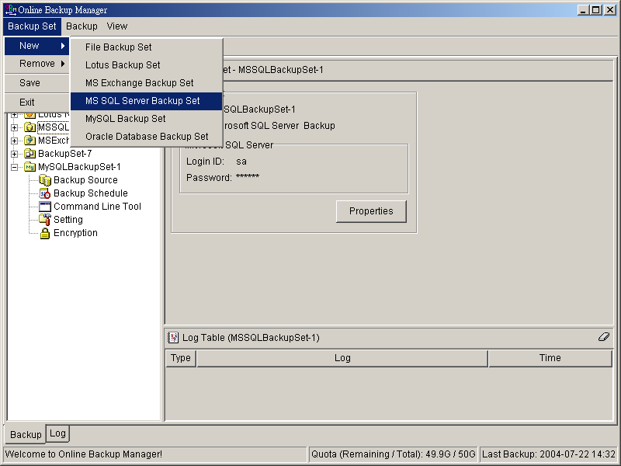
  - Enter a name for your backup set
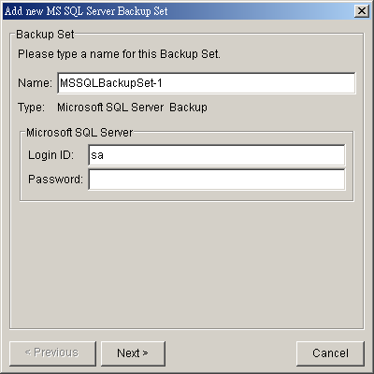
  - Enter the Microsoft SQL Server administrator username and password
  - Select the database(s) you want to backup
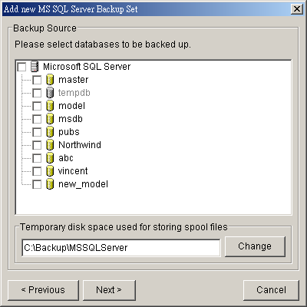
  - Enter a temporary location to store the backup files before they are sent to an Offsite Backup Server
  - Set the backup schedule for full database backup and transaction log backup
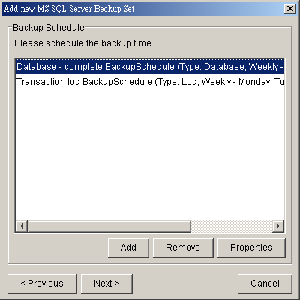
(Note: You can have more than one schedule in a backup set, i.e. you can perform intra-day transaction log backup by adding more than one daily transaction log backup schedule to your backup set)
  - Set the encryption algorithm, encryption mode and encrypting key for this backup set
(Hint: For maximum security, please select AES (Advanced Encryption Standard) Algorithm, CBC (Cipher Block Chaining) mode and use an encrypting key with more than 8 characters.)
- Run Backup
  - Select the backup set you want to run on the left panel and press the [Start Backup] button (►)
  - Select the backup type (e.g. Complete, Differential, Transaction Log) you would like to perform
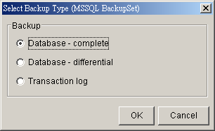
  - Select [Off-site Backup Server] to start backing up your files to an Offsite Backup Server.
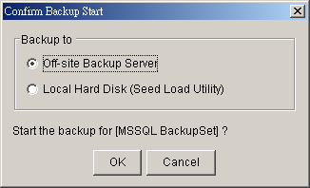

How to restore Microsoft SQL Server database(s)
Please follow the instructions below to restore your Microsoft SQL Server databases from an Offsite Backup Server.
- Download the backup files (.bak) from the Offsite Backup Server
Please refer to the [Quick Start - Backup File] section for information on how to download backup files from Offsite Backup Server.
- Open Microsoft SQL Enterprise Manager
You can open Microsoft SQL Enterprise Manager from [Start Menu] -> [Program] -> [Microsoft SQL Server] -> [Enterprise Manager]
- (Optional) Restore “master” database
You need to restore “master” database if you:
  - are rebuilding all your databases from scratch
  - have changing any server-wide or database configuration options
  - have added logins or other login security-related operations.
  - have created or removed logical backup devices.
  - have configured the server for distributed queries and remote procedure calls, such as adding linked servers or remote logins.

You do not need to restore your master database if you just want to restore a user database. For more information on Microsoft SQL Server “master” database, please visit http://www.microsoft.com/sql/.

To restore “master” database, please do the following:
  - Start Microsoft SQL Server in “Single User Mode”
- Right click your Microsoft SQL Server and select [Properties]
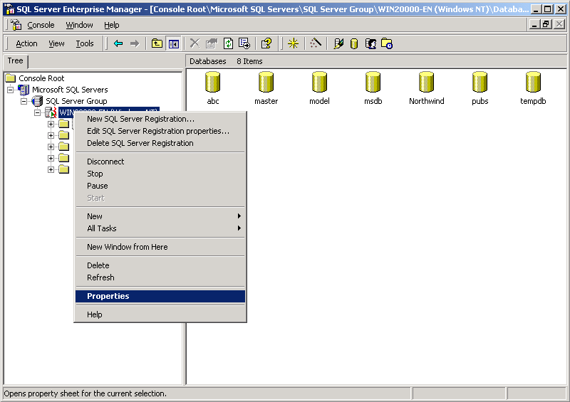
- Press the [Startup Parameters] button
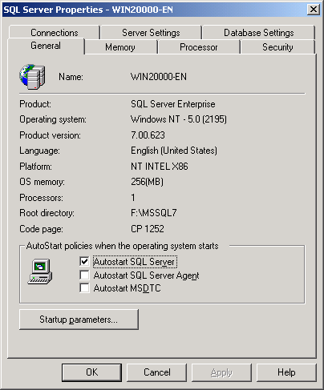
- Add a “-m” parameter to the [Startup Parameters]
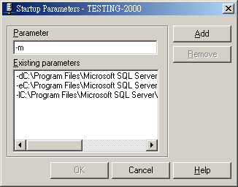
- Restart Microsoft SQL Server
From [Enterprise Manager], right click your Microsoft SQL Server and select [Stop] and then [Start].
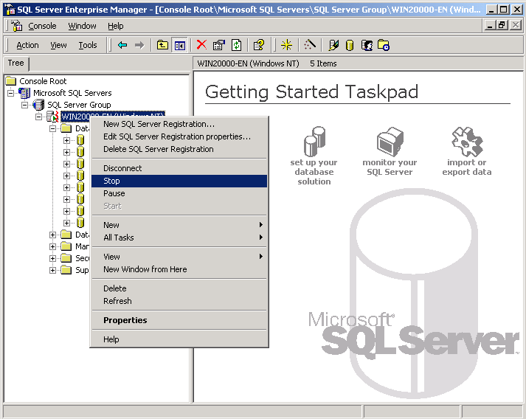
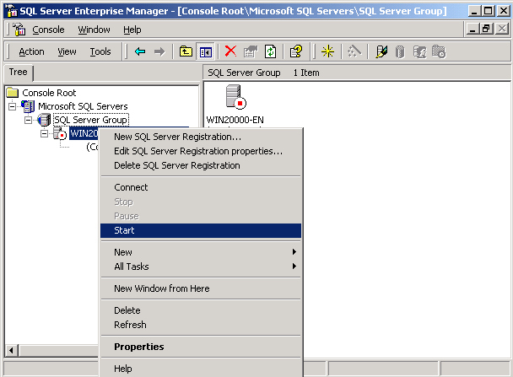
  - Restore “master” database
- From [Enterprise Manager] -> [Tools] -> [Restore Database]
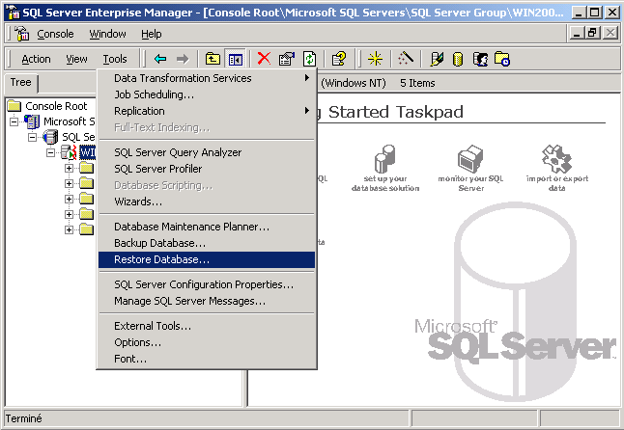
- Select [master] in the [Restore as database] drop down list
- Select the [From device] radio button.
- Press the [Select Devices] button.
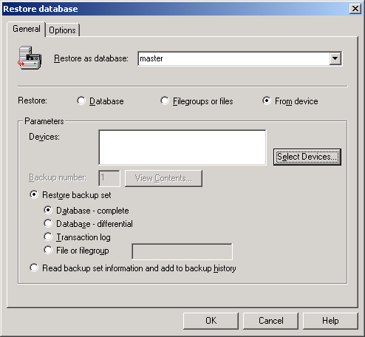
- From the [Choose Restore Devices], press the [Add] button.
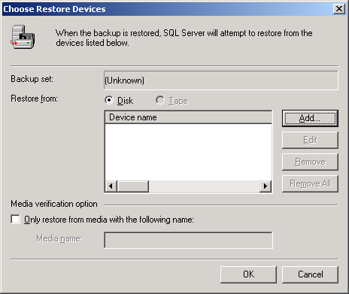
- From the [Choose Restore Destination] panel, press the […] button to choose your master backup (*.bak) from your backup files
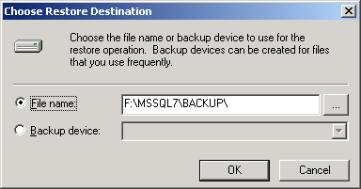
- Press the [OK] button, to start restoring the “master” database.
  - Restart Microsoft SQL Server in “Normal Mode”
- Remove “-m” parameter from the [Startup Parameters] as in previous step
- Restart your Microsoft SQL Server as in previous step
- (Optional) Restore “model”, “msdb” and “distribution” database
You need to restore “model” database if you have changed the database template of your SQL Server.
You need to restore “msdb” database if you have changed the scheduling information or you want to restore the backup and restore history of your databases.
You need to restore “distribution” database if you are running the replication components of SQL Server.
You do not need to restore these databases if you just want to restore a user database. For more information on Microsoft SQL Server “model”, “msdb” and “distribution” database, please visit http://www.microsoft.com/sql/.
You need to restore each of these databases one by one. To restore any of these databases, please do the following:
  - From [Enterprise Manager] -> [Tools] -> [Restore Database]
  - Select the database to be restored in the [Restore as database] drop down list
  - Select the [From device] radio button.
  - Press the [Select Devices] button
  - Press the […] button to choose your backup files (*.bak) for the database to be restored
  - Press the [OK] button
- Restore user database(s)
For each of the database you would like to restore,
  - From [Enterprise Manager] -> [Tools] -> [Restore Database]
  - Select the database to be restored in the [Restore as database] drop down list
  - Select the [Database] radio button.
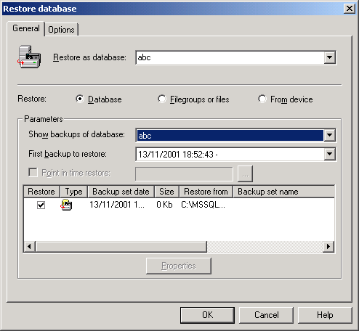
  - From the [Show backups of database] drop down list, select the database to be restored
  - From the [First backup to restore] drop down list, select the snapshot of the database you would like to restore to.
You can restore your database to the snapshot of your database at any point of the time between the time you did your full backup and the time you did your last subsequent backup.
  - Change the [Restore From] entry
If you backup files (*.bak) are not in the default directory, you need to update the full path to your backup files by pressing the [Properties] button.
  - Press the [OK] button
- All database(s) restored successfully

Backup/Restore Lotus Domino / Notes
This chapter will describe in details how to use OBM to backup your Lotus Domino server / Notes client 5 / 6 / 6.5 and how you can restore your Lotus Domino server / Notes client 5 / 6 / 6.5 from the backup files.

Requirements
- OBM must be installed onto the computer running Lotus Domino server / Notes client.
- Data from Lotus Domino server / Notes client will be backed up to a temporary directory before they are sent to Offsite Backup Server. Please make sure you have sufficient disk space on your computer to store these data when you run the backup job.
- Lotus Domino server must runs with archive transaction logging enabled
To set up transaction logging in archive style, please do the following:
  - Ensure that all databases to be logged reside in the Domino data directory, either at the root or in subdirectories.
  - From the Domino Administrator, click the Configuration tab.
  - In the "Use Directory on" field, choose the server's Domino Directory.
  - Click Server Configuration, and then click Current Server Document.
  - Click the Transactional Logging tab.
  - Complete these fields, and then save the document.
Field | Enter
Transactional Logging | Choose Enabled. The default is Disabled.
Log path | Path name location of the transaction log.  The default path name is \LOGDIR in the Domino data directory, although it is strongly recommended to store the log on a separate, mirrored device, such as a RAID (Redundant Array of Independent Disks) level 0 or 1 device with a dedicated controller.  The separate device should have at least 1GB of disk space for the transaction log. If you are using the device solely for storing the transaction log, set the "Use all available space on log device" field to Yes.
Logging style | Choose Archive. The default is Circular.
Maximum log space | The maximum size, in MB, for the transaction log.  Default is 192MB. Maximum is 4096MB (4GB).  Domino formats at least 3 and up to 64 log files, depending on the maximum log space you allocate.
Use all available space on log device | Choose one:  - Yes to use all available space on the device for the transaction log. This is recommended if you use a separate device dedicated to storing the log. If you choose Yes, you don’t need to enter a value in the "Maximum log space" field.  - No to use the default or specified value in the "Maximum log space" field.
Automatic fixup of corrupt databases | Choose one:  - Enabled (default). If a database is corrupt and Domino cannot use the transaction log to recover it, Domino runs the Fixup task, assigns a new DBIID, and notifies the administrator that a new database backup is required.  - Disabled. Domino does not run the Fixup task automatically and notifies the administrator to run the Fixup task with the -J parameter on corrupt logged databases.
Runtime / Restart performance | This field controls how often Domino records a recovery checkpoint in the transaction log, which affects server performance.  To record a recovery checkpoint, Domino evaluates each active logged database to determine how many transactions would be necessary to recover each database after a system failure. When Domino completes this evaluation, it:  - Creates a recovery checkpoint record in the transaction log, listing each open database and the starting point transaction needed for recovery  - Forces database changes to be saved to disk if they have not been saved already  Choose one:  - Standard (default and recommended). Checkpoints occur regularly.  - Favor runtime. Domino records fewer checkpoints, which requires fewer system resources and improves server run time performance.  - Favor restart recovery time. Domino records more checkpoints, which improves restart recovery time because fewer transactions are required for recovery.
Notes:
You can only run transaction log backup if you have transaction logging enabled and you are using archive mode. This command does not apply if you have transaction logging enabled not in archive mode or if transaction logging is not enabled at all. If you try to issue it, you will receive an error message.

Overview
OBM will backup your Lotus Domino server / Notes client by taking the following steps:
- Run all Pre-Commands of this backup set
- If the backup type to run is [Database Backup type],
  - all file(s) / database(s) selected are copied to the temporary directory specified by this backup set
  - the notes.ini file, if selected, will be copied to the temporary directory
  - only filled log extents will be copied to the temporary directory, and the Domino server is notified of their availability for reuse (for Domino server only)
- (for Domino server only) If the backup type to run is [Transaction Log Backup type],
  - only filled log extents will be copied to the temporary directory, and the Domino server is notified of their availability for reuse
- Run all Post-Commands of this backup set
- Upload all files copied to the temporary directory to the Offsite Backup Server
- Remove temporary files from the temporary directory if [Setting] -> [Temporary Directory for storing backup files] is enabled

How to backup Lotus Domino / Notes database(s) / file(s) on Windows
Please follow the instructions below to backup your Lotus Domino server / Notes client databases / files using OBM.
- Open OBM
Right click OBM icon available in the system tray and choose [Open]
- Create a backup set
  - From the Menu, Choose [Backup Set] -> [New] -> [Lotus Backup Set]
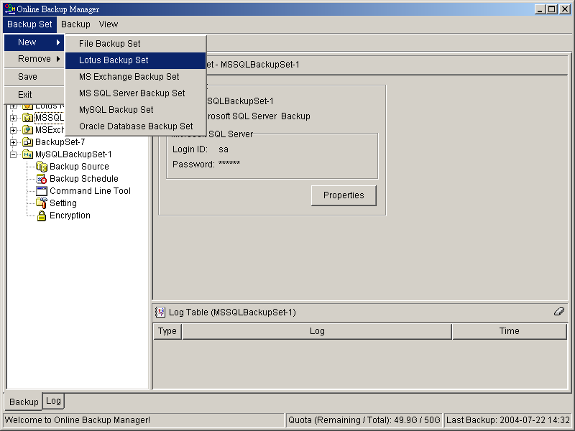
  - Enter a name for your backup set
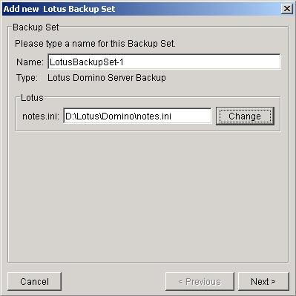
  - Select the Backup Set Type (Lotus Domino Server Backup / Lotus Notes Client Backup)
  - Select the database(s) / file(s) you want to backup
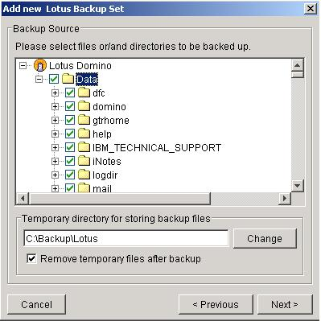
  - Enter a temporary location to store the backup files before they are sent to an Offsite Backup Server
  - Set the backup schedule for Database Backup
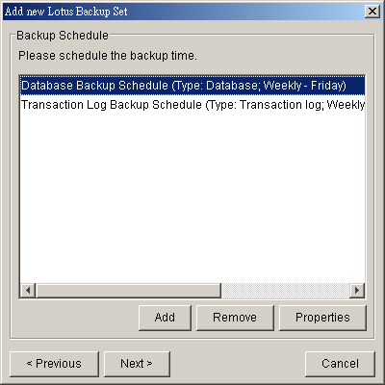
  - Set the backup schedule for Transaction Log Backup (for Domino server only)
(Note: You can have more than one schedule in a backup set, i.e. you can perform intra-day transaction log backup by adding more than one daily transaction log backup schedule to your backup set)
  - Set the encryption algorithm, encryption mode and encrypting key for this backup set
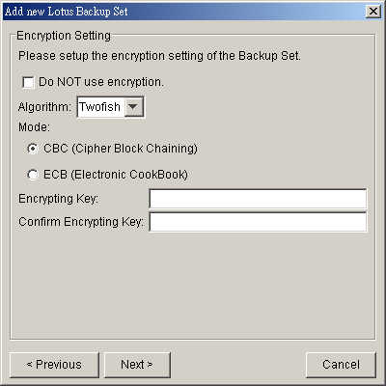
(Hint: For maximum security, please select AES (Advanced Encryption Standard) Algorithm, CBC (Cipher Block Chaining) mode and use an encrypting key with more than 8 characters.)
- Run Backup
  - Select the backup set you want to run on the left panel and press the [Start Backup] button (►)
  - Select the backup type (e.g. Database, Transaction Log) you would like to perform (for Domino server only)
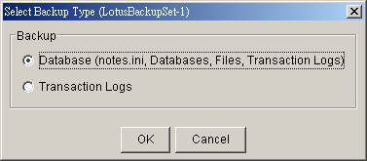
  - Select [Off-site Backup Server] to start backing up your files to an Offsite Backup Server.
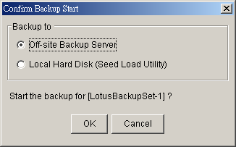

How to restore Lotus Domino / Notes database(s) / file(s) on Windows
Please follow the instructions below to restore Lotus Domino server / Notes client database(s) / file(s) from an Offsite Backup Server.
- Install Lotus Domino server / Notes client back to its original folder (if required)
- Install OBM
Please refer to the [Installation] section for information on how to install OBM onto your computer.
- Shutdown Lotus Domino Server
- If you want to perform a full domino restore (restore all databases and files):
  - Download the backup files to be restored from the Offsite Backup Server and save them back to its original location. It includes notes.ini, all backup files from the lotus domino data directory and all archived transaction logs
  - Modify the “DominoRecover.bat” located under the bin directory of the OBM installation to reflect your setup. You need to specify the lotus executable directory.
For example change the PROGRAM_DIR to:
PROGRAM_DIR=C:\Lotus\Domino
  - Run “DominoRecover.bat” and press ‘Y’ to continue.
For example: C:\program files\obm\bin\DominoRecover.bat
This will run media recovery for all databases (*.nsf and mail.box) found under the Lotus data directory (e.g. C:\Lotus\Domino\Data). You should see something similar to the screen below.
Media Recovery Example:
C:\program files\obm\bin>DominoRecover.bat
Media Recovery Utility for Lotus Domino 5.0 or above

Please make sure that you have done the following:
1. Reinstall Lotus Domino on this computer in the same directory
2. Restore Notes.ini to the Lotus Domino installation directory
(e.g. C:\Lotus\Domino)
3. Restore Domino Data directory back to the directory defined
in Notes.ini (e.g. C:\Lotus\Domino\Data)
4. Restore all archived transaction logs to the directory defined
in Notes.ini (e.g. C:\Lotus\Domino\Data\logdir)

Continue ? (Y) or (N) y
Running media recovery ...
Please wait, creating new transaction logs in directory: C:\logdir\
02/12/2003 14:39:19 Recovery Manager: Restart Recovery complete. (0/0
databases needed full/partial recovery)
Media Recovery Replay (122 MB): 10% 20% 30% 40% 50% 60% 70% 80% 90% 100%
02/12/2003 14:39:22 Recovery Manager: Media Recovery complete for
C:\Lotus\Domino\Data\admin4.nsf, last update applied .

Backup file C:\Lotus\Domino\Data\admin4.nsf recovered.

…………

Media Recovery Replay (122 MB): 10% 20% 30% 40% 50% 60% 70% 80% 90% 100%
02/12/2003 14:40:57 Recovery Manager: Media Recovery complete for
C:\Lotus\Domino\Data\statrep.nsf, last update applied .

Backup file C:\Lotus\Domino\Data\statrep.nsf recovered.

C:\program files\obm\bin>

  - All content of all database(s) are now rolled forward to the last committed transaction found in the last archived transaction log.
  - Restart Lotus Domino server

- If you just want to restore a single database:
  - Download the database file to be restored from the Offsite Backup Server and save them back to its original location.
  - (optional) If you need to perform media recovery on this database, please download all archived transaction logs and save them back to its original location
  - Modify the “DominoRecover.bat” located under the bin directory of the OBM installation to reflect your setup.
For example we will recover the “admin4.nsf” and have restored the file to C:\restore\notesdata, change the tags to:
PROGRAM_DIR=C:\Lotus\Domino
INPUTFILE=C:\restore\notesdata\admin4.nsf
RESTOREDB=C:\Lotus\Domino\Data\admin4.nsf
RECDATE=18/01/2007
RECTIME=00:02
  - Run “DominoRecover.bat”.
You should see something similar to the screen below.
Media Recovery Example:
C:\program files\obm>DominoRecover.bat
Media Recovery Utility for Lotus Domino 5.0 or above

Running media recovery ...
Restart Analysis (0 MB): 100%
18/01/2007 14:42:15 Recovery Manager: Restart Recovery complete. (0/0
databases needed full/partial recovery)
Media Recovery Replay (122 MB): 10% 20% 30% 40% 50% 60% 70% 80% 90% 100%
18/01/2007 14:42:17 Recovery Manager: Media Recovery complete for
C:\Lotus\Domino\data\admin4.nsf, last update applied .

Backup file C:\Lotus\Domino\data\admin4.nsf recovered.

C:\Lotus\Domino>

  - All content of the database are now rolled forward to the last committed transaction found in the last archived transaction log.
  - Restart Lotus Domino Server

How to backup Lotus Domino / Notes database(s) / file(s) on Linux
Please make sure that the user running OBM have sufficient privileges to read and write to the “notesenv” file located in the “bin” subdirectory of where OBM is installed. This file is used by OBM to store the location of the domino/notes application executables. e.g. use chmod to set read, write & execute permissions
# cd $OBM_HOME/bin
# chmod 777 notesenv
Please follow the instructions below to backup your Lotus Domino server / Notes client databases / files using OBM.
- Open OBM by typing the following in a terminal
# cd $OBM_HOME
# ./bin/BackupManager.sh
- Create a backup set
  - From the Menu, Choose [Backup Set] -> [New] -> [Lotus Backup Set]
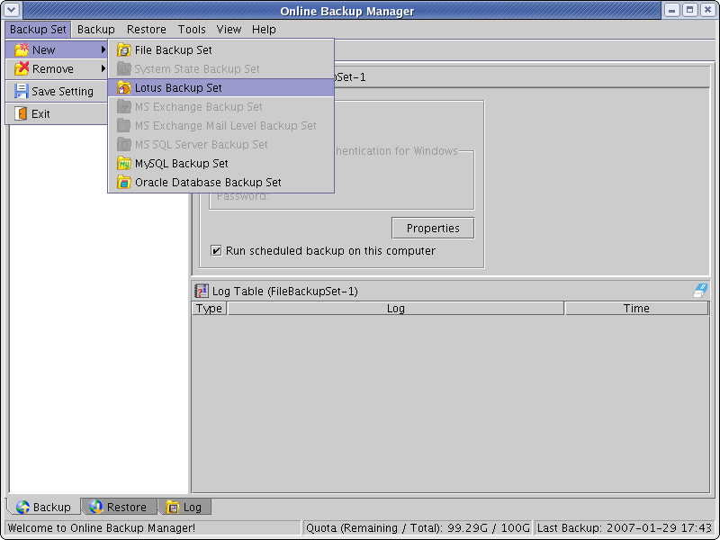
  - Enter a name for your backup set
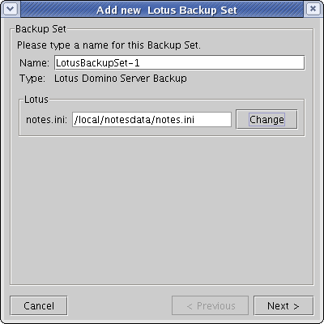
  - Select the location of the “note.ini” file. The default path for this will be in the /local/notesdata folder.
  - Select the database(s) / file(s) you want to backup
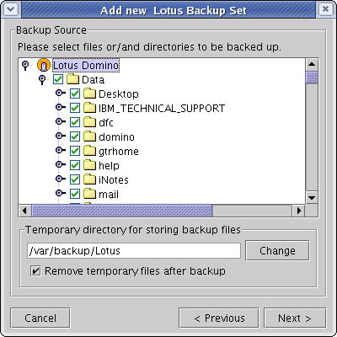
  - Enter a temporary location to store the backup files before they are sent to an Offsite Backup Server. Please make sure that the user running OBM have sufficient privileges to read and write to this location and sufficient space is available.
  - Set the backup schedule for Database Backup
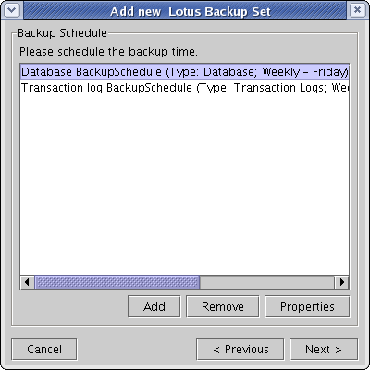
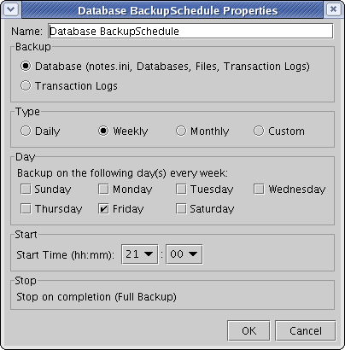
  - Set the backup schedule for Transaction Log Backup (for Domino server only)
(Note: You can have more than one schedule in a backup set, i.e. you can perform intra-day transaction log backup by adding more than one daily transaction log backup schedule to your backup set)
  - Set the encryption algorithm, encryption mode and encrypting key for this backup set
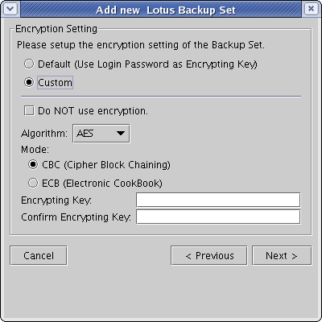
(Hint: For maximum security, please select AES (Advanced Encryption Standard) Algorithm, CBC (Cipher Block Chaining) mode and use an encrypting key with more than 8 characters.)
- Run Backup
  - Select the backup set you want to run on the left panel and press the [Start Backup] button (►)
  - Select the backup type (e.g. Database, Transaction Log) you would like to perform (for Domino server only)
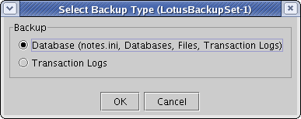
  - Select [Off-site Backup Server] to start backing up your files to an Offsite Backup Server.
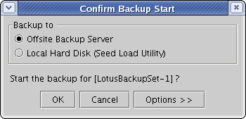
  - You should get something similar to the screen shot below.
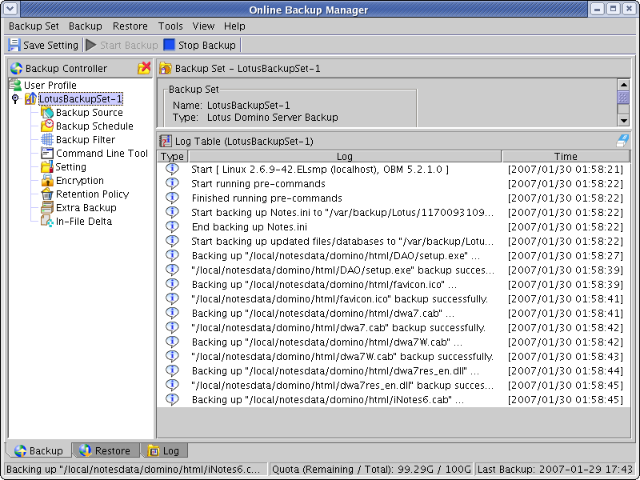

How to restore Lotus Domino / Notes database(s) / file(s) on Linux
Please follow the instructions below to restore Lotus Domino server / Notes client database(s) / file(s) from an Offsite Backup Server.
- Install Lotus Domino server / Notes client back to its original folder (if required)
- Install OBM
Please refer to the [Installation] section for information on how to install OBM onto your computer.
- Shutdown Lotus Domino Server
- If you want to perform a full domino restore (restore all databases and files):
  - Download the backup files to be restored from the Offsite Backup Server and save them back to its original location. It includes notes.ini, all backup files from the lotus domino data directory and all archived transaction logs. If you encounter any access problems, please try restoring using the “root” user.
  - Make sure that the owner and group permissions of the restored files are the notes user
For example: # chown –R notes:notes /local/notesdata
This will assign the owner and group to all files and directories within /local/notesdata.
  - Modify the “DominoRecover.sh” located under the bin directory of the OBM installation to reflect your setup. You need to specify the data directory and the lotus executable directory.
For example change the DATA_DIR and LOTUS tags to:
DATA_DIR=/local/notesdata
LOTUS=/opt/ibm/lotus
  - Make sure the current user is the notes user before running the “DominoRecover.sh”.
  - Run “DominoRecover.sh” and press ‘Y’ to continue.
For example: #./usr/local/obm/bin/DominoRecover.sh
This will run media recovery for all databases (*.nsf and mail.box) found under the Lotus data directory (e.g. /local/notesdata). You should see something similar to the screen below.
Media Recovery Example:
bash-3.00$ cd /usr/local/obm/bin
bash-3.00$ ./DominoRecover.sh
Media Recovery Utility for Lotus Domino 5.0 or above

Please make sure that you have done the following:
1. Reinstall Lotus Domino on this computer in the same directory
2. Restore Notes.ini to the Lotus Domino installation directory
(e.g. /local/notesdata)
3. Restore Domino Data directory back to the directory defined
in Notes.ini (e.g. /local/notesdata)
4. Restore all archived transaction logs to the directory defined
in Notes.ini (e.g. /local/notesdata/logdir)

Continue ? (Y) or (N) y

Running media recovery ...
directory /local/notesdata// already exists
Please wait, creating new transaction logs in directory: /local/notesdata/logdir/
02/01/2007 11:38:43 AM Recovery Manager: Restart Recovery complete. (0/0 databases needed full/partial recovery)
02/01/2007 11:38:45 AM Recovery Manager: Assigning new DBIID for /local/notesdata/names.nsf (need new backup for media recovery).
Media Recovery Replay (0 MB): 100%
02/01/2007 11:38:45 AM Recovery Manager: Media Recovery complete for /local/notesdata/dfc/dfc100.nsf, last update applied .

Backup file /local/notesdata/dfc/dfc100.nsf recovered.
Media Recovery Replay (0 MB): 100%
02/01/2007 11:38:46 AM Recovery Manager: Media Recovery complete for /local/notesdata/help/decsdoc.nsf, last update applied .

…

Backup file /local/notesdata/iNotes/help70_iwa_en.nsf recovered.
Media Recovery Replay (0 MB): 100%
02/01/2007 11:38:50 AM Recovery Manager: Media Recovery complete for /local/notesdata/mail/notes.nsf, last update applied .

Backup file /local/notesdata/mail/notes.nsf recovered.
bash-3.00$

  - All content of all database(s) are now rolled forward to the last committed transaction found in the last archived transaction log.
  - Restart Lotus Domino server

- If you just want to restore a single database:
  - Download the database file to be restored from the Offsite Backup Server and save them back to its original location.
  - (optional) If you need to perform media recovery on this database, please download all archived transaction logs and save them back to its original location
  - Modify the “DominoRecover.sh” located under the bin directory of the OBM installation to reflect your setup.
For example we will recover the “admin4.nsf” and have restored the file to /restore/local/notesdata, change the tags to:
DATA_DIR=/local/notesdata
LOTUS=/opt/ibm/lotus
INPUTFILE=/restore/local/notesdata/admin4.nsf
RESTOREDB=/local/notesdata/admin4.nsf
RECDATE=18/01/2007
RECTIME=22:41
  - Make sure the current user is the notes user before running the “DominoRecover.sh”.
  - Run “DominoRecover.sh”.
You should see something similar to the screen below.
Media Recovery Example:
bash-3.00$ cd /usr/local/obm/bin
bash-3.00$ ./DominoRecover.sh
Media Recovery Utility for Lotus Domino 5.0 or above

directory /local/notesdata// already exists

Recovering backup file ...

Restart Analysis (0 MB): 100%
18/01/2007 03:35:56 PM Recovery Manager: Restart Recovery complete. (0/0 databa ses needed full/partial recovery)
Media Recovery Replay (1 MB): 30% 50% 80% 100%
18/01/2007 03:35:57 PM Recovery Manager: Media Recovery complete for /local/res tore/local/notesdata/admin4.nsf, last update applied .

Backup file /local/restore/local/notesdata/admin4.nsf recovered.

Taking database /local/notesdata/admin4.nsf offline ...

Restoring database /local/notesdata/admin4.nsf
from recovered backup file /local/restore/local/notesdata/admin4.nsf ...
Database file /local/notesdata/admin4.nsf restored from /local/restore/local/not esdata/admin4.nsf

Bringing database /local/notesdata/admin4.nsf online ...

Program completed successfully.
bash-3.00$

  - All content of the database are now rolled forward to the last committed transaction found in the last archived transaction log.
  - Restart Lotus Domino Server

Backup/Restore Microsoft Exchange Server
This chapter will describe in details how to use OBM to backup your Microsoft Exchange Server 2000 / 2003 and how you can restore your Microsoft Exchange Server 2000 / 2003 from the backup files.

Requirements
- Microsoft Exchange Server 2000 with Services Pack 3 and post-SP3 update rollup installed. Please refer to http://www.microsoft.com/exchange/ for more information.
or
Microsoft Exchange Server 2003.
- OBM must be installed onto the computer running Microsoft Exchange Server 2000 / 2003.
- Data from Microsoft Exchange Server will be backed up to a temporary directory before they are sent to Offsite Backup Server. Please make sure you have sufficient space on your computer to store these data when you run the backup job.

Overview
A Microsoft Exchange Server 2000/2003 stores its data in Windows Active Directory as well as in its databases. To fully backup a Microsoft Exchange Server 2000/2003, you need to backup the following components:
- Windows System State
The Windows System State contains the information about your Windows system, including Windows Active Directory. A Microsoft Exchange Server 2000 / 2003 stores some of its configuration, e.g. email accounts and mailbox properties, inside Windows Active Directory. It is important that Windows Active Directory is backup properly when backing up a Microsoft Exchange Server.
Active Directory is stored inside a Windows Server running as Windows domain controller. If your Exchange Server is a domain controller, you can simply backup the Windows System State of your Exchange Server. If your Exchange Server is running as a member server, you will need to install another copy of OBM onto the domain controller to backup the Windows System State of inside the domain controller.
For more information on Active Directory, please refer to http://www.microsoft.com/windows2000/technologies/directory/ad/default.asp
- Microsoft Information Store
Exchange Server stores all emails and documents inside its databases, which are grouped together as storage groups inside Microsoft Information Store. It is important that Microsoft Information Store is fully backup when backing your Exchange Server.
- Microsoft Site Replication Service
Microsoft Site Replication Service is installed automatically when exchange server site replication feature is enabled. Microsoft Site Replication stores its runtime and configuration information inside its own database. If you are running your Exchange Server with Site Replication Service enabled, please make sure that you backup the site replication database as well.
- Microsoft Key Management Service (Exchange 2000 only)
Similarly, if you have setup your Exchange Server with Key Management Services enabled, please make sure that you backup the key management database as well.
OBM will backup your Microsoft Exchange Server by taking the following steps:
- Run all Pre-Commands of this backup set
- If the backup type to run is [Database Backup type],
  - Windows System State will be backed up to a temporary directory specified in its backup set
  - All exchange database(s) selected are backed up to a temporary directory specified in its backup set
- If the backup type to run is [Transaction Log Backup type],
  - New transaction log extents generated since last backup will be copied to the temporary directory
- Remove transaction log extents backed up from the Exchange Server
- Run all Post-Commands of this backup set
- Upload all backup files from the temporary directory to an Offsite Backup Server
- Remove temporary files from the temporary directory if [Setting] -> [Temporary Directory for storing backup files] is enabled

How to backup Microsoft Exchange Server
Please follow the instructions below to backup your Microsoft Exchange Server 2000 / 2003 using OBM:
- Open OBM
Right click OBM icon available in the system tray and choose [Open]
- Create a backup set
  - From the Menu, Choose [Backup Set] -> [New] -> [MS Exchange Backup Set]
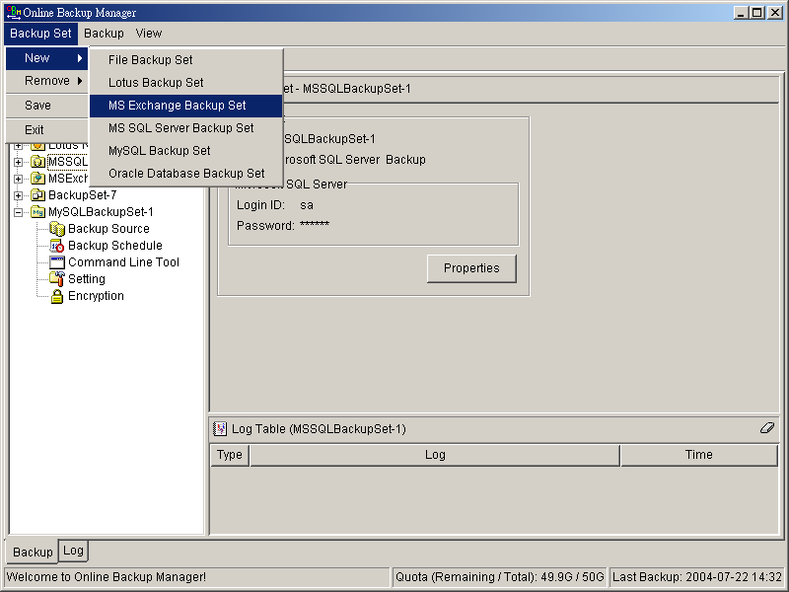
  - Enter a name for your backup set
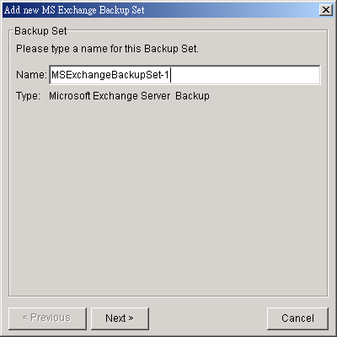
  - Select the database(s) to be backup
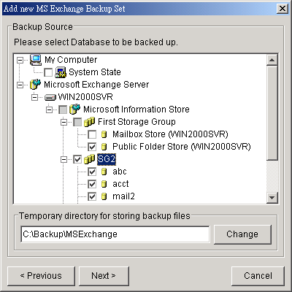
If this Exchange Server is also a domain controller of this Active Directory, select the [System State] checkbox as well. Otherwise, please install OBM to the domain controller of this Active Directory and select the [System State] checkbox on that computer
  - Enter a temporary directory for storing the backup files before they are sent to an Offsite Backup Server
  - Set the backup schedule for Database Backup
  - Set the backup schedule for Transaction Log Backup
(Note: You can have more than one schedule in a backup set, i.e. you can perform intra-day transaction log backup by adding more than one daily transaction log backup schedule to your backup set)
  - Set the encryption algorithm, encryption mode and encrypting key for this backup set
(Hint: For maximum security, please select AES (Advanced Encryption Standard) Algorithm, CBC (Cipher Block Chaining) mode and use an encrypting key with more than 8 characters.)
- Run Backup
  - Select the backup set you want to run on the left panel and press the [Start Backup] button (►)
  - Select the backup type (e.g. Database, Log Files) you would like to perform
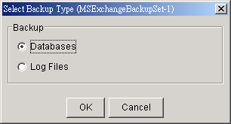
  - Select [Off-site Backup Server] to start backing up your files to an Offsite Backup Server and press the [OK] button
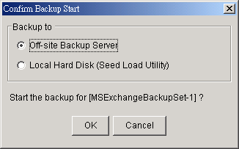
  - You should get something similar to the screen shot below.
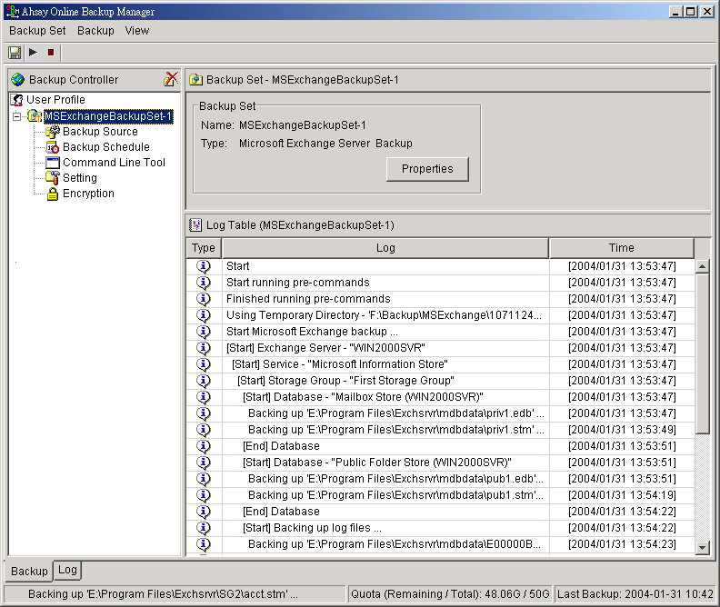

How to restore Microsoft Exchange Server
Please follow the instructions below to restore Microsoft Exchange Server 2000 / 2003 from an Offsite Backup Server.
- Prepare the system for your Exchange Server (if required)
Install the original version of Windows and Exchange Server (with the same level of service pack installed as in the original system) back to your computer
- Restore Windows Active Directory (if required)
If you have re-installed Windows, please download the Windows System State backup file, named [SystemState.bkf], from Offsite Backup Server and then use [NTBackup.exe] to restore your Windows System State to its backup time from the backup file by following the instructions below:
  - Run [NTBackup.exe] from [Start] -> [Run]
  - Press the [Restore Wizard] button and then press the [Next] button
  - Press the [Import] button and use the [Browse] button to select the backup file [SystemState.bkf] downloaded
  - Select the checkbox next to the description that matches your backup file
  - Press the [Next] button and then the [Finish] button
- Install OBM (if required)
Please refer to the [Installation] section for information on how to install OBM onto your computer.
- Startup the [Microsoft Information Store] services from Windows Services
- Restore exchange database(s) from backup:
  - Download the database backup files to be restored from the Offsite Backup Server (or find the cached copy available in the temporary directory defined in your backup set) and save them to your hard disk (please make sure the directory structure is the same as it appears on the browser), namely:
->[C:]
-->[backup]
---->[ABC]
------>[Microsoft Information Store]
-------->[First Storage Group]
---------->[Mailbox Store(ABC)]
--------------->Priv1.edb
--------------->Priv1.stm
---------->[Public Folder Store(ABC)]
--------------->Pub1.edb
--------------->Pub1.stm
---------->E0000001.log
  - If the database to be restored exists on your computer already, please dismount it from the services using [Start] -> [Program] -> [Microsoft Exchange] -> [System Manager]
  - Use [ExchangeRestore.exe] from the [bin] directory under the installation directory of OBM (e.g. C:\Program Files\OBM\bin\ExchangeRestore.exe) to restore the exchange database(s).
Simply run [ExchangeRestore.exe] to print the usage
ExchangeRestore.exe Usage:
C:\Program Files\OBM\bin> ExchangeRestore.exe

Microsoft Exchange Server 2000/2003 Backup Recovery Utility

Usage:
ExchangeRestore DIR=path SERVER=server TEMP=tempDir [SERVICE=service [STORAGE=st
orage [DATABASE=database]]]

DIR Directory containing all backup files
SERVER Name of Exchange Server to be restored
TEMP Temporary directory to be used during restore
Please specific a path with plenty of free space
SERVICE Name of Exchange Service to be restored. It must be either
"Microsoft Information Store", "Microsoft Key Management Service"
or "Microsoft Site Replication Service"
STORAGE Name of storage group to be restored
DATABASE Name of database to be restored

Examples:
1. To restore an exchange server:
ExchangeRestore DIR="C:\Backup" SERVER="ExchangeServer" TEMP="C:\Temp"

2. To restore the information store:
ExchangeRestore DIR="C:\Backup" SERVER="ExchangeServer" TEMP="C:\Temp"
SERVICE="Microsoft Information Store"

3. To restore an exchange storage group:
ExchangeRestore DIR="C:\Backup" SERVER="ExchangeServer" TEMP="C:\Temp"
SERVICE="Microsoft Information Store" STORAGE="StorageGroup1"

4. To restore an exchange database:
ExchangeRestore DIR="C:\Backup" SERVER="ExchangeServer" TEMP="C:\Temp"
SERVICE="Microsoft Information Store" STORAGE="StorageGroup1"
DATABASE="Database1"
where
"C:\Backup" is the directory containing all backup files
"ExchangeServer" is the server name of an exchange server
"C:\Temp" is the temporary directory to be used
"StorageGroup1" is the name of a storage group
"Database1" is the name of a database

  - (Example 1) To restore all databases from backup available in [F:\Backup] to an exchange server named [WIN2000SVR] using the temporary directory [F:\Temp], you can use this command:
E:\Program Files\OBM\bin> ExchangeRestore DIR="F:\Backup" TEMP="F:\Temp" SERVER="WIN2000SVR"
Exchange Server Recovery Example:
E:\Program Files\OBM\bin> ExchangeRestore DIR="F:\Backup" TEMP="F:\Temp" SERVER="WIN2000SVR"

Microsoft Exchange Server 2000/2003 Backup Recovery Utility

[Start] Exchange Server - 'WIN2000SVR'
[Start] Service - 'Microsoft Information Store'
[Start] Storage Group - 'First Storage Group'
[Start] Database - 'Mailbox Store (WIN2000SVR)'
Restoring file 'E:\Program Files\Exchsrvr\mdbdata\priv1.edb' ...
Restoring file 'E:\Program Files\Exchsrvr\mdbdata\priv1.stm' ...
[End] Database - 'Mailbox Store (WIN2000SVR)'
[Start] Database - 'Public Folder Store (WIN2000SVR)'
Restoring file 'E:\Program Files\Exchsrvr\mdbdata\pub1.edb' ...
Restoring file 'E:\Program Files\Exchsrvr\mdbdata\pub1.stm' ...
[End] Database - 'Public Folder Store (WIN2000SVR)'
[Start] Restoring transaction log - 'First Storage Group'
Restoring Log File 'F:\Temp\restore.tmp\First Storage Group\E00000B3.log' ...
Restoring Log File 'F:\Temp\restore.tmp\First Storage Group\E00000B4.log' ...
[End] Restoring transaction log - 'First Storage Group'
[Start] Applying transaction log ...
[End] Applying transaction log
[End] Storage Group - 'First Storage Group'
……………
[Start] Storage Group - 'SG2'
[Start] Database - 'acct'
Restoring file 'E:\Program Files\Exchsrvr\SG2\acct.edb' ...
Restoring file 'E:\Program Files\Exchsrvr\SG2\acct.stm' ...
[End] Database - 'acct'
[Start] Restoring transaction log - 'SG2'
Restoring Log File 'F:\Temp\restore.tmp\SG2\E0100072.log' ...
Restoring Log File 'F:\Temp\restore.tmp\SG2\E0100073.log' ...
[End] Restoring transaction log - 'SG2'
[Start] Applying transaction log ...
[End] Applying transaction log
[End] Storage Group - 'SG2'
[End] Exchange Server - 'WIN2000SVR'

E:\Program Files\OBM\bin>

  - (Example 2) To restore the database named [mail] in storage group [SG5] from backup available in [F:\Backup] to an exchange server named [WIN2000SVR] using the temporary directory [F:\Temp], you can use this command:
E:\Program Files\OBM\bin> ExchangeRestore DIR="F:\Backup" TEMP="F:\Temp" SERVER="WIN2000SVR" SERVICE="Microsoft Information Store" STORAGE="SG5" DATABASE="mail1"
Exchange Server Recovery Example:
E:\Program Files\OBM\bin> ExchangeRestore DIR="F:\Backup" TEMP="F:\Temp" SERVER="WIN2000SVR" SERVICE="Microsoft Information Store" STORAGE="SG5" DATABASE="mail"

Microsoft Exchange Server 2000/2003 Backup Recovery Utility

[Start] Storage Group - 'SG5'
[Start] Database - 'mail'
Restoring file 'E:\Program Files\Exchsrvr\SG5\mail.edb' ...
Restoring file 'E:\Program Files\Exchsrvr\SG5\mail.stm' ...
[End] Database - 'mail'
[Start] Restoring transaction log - 'SG5'
Restoring Log File 'F:\Temp\restore.tmp\SG5\E0300012.log' ...
Restoring Log File 'F:\Temp\restore.tmp\SG5\E0300013.log' ...
[End] Restoring transaction log - 'SG5'
[Start] Applying transaction log ...
[End] Applying transaction log
[End] Storage Group - 'SG5'

E:\Program Files\OBM\bin>
  - Repeat the same procedure for each database to be restored to the Exchange Server.
  - You can use [Start] -> [Program] -> [Administrative Tools] -> [Event Viewer] to check if there are any errors generated from the exchange databases restoring activities.
- However, if ExchangeRestore.exe still cannot mount the restored files and returns with strange errors, e.g. bad signature, or null errors. Then Exchange server might have incorrectly spooled the backup files in the first place. Please try to mount the restored database and log files manually by the following instructions:
  - In MS Exchange System Manager, dismount both the Mailbox Store and Public Folder Store from the server.
  - Copy all the restored database files to the MDBDATA folder (By default, the MDBDATA folder is located under C:\Program Files\Excgsrvr\)
Mailbox Store:
      - priv1.edb
      - priv1.stm
Public Folder Store:
      - pub1.edb
      - pub1.stm
  - Run "eseutil /r" to apply the transaction log files to bring the database to a consistent state, e.g.:
C:\Program Files\Exchsrvr\MDBDATA> ..\bin\eseutil /r e00
The above command will try to bring all the databases handled by the transaction log files starting with “e00” located in “C:\Program Files\Exchsrvr\MDBDATA” into clean shutdown state.
  - Run "eseutil /p" to repair the database files, e.g.:
C:\Program Files\Exchsrvr\MDBDATA> ..\bin\eseutil /p priv1.edb
C:\Program Files\Exchsrvr\MDBDATA> ..\bin\eseutil /p pub1.edb

  - Mount both Mailbox Store and Public Folder Store to the Server through the MS Exchange System Manager.

- Completed

Backup/Restore Windows System State
This chapter will describe in details how to use OBM to backup Windows System State and how you can restore your Windows System State from backup.

Requirements
- Microsoft Windows XP Professional / 2003
- OBM must be installed onto the computer containing the system state you want to backup
- Windows system state will be backed up to a temporary file before it is sent to OBS. Please make sure you have sufficient space on your computer to store the temporary file when you run the backup job.

Overview
OBM will backup your Microsoft Exchange Server by taking the following steps:
- Run all Pre-Commands of this backup set
- Windows System State will be backed up to a temporary directory specified in its backup set
- Run all Post-Commands of this backup set
- Upload the Windows System State backup files from the temporary directory to an Offsite Backup Server
- Remove the Windows System State temporary backup files from the temporary directory if [Setting] -> [Temporary Directory for storing backup files] is enabled

How to backup Windows System State
Please follow the instructions below to backup Windows System State using OBM:
- Open OBM
Right click OBM icon available in the system tray and choose [Open]
- Create a backup set
  - From the Menu, Choose [Backup Set] -> [New] -> [System State Backup Set]
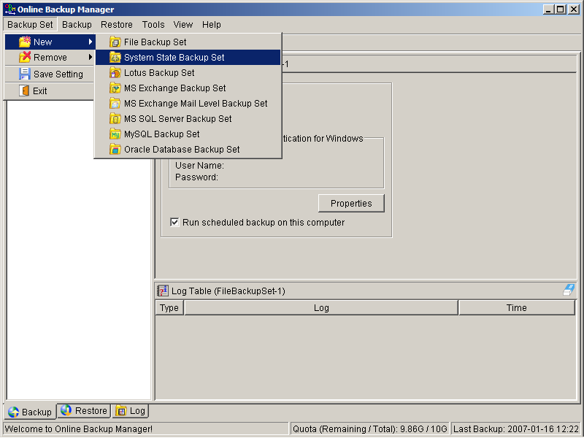
  - Enter a name for your backup set
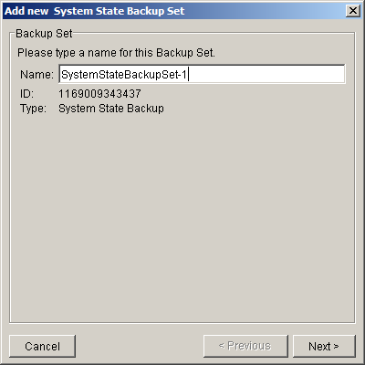
  - Use the [Change] button to configure the [Temporary directory for storing backup files] setting and check the [Remove temporary files after backup] if you want temporary files to be removed automatically after backup
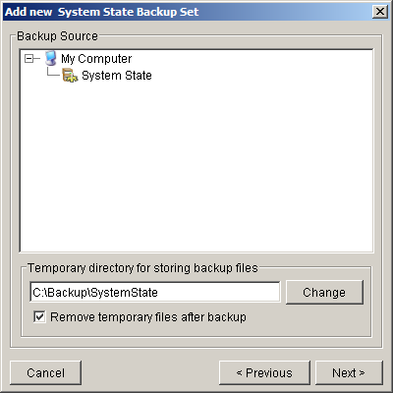
  - Enter a temporary directory for storing the backup files before they are sent to an Offsite Backup Server
  - Set the backup schedule for this backup set
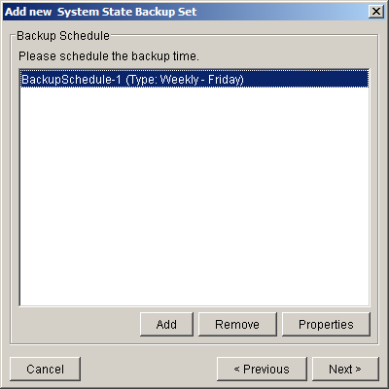
  - Set the encryption algorithm, encryption mode and encrypting key for this backup set
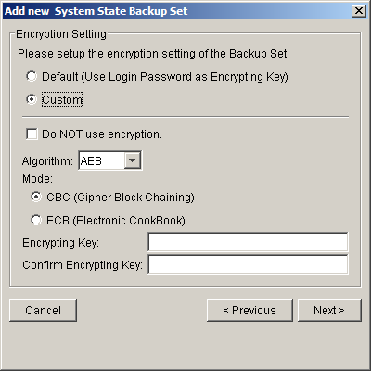
(Hint: For maximum security, please select AES (Advanced Encryption Standard) Algorithm, CBC (Cipher Block Chaining) mode and use an encrypting key with more than 8 characters.)
- Run Backup
  - Select the backup set you want to run on the left panel and press the [Start Backup] button (►)
  - Select [Off-site Backup Server] to start backing up your files to an Offsite Backup Server and press the [OK] button
  - You should get something similar to the screen shot below.

How to restore Windows System State
Please follow the instructions below to restore Windows System State from an Offsite Backup Server.
- Install OBM (if required)
Please refer to the [Installation] section for information on how to install OBM onto your computer.
- Restore the Windows System State Backup File (i.e. SystemState.bkf) from the backup server
- Use [NTBackup.exe] to restore your Windows System State to its backup time from the backup file by following the instructions below:
  - Run [NTBackup.exe] from [Start] -> [Run]
  - Press the [Restore Wizard] button and then press the [Next] button
  - Press the [Import] button and use the [Browse] button to select the backup file [SystemState.bkf] downloaded
  - Select the checkbox next to the description that matches your backup file
  - Press the [Next] button and then the [Finish] button
- Completed

Backup/Restore Individual Brick Level Backup for Microsoft Exchange Server

Requirements
- Microsoft Exchange Server 2000 with Services Pack 3 and post-SP3 update rollup installed. Please refer to http://www.microsoft.com/exchange/ for more information.
or
Microsoft Exchange Server 2003.
- OBM must be installed onto the computer running Microsoft Exchange Server 2000 / 2003.

Overview
Brick Level Backup for Microsoft Exchange Server is not designed to fully protect an Exchange server, but to facilitate easy backup and fast restore of individual emails, contacts, calendars, tasks etc. The brick level restore cannot fully recover the Information Store after a disaster. If used, a brick level backup must be utilized in conjunction with full Information Store Backup, in order to fully protect the exchange server.

Granting Privileges
Brick Level Backup requires “Full Mailbox Access” permission for the user running OBM. Normally, OBM can acquire the permission on it’s own but if you encounter ‘Access Denied’ errors you need to manually grant access privileges to the user running OBM using one of the following instructions below:

For one specific mailbox
Use the following procedure to grant access to an Exchange 2000 or an Exchange 2003 mailbox:
- Start Active Directory Users and Computers.
- On the View menu, ensure that the Advanced Features check box is selected.
- Right-click the user whose mailbox you want to give permissions to and choose Properties.
- On the Exchange Advanced tab, click Mailbox Rights.
- Notice that the Domain Admins and Enterprise Admins have both been given Deny access to Full Mailbox access.
- Click Add, click the user or group who you want to have access to this mailbox, and then click OK.
- Be sure that the user or group is selected in the Name box.
- In the Permissions list, click Allow next to Full Mailbox Access, and then click OK.
- Click Ok all the way out.
- Restart the Microsoft Exchange Information Store.

For mailboxes located within a specific mailbox store
Use the following procedure to grant access to an Exchange 2000 or an Exchange 2003 mailbox found on a specific mailbox store:
- Start Exchange System Manager.
- Drill down to your server object within the appropriate Administrative Group. Expand the server object and find the required mailbox store within the appropriate Storage Group. Right-click it and choose Properties.
- In the Properties window go to the Security tab.
- Click Add, click the user or group who you want to have access to the mailboxes, and then click OK.
- Be sure that the user or group is selected in the Name box.
- In the Permissions list, click Allow next to Full Control, and then click OK.
- Click 'Apply' and 'OK'
- Restart the Microsoft Exchange Information Store.

For mailboxes located within a specific server
- Start Exchange System Manager.
- Drill down to your server object within the appropriate Administrative Group. Right-click it and choose Properties.
- In the Properties window go to the Security tab.
- Click Add, click the user or group who you want to have access to the mailboxes, and then click OK.
- Be sure that the user or group is selected in the Name box.
- In the Permissions list, click Allow next to Full Control, and then click OK.
- Click Ok all the way out.
- Restart the Microsoft Exchange Information Store.

How to backup Individual Brick Level Backup
Please follow the instructions below to backup all individual items within your Microsoft Exchange Server 2000 / 2003 using OBM:
- Open OBM
Right click OBM icon available in the system tray and choose [Open]
- Create a backup set
  - From the Menu, Choose [Backup Set] -> [New] -> [MS Exchange Mail Level Backup Set]
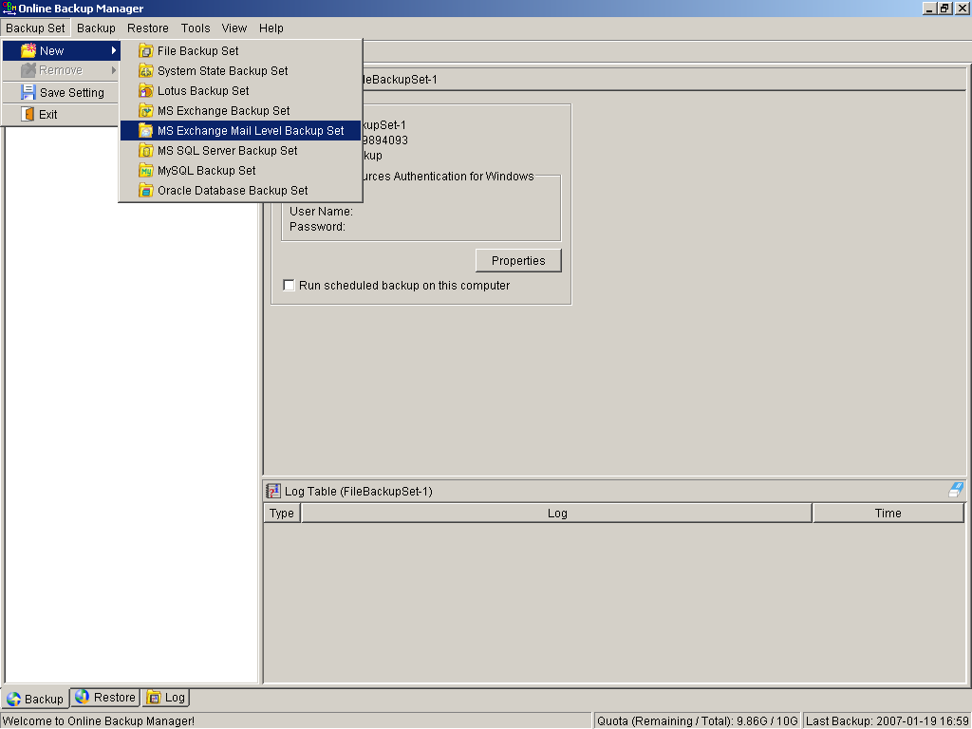
  - Enter a name for your backup set
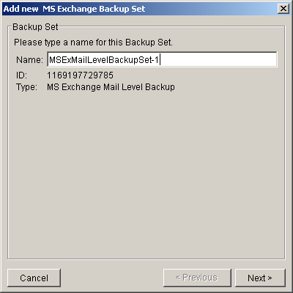
  - Select the email account(s) to backup
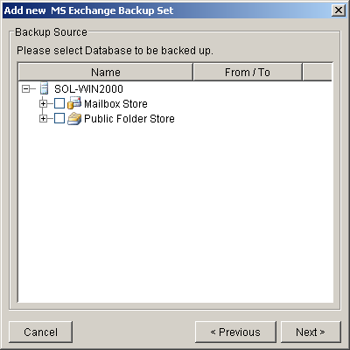
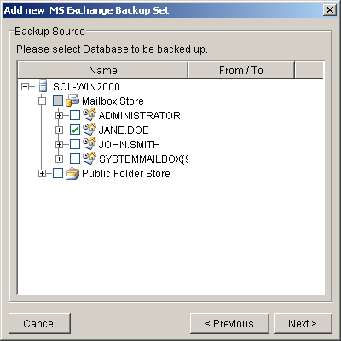
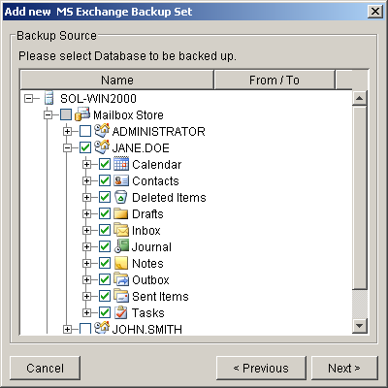
You can drill down to select individual items.
  - Set the backup schedule
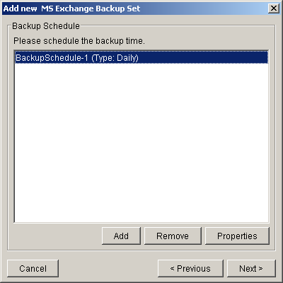
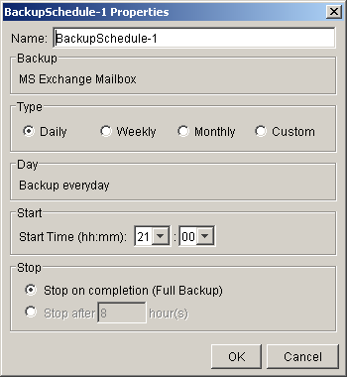
  - Set the encryption algorithm, encryption mode and encrypting key for this backup set
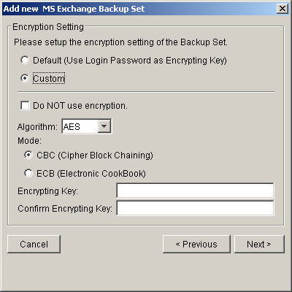
(Hint: For maximum security, please select AES (Advanced Encryption Standard) Algorithm, CBC (Cipher Block Chaining) mode and use an encrypting key with more than 8 characters.)
- Run Backup
  - Select the backup set you want to run on the left panel and press the [Start Backup] button (►)
  - Select [Offsite Backup Server] to start backing up your files to an Offsite Backup Server and press the [OK] button
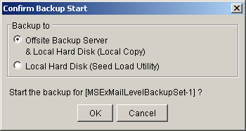
  - You should get something similar to the screen shot below.
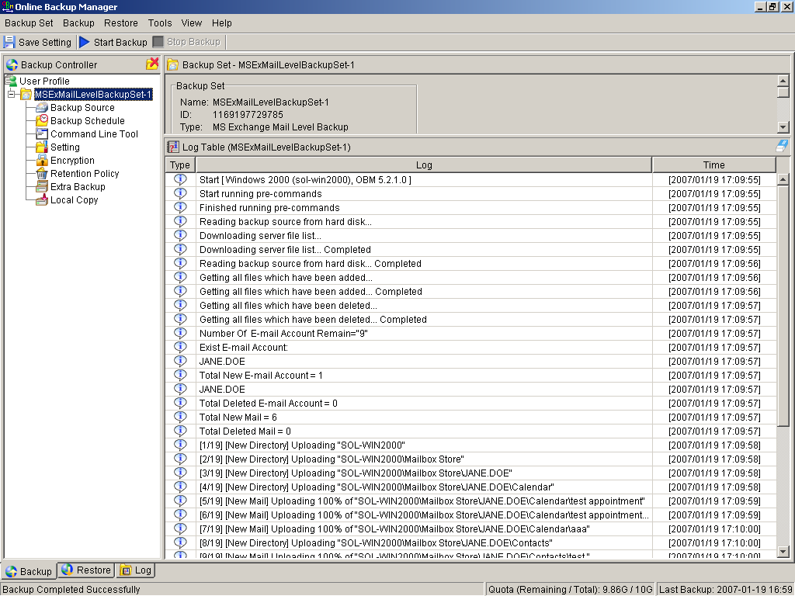

How to restore Individual Brick Level Backup
Please follow the instructions below to restore individual emails, contacts, calendars, tasks etc. from an Offsite Backup Server back into your exchange server. Please note that individual brick level can only be restored using the OBM client.
- Open OBM
Right click OBM icon available in the system tray and choose [Open]
- Choose the [Restore] tab and select the items you want to restore
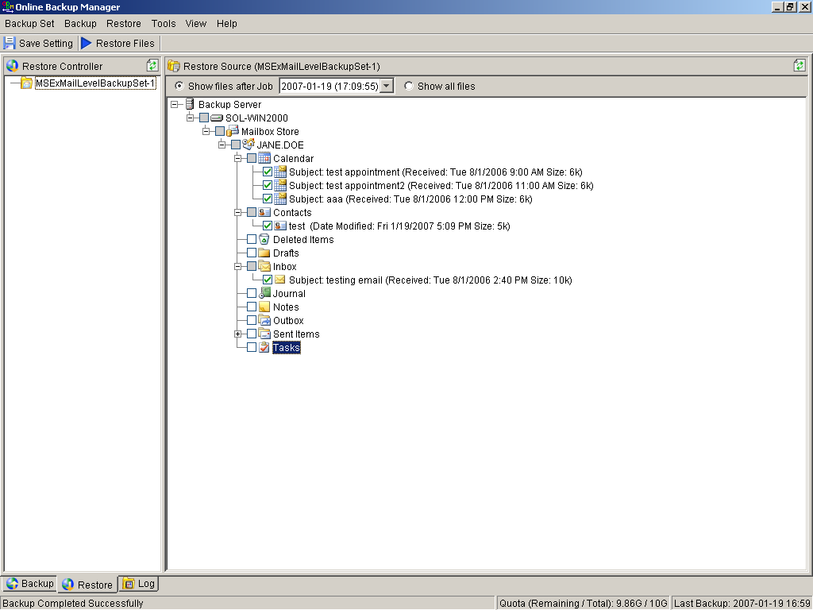
- Press the [Restore Files] button
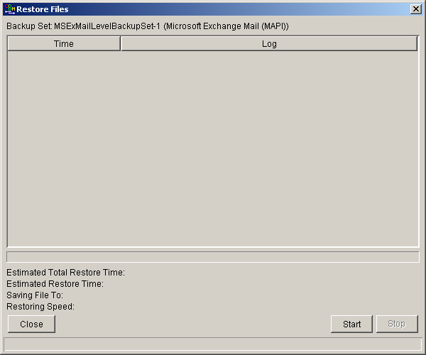
- Press [Start]
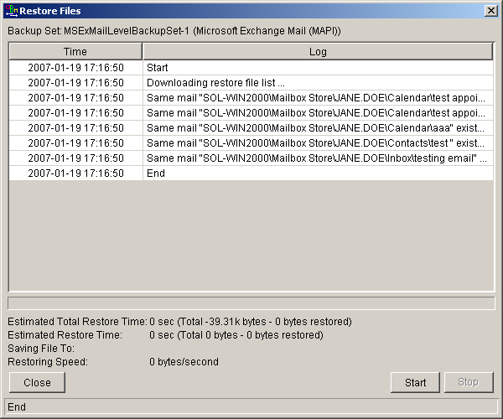
- Restore complete. Please logon to exchange to get the restored items.

Backup/Restore MySQL Server
This chapter will describe in details how to use OBM to backup your MySQL server and how you can restore your MySQL server from the database backup files.

Requirements
- OBM must be installed onto the computer running MySQL server.
- Data from MySQL server will be backed up to a temporary directory before they are sent to Offsite Backup Server. Please make sure you have sufficient space on your computer to store these data when you run the backup job.
- There must be a MySQL account can be used to connect from localhost.
Add two new MySQL accounts for Backup Manager
mysql> GRANT ALL PRIVILEGES ON *.* TO 'root'@'localhost'
-> IDENTIFIED BY 'some_pass';
mysql> GRANT ALL PRIVILEGES ON *.* TO 'root'@'localhost.localdomain'
-> IDENTIFIED BY 'some_pass';
mysql> FLUSH PRIVILEGES;
They are superuser accounts with full privileges to do anything with a password of some_pass.

Overview
OBM will backup your MySQL server by taking the following steps:
- Run all Pre-Commands of this backup set
- All database(s) (either local or external) selected are backed up to a temporary directory specified in its backup set
- Run all Post-Commands of this backup set
- Upload all backup files from the temporary directory to an Offsite Backup Server
- Remove temporary files from the temporary directory if [Setting] -> [Temporary Directory for storing backup files] is enabled

How to backup MySQL server on Windows
Please follow the instructions below to backup your MySQL server using OBM:
- Open OBM
Right click OBM icon available in the system tray and choose [Open]
- From the Menu, Choose [Backup Set] -> [New] -> [MySQL Backup Set]
Create a backup set
  - From the Menu, Choose [Backup Set] -> [New] -> [MySQL Backup Set]
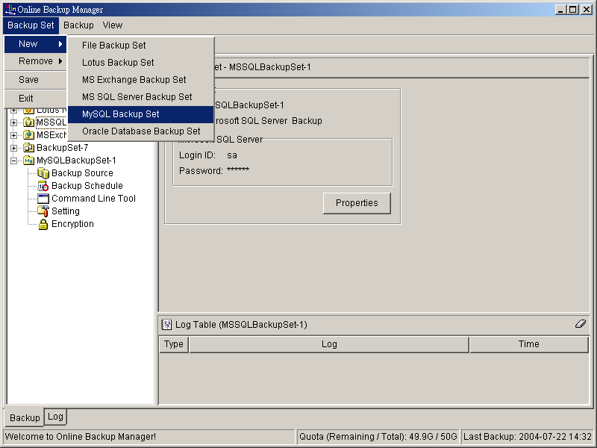
  - Enter a name for your backup set
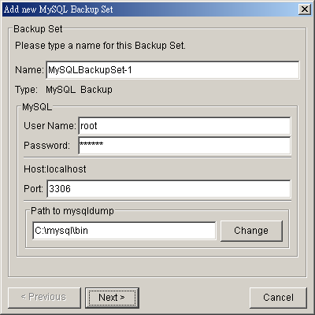
  - Enter the root password, the MySQL server TCP/IP port number and the path to MySQL backup utility (mysqldump)
  - Select the database(s) to be backup
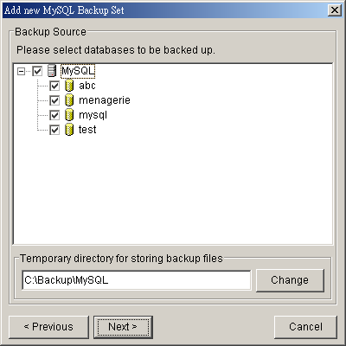
  - Enter a temporary directory for storing the backup files before they are sent to an Offsite Backup Server, e.g. C:\Backup\MySQL
  - Set the backup schedule for Database Backup
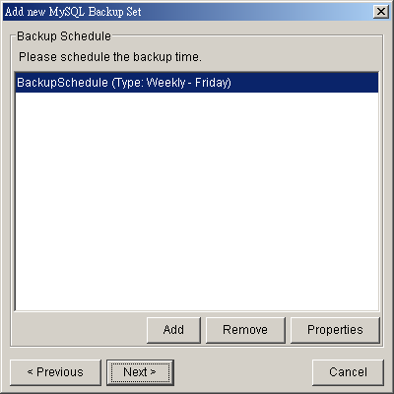
  - Set the encryption algorithm, encryption mode and encrypting key for this backup set
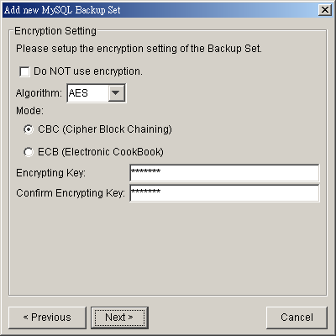
(Hint: For maximum security, please select AES (Advanced Encryption Standard) Algorithm, CBC (Cipher Block Chaining) mode and use an encrypting key with more than 8 characters.)
- Run Backup
  - Select the backup set you want to run on the left panel and press the [Start Backup] button (►)
  - Select [Off-site Backup Server] to start backing up your files to an Offsite Backup Server and press the [OK] button
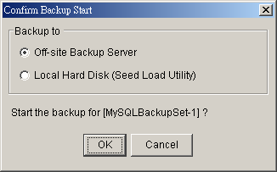
  - You should get something similar to the screen shot below.
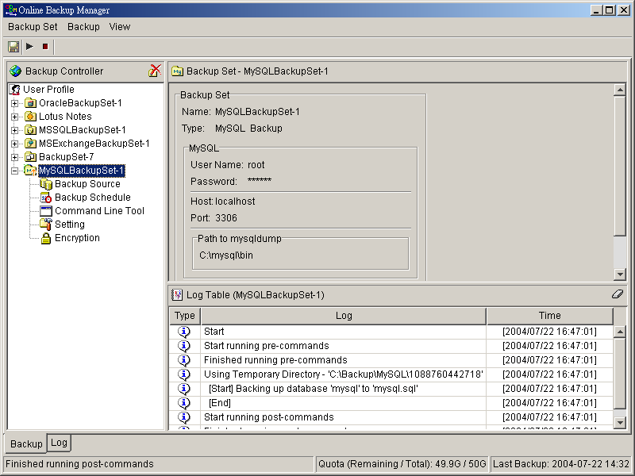

How to backup MySQL server on Linux (command line mode)
If you want to setup OBM to backup MySQL server running on Linux using command line mode, please do the followings:
- Create a backup account on OBS
- Logon to the web interface of OBS using the backup account created in the previous step (doesn’t matter if it is not from the Linux server running the MySQL server to be backed up)
- Create a new backup set by pressing the [Backup Set] -> [Add] button
- Select the [Backup Set] -> [Type] -> [MySQL Database Server] radio button and press the [Update] button (which can be found at the bottom of the page)
- Setup all [Backup Set] -> [Database Backup Setting]
Settings | Descriptions
MySQL Username (e.g root) | A MySQL user account that has backup access to the databases to be backed up (e.g. root). Please refer to the [Requirements] section for details
MySQL Password | Password of the MySQL user account being used
Host | IP address / Hostname of the MySQL Server, e.g. localhost
MySQL Connection TCP/IP Port | TCP/IP port used to access the MySQL Server (default: 3306)
Path to MySQL backup utility (mysqldump) | Full path to where mysqldump can be found (e.g. /usr/bin/mysqldump)
Temporary Spooling Directory | A temporary directory to be used to store all MySQL database dump files before they are uploaded to the backup server
Enable Delete Temp. File | Whether to delete the temporary MySQL database dump files after they are uploaded to the backup server

- Setup the [Backup Set] -> [Backup Source] setting
- Add an “MySQL” entry to the [Backup Source] if you want to backup all databases under this MySQL Server
- Add two entries, “MySQL/database1” and “MySQL/database2”, to the [Backup Source] if you want to backup both “database1” and “database2” under this MySQL Server
(Please use “\” instead of “/” if the MySQL server to be backed up is running on Windows instead of Linux)
- Setup the [Backup Set] -> [Backup Schedule] by pressing the [Add] link next the the “Backup Schedule” sub-title
- Install OBM onto the Linux server running MySQL server (Please refer to the [2.1 Installation of OBM] section for details. The command line mode installation instructions are available on the web interface)
- Completed
If you have started up the OBM backup scheduler in the previous step, selected databases will be backed up automatically at scheduled time

How to restore MySQL server
Please follow the instructions below to restore MySQL server from an Offsite Backup Server.
- Download the database backup files to be restored from the Offsite Backup Server
Please refer to the [5.3 Restoring file] section for information on how to download backup files from Offsite Backup Server.
- Restore the database named [db_name] from the database backup file [db_name.sql]:
  - Connect to the MySQL server
(Windows) C:\> mysql
(Linux) [root@server ~]# mysql
  - Create the database to be restored
mysql> CREATE DATABASE IF NOT EXISTS db_name
  - Restore the database backup file back into the MySQL server
mysql> use db_name ;
mysql> source db_name.sql ;
If db_name.sql is not located in the current directory, please specify the full path to the db_name.sql file in the command above.
- Repeat the same procedure for each database to be restored to the MySQL Server.
- Completed

Email Reporting
Offsite Backup Server makes use of the email system to keep you informed with the status of your backup activities. Please make sure your contact information within the backup system is correct to receive the reports described in this chapter.

New User Report
When a new backup account is added to the backup server, a new user report will be delivered to the contact email(s) of the new account. The New User Report contains the following information:
Sample Report
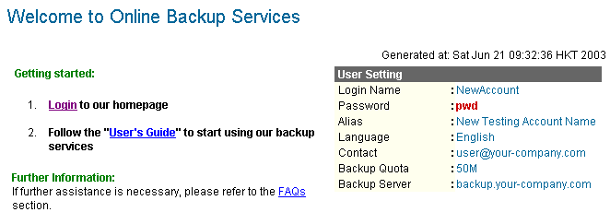

Key | Description
Login Name | Login name
Password | Password
Alias | Alias
Language | Preferred Language for your backup report
Contact | Email Address that will be used to contact you
Backup Quota | Backup quota
Backup Server | Backup server

Forgot Password Report
If you have forgotten your password, you can use the [Forgot Password] feature available on the web interface to have your password delivered to you through email. (Please refer to “Retrieve Forgotten Password” section in the next chapter for more information on how to retrieve your forgot password report.) The Forgot Password Report contains the following information:
Sample Report
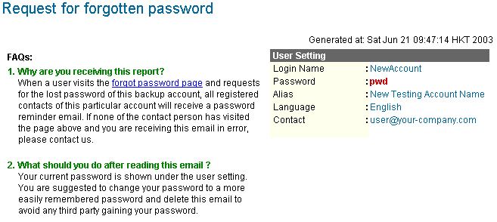

Key | Description
Login Name | Login name
Password | Password
Alias | Alias
Language | Preferred Language for your backup report
Contact | Email Address that will be used to contact you

Backup Job Report
For each backup job you have run, a backup job report will be sent to you by email. This report contains a summary for the backup job that was run and a full listing of all files being backed up by the backup job. The backup summary report contains the following information:
Sample Backup Summary Report
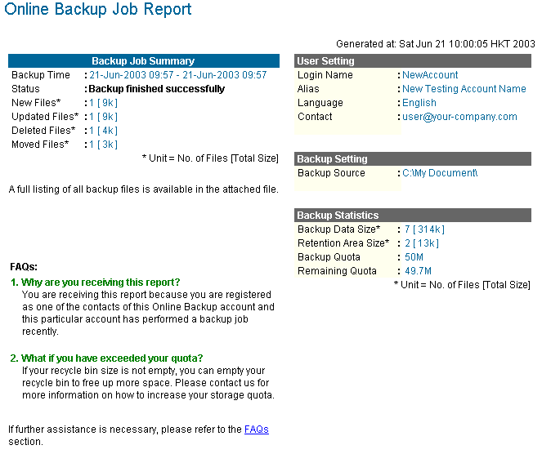

Key | Description
Backup Time | The time when the backup job ran
Backup Status | The overall status of the backup job. Normally, you should see “Backup finished successfully” in this field. If you happen to get something else, please consult the attached full report for more information.
New Files | Total number and size of backup files added to your backup set
Updated Files | Total number and size of backup files updated in your backup set
Deleted Files | Total number and size of backup files deleted from your backup set
Moved Files | Total number and size of backup files relocated in your backup set
Login Name | Login name
Alias | Alias
Language | Preferred Language for your backup report
Contact | Email Address that will be used to contact you
Backup Source | All files/directories that will be backed up
Backup Data Size | The total backup data stored in the data area
Retention Area Size | The total backup data stored in the retention area. Old copies of updated or deleted backup files are retained in the retention area for the number of days as specified by the retention policy of the backup set before they are removed from the system.
Backup Quota | Backup Quota
Remaining Quota | Remaining Quota

The full backup report, which contains a full listing of all files backed up by the backup job, is attached to the backup job report email as a zip file. You need to unzip it before you can read the full report.
Sample Report
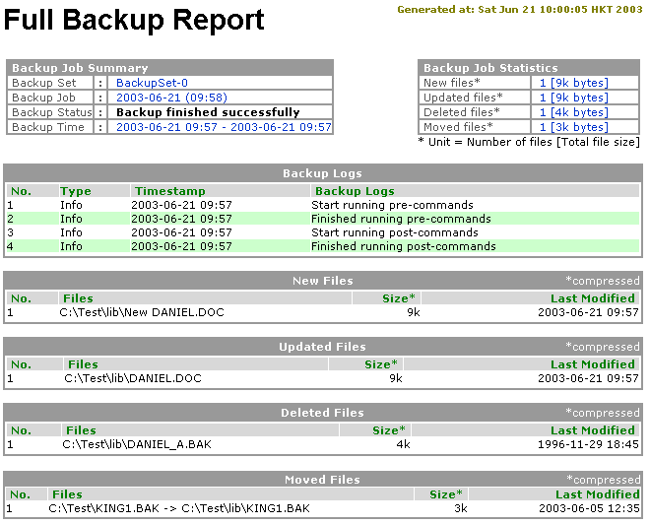

Key | Description
Backup Set | The name of the backup set
Backup Job | The name of the backup job (which is the start time of the backup job)
Backup Status | The overall status of the backup job. Normally, you should see “Backup finished successfully” in this field. If you happen to get something else, please consult the attached full report for more information.
Backup Time | The time when the backup job ran
Backup Log | All messages logged when running this backup job
New Files | Total number and size of backup files added to your backup set
Updated Files | Total number and size of backup files updated in your backup set
Deleted Files | Total number and size of backup files deleted from your backup set
Moved Files | Total number and size of backup files relocated in your backup set
New File List | Full list of all backup files added to your backup set
Updated File List | Full list of all backup files updated in your backup set
Deleted File List | Full list of all backup files deleted from your backup set
Moved File List | Full list of all backup files relocated in your backup set

Setting Change Report
After you have updated your user profile or backup setting, a setting change report will be sent to you. This report allows you to track record of the changes that have been made to your backup account.
Sample Report
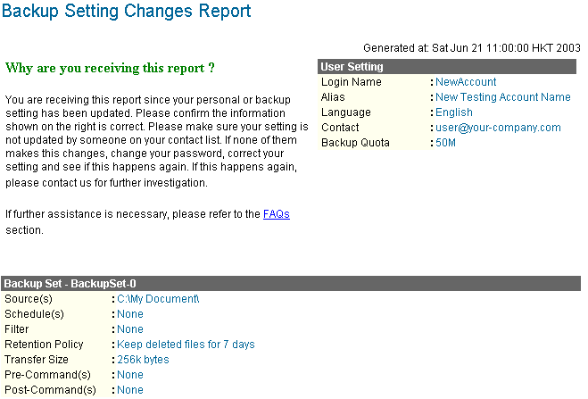

Key | Description
Login Name | Login name
Alias | Alias
Language | Preferred Language for your backup reports
Contact | Email Address that will be used to contact you
Backup Quota | Backup Quota
Backup Source(s) | All backup sources of the backup set
Backup Schedule(s) | All backup schedules of the backup set
Filter(s) | All backup filters of the backup set
Retention Policy | The retention policy of the backup set
Transfer Size | The transfer block size of the backup set
Pre-Command(s) | All Pre-Command(s) of the backup set
Post-Command(s) | All Post-Command(s) of the backup set

Inactive User Reminder
You will receive an inactive user reminder in email if your account has been left inactive for the period of 7 days (or the period specified by the system administrator). This is to remain you that you have not been running backup for more 7 days. If you are a free trial user, your account will be removed from the system automatically if the system can track no records of your backup activities in the next 30 days after receiving this report.
Sample Report
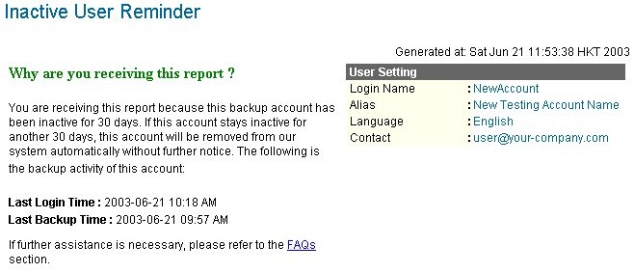

Key | Description
Login Name | Login name
Alias | Alias
Language | Preferred Language for your backup reports
Contact | Email Address that will be used to contact you
Backup Quota | Backup Quota
Last Login Time | The last time you logon to the backup system
Last Backup Time | The last time you ran a backup job

Web Features
Other than the features of OBM described in the previous chapter, the web interface of Offsite Backup Server provides you access to some additional features that are not available in OBM. This chapter describes each of these features in details.

Install OBM
Before you can use OBM, you have to download the OBM installer from the web interface of Offsite Backup Server and install OBM onto your computer. Please refer to the installation section (Chapter 2) for information on how to install OBM onto your computer.

Update User Profile
You can update your user profile by using the [Profile] panel available on the web interface. To change your profile, just make any changes to your profit on the panel shown below and press the [Update] button.
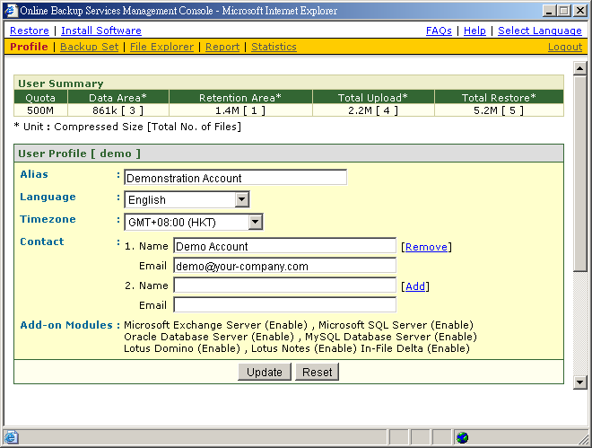
Key | Description
Quota | Backup Quota
Data Area | Total number and size backup files stored in the data area
Retention Area | Total number and size of backup files stored in the retention area
Total Upload | Total number and size of backup files uploaded to the backup server
Total Restore | Total number and size of backup files restored from the backup server
Login Name | Login name
Display Name | Alias of your backup account
Language | Preferred Language for your backup report
Time Zone | Your Time zone
Contact | Email Address that will be used to contact you

Request Forgotten Password
If you have forgotten your password, you can retrieve it by simply entering your login name or your registered email address on the [Password Request] form and press the [Request] button. Your password will be sent to your registered email address automatically.
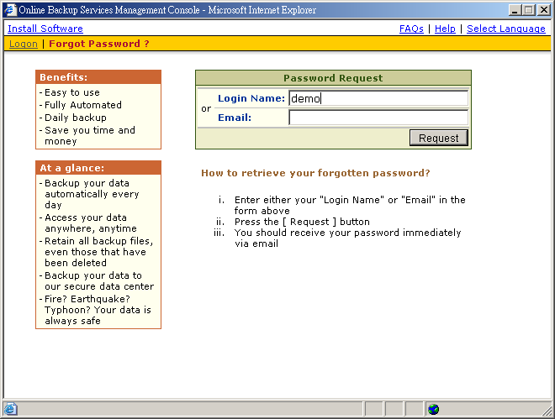

Restore/Delete/Undelete Backup Files
Using the [File Explorer], you can browse through the backup data (both current and previous versions) on OBS. You can select any current backup files to Restore or Delete. You can also select any deleted backup files (in gray) to Undelete.
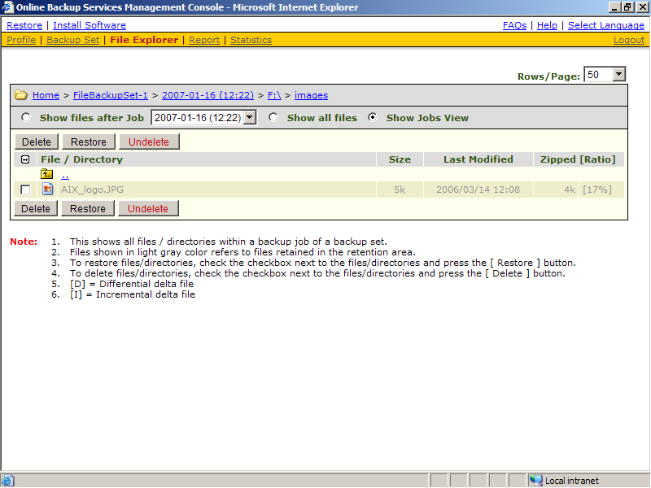

Review Backup Jobs
In addition to reviewing your backup activities from the email report and from OBM, you can also review any of your backup Jobs by using the [Report] panel available on the web interface. To review a backup job, just select the required backup job from the [Backup Set] and [Backup Job] drop down list.
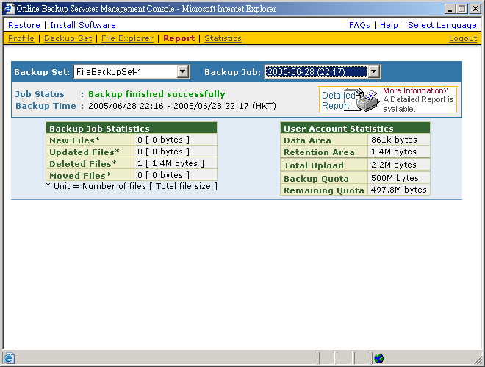
Key | Description
Job Status | The overall status of the backup job. Normally, you should see “Backup finished successfully” in this field. If you happen to get something else, please click the [Detailed Report] images on the page.
Backup Time | The time when the backup job ran
New Files | Total number and size of backup files added to your backup set
Updated Files | Total number and size of backup files updated in your backup set
Deleted Files | Total number and size of backup files deleted from your backup set
Moved Files | Total number and size of backup files relocated in your backup set
Backup Data Size | The total backup data stored in the data area
Retention Area Size | The total backup data stored in the retention area. Old copies of updated or deleted backup files are retained in the retention area for the number of days as specified by the retention policy of the backup set before they are removed from the system.
Total Upload | Total number and size of backup files uploaded to the backup server
Backup Quota | Backup Quota
Remaining Quota | Remaining Quota

You can open the [Full Backup Report] to review all information logged by a backup job by clicking the [Detailed Report] image on the [Report] panel.
Full Backup Report

Parameter | Description
Backup Set | The name of the backup set
Backup Job | The name of the backup job (which is the start time of the backup job)
Backup Status | The overall status of the backup job.
Backup Time | The time when the backup job ran
Backup Log | All messages logged when running this backup job
New Files | Total number and size of backup files added to your backup set
Updated Files | Total number and size of backup files updated in your backup set
Deleted Files | Total number and size of backup files deleted from your backup set
Moved Files | Total number and size of backup files relocated in your backup set
New File List | Full list of all backup files added to your backup set
Updated File List | Full list of all backup files updated in your backup set
Deleted File List | Full list of all backup files deleted from your backup set
Moved File List | Full list of all backup files relocated in your backup set

Review Storage Statistics
You can review the amount of data you have stored on the backup server and uploaded to the backup server on each day by opening the [Statistics] panel available on the web interface. To review your storage statistics for a different month, just select the month you are after by selecting from the [Month] drop down list.
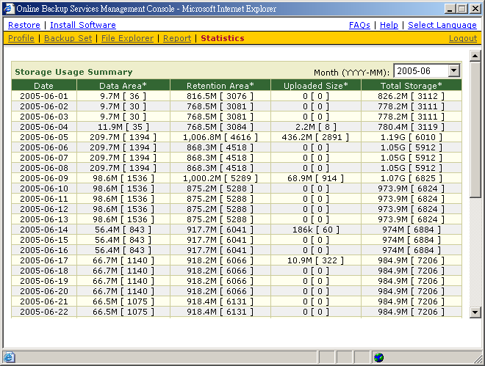
Key | Description
Date | The date the following statistics are collected
Data Area | Total number and size of backup files stored in the data area on a particular date
Retention Area | Total number and size of backup files stored in the retention area on a particular date
Uploaded Size | Total number and size of backup files uploaded to the backup server on a particular date
Total Storage | Total number and size of backup files stored under your backup account on a particular date

Further Information

FAQs
Please see if your question has already been answered in our FAQs available on our website.

Contact Us
You can backup your data to an Offsite Backup Server by following instructions below.
- Open OBM from the system tray
- Choose [View] -> [About] from the top menu
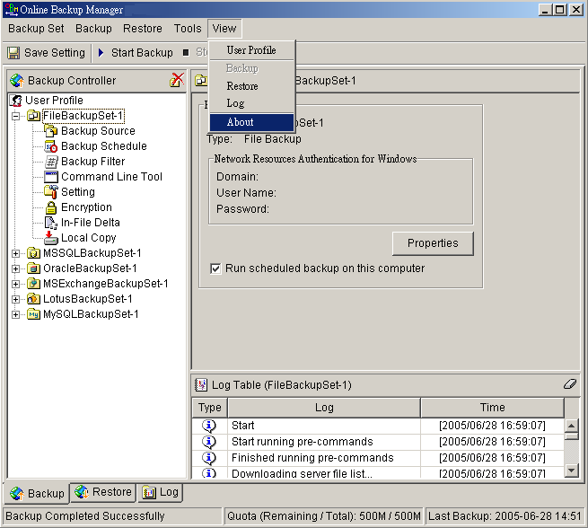
- Contact your backup service provider using the information shown in the [About] dialog box


