

Professional Client v5.2

User’s Guide

Copyright Notice

The use and copying of this product is subject to a license agreement. Any other use is prohibited. No part of this publication may be reproduced, transmitted, transcribed, stored in a retrieval system or translated into any language in any form by any means without the prior written consent of us. Information in this manual is subject to change without notice and does not represent a commitment on the part of the vendor. We do not warrant that this document is error free. If you find any errors in this document, please report to us in writing.

Trademarks

Microsoft, Windows, Microsoft Exchange Server and Microsoft SQL Server are registered trademarks of Microsoft Corporation.
Sun, Solaris, SPARC, Java and Java Runtime Environment are registered trademarks of Sun Microsystems Inc.
Apple and Mac OS X are registered trademarks of Apple Computer, Inc.
All other product names are registered trademarks of their respective owners.

Contents
1 Overview 3
1.1 Benefits 3
1.2 Features 3
1.3 Security 3
1.4 System Requirements 3
2 Installing Professional Client 5
2.1 Installing for Windows 5
2.2 Installing for Mac OS X 5
3 Uninstalling Professional Client 6
3.1 Uninstalling Professional Client for Windows 6
3.2 Uninstalling Professional Client for Mac OS X 6
4 Using the Professional Client 7
4.1 System Tray Launcher (Windows Only) 7
4.2 Logon Dialog 8
4.3 Language Selection 8
4.4 User Profile 9
4.5 Backup Logs 9
5 Setting Up Your Backup Set 10
5.1 Backup Set Filters 11
5.2 User Authentication for Windows 12
5.3 Backup Schedule 12
5.4 Backup Setting 13
5.5 Microsoft’s Volume Shadow Copy Service (VSS) 14
5.6 Encryption 14
5.7 Retention Policy 14
5.8 Extra Backup (Off-line backup, Logout Reminder) 15
6 In-File Delta Technology (Configured in Web Interface) 16
6.1 Overview 16
6.2 Block Size 17
6.3 Minimum File Size 17
6.4 Uploading full file again 17
7 Backing Up Files 19
7.1 How files are backed up 19
8 Restoring Files 20
8.1 Restore backup files directly from backup server 20
9 Email Reporting 23
9.1 Backup Job Report 23
9.2 Setting Change Report 25
9.3 Inactive User Reminder 26
10 Web Features 27
10.1 Install Professional Client 27
10.2 Update User Profile 27
10.3 Restore/Delete/Undelete Backup Files 28
10.4 Review Backup Jobs 28
10.5 Review Storage Statistics 30

Overview

Benefits
- Easy Backup of
  - My Documents / My Pictures / My Music
  - Outlook and Outlook Express (i.e. *.pst, *.dbx and *.wab)
  - Important personal settings, e.g. Desktop, Favorite, My Documents and History etc
  - E-Mails
  - All other common files (e.g. *.doc, *.xls)
  - Accounting Software (Quickbooks, Peachtree, etc.)

- Support backing up only changes within a file (using in-file delta technology)
- Support backing up of open database files on Windows XP/2003 (Volume Shadow Copy)
- Support backing up of Windows NTFS permissions, Mac OS X metadata and resource forks
- Easy to use, setup and maintain

Features
- Choose whether to restore “file permissions” during restore.
- Auto Upgrade Agent to automatically upgrade the client software.
- User configurable incremental / differential in-file delta backup mode (i.e. backing up only changes within a file since the last incremental or full backup according to each user’s preference).
- Allow in-file delta backup mode to be overridden by each user individually according to backup time (e.g. enforcing full (or incremental or differential) backup of all files every Sunday or the 1st day of every month).
- Volume Shadow Copy backup (i.e. backing up files even when they are exclusively open, e.g. Outlook.pst).
- In-File Delta backup (i.e. backing up only changes within files).
- Off-line backup mode and logout backup reminder.
- Customizable backup schedule allows backups to be scheduled at any time.
- Compress and encrypt data automatically before sending them to the server (server stores only encrypted data).
- Incremental backup strategy ensures that only new or updated files are sent to the backup server.
- Access backup data anytime, anywhere by using a web browser.
- Comprehensive backup report lists all files backed up. Backup report delivered automatically via email.
- Backup data are CRC validated before they are stored on server.
- Fully user customizable data retention policy allows users to have access to deleted files using the least possible storage space on the backup server.
- Can select source backup files easily by using a backup filter, e.g. selecting all *.doc and *.xls in your computer in a single operation.
- Run any custom OS commands before/after a backup job.
- Run on Windows, and Mac OS X
- Periodic backup files validation on backup server ensures backup files are 100% valid and fully restorable when needed.

Security
- 128-bit point-to-point SSL communication between server and client
- Support HTTP/HTTPS Proxy and Socks v4/v5 firewall
- Data are 128-bit encrypted when stored on the backup server
- Twofish, Triple DES, Advanced Encryption Standard (AES)
- Electronic Cook Book (ECB) and Cipher Block Chaining (CBC)
- Random initializing vector, salt and iteration count will be generated by the software automatically for each file when encrypting your data

System Requirements

* The use of Windows 2000 WorkStation and XP Professional is only recommended for backup system with less than 20 users. For 20 or more users, please use Windows 2000 or 2003 Server instead.

Client-side applications
 | Supported Platforms | Application Compatibilities | Hardware Requirements
Pro | - Windows 95 / 98 / ME / NT / 2000 / XP / 2003 / Vista  - Mac OS X 10.2 or above | - Outlook / Outlook Express i.e. *.pst, *.dbx and *.wab  - Other common files e.g. *.doc, *.xls  - Also supports backing up of:  - Windows NTFS access privileges | - Memory:  - 128MB (minimum)  - 256MB (recommended)  - Disk Space:  - 110MB  - Network Protocol:  - TCP/IP (http/https)

Installing Professional Client
Before you can start backing up data to the Offsite Backup Server, you need to install the Professional remote backup client onto your computer.

Installing for Windows
- Download the installer from your control panel at our website. ( http://www.influxpc.com/ )
- Double click the icon to run the installer.
- Follow on screen instructions.
- After installation, the backup client will start automatically.

Installing for Mac OS X
- Download the installer from your control panel at our website. ( http://www.influxpc.com/ )
- Expand the zip file.
- Double click the .pkg file icon to run the installer.
- Follow on screen instructions.
- After installation, the installer will need to restart your computer.
- After restarting your computer, click the newly added Professional icon on your desktop. You can manually drag the icon to your dock bar if you wish.

Uninstalling Professional Client
This section describes the steps required to uninstall Professional Client from your computer.

Uninstalling Professional Client for Windows
- Open [Start] -> [Control Panel] -> [Add/Remove Programs]
- Select InFlux Backup - Professional from the list and press the [Remove] button

Uninstalling Professional Client for Mac OS X
- Remove all program files by running
# cd $OBM_HOME/bin
# sudo ./uninstall.sh
- Remove all backup setting by removing ~/.obm
# rm –rf ~/.obm
- Restart your computer

Using the Professional Client
This chapter will describe all the features available in the Professional client and outline how you can use it to meet various backup needs.

System Tray Launcher (Windows Only)
After you have successfully installed Professional Client onto your computer, a Professional Client icon will be added to the system tray area (next to your system clock) automatically.
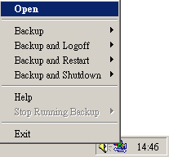
This icon is the entry point to Professional Client. Right clicking the icon will show a menu that provides the following functions:
Menu Item | What it does
Open | Run Professional Client.
Backup | Runs a specific backup set (or all backup sets) chosen from the sub-menu in silent background mode.
Backup and Logoff | Runs a specific backup set (or all backup sets) chosen from the sub-menu in silent background mode and then logoff from Windows when finished.
Backup and Restart | Runs a specific backup set (or all backup sets) chosen from the sub-menu in silent background mode and restart Windows when finished.
Backup and Shutdown | Runs a specific backup set (or all backup sets) chosen from the sub-menu in silent background mode and shutdown the computer when finished.
Help | Shows a help dialog
Stop running backup | Interrupts a running backup set (or all backup sets) chosen from the sub-menu.
Exit | Close this system tray launcher application.

Logon Dialog
Before you can use Professional Client, you have to be authenticated by our backup server first. The logon dialog shown below will check if you have the right to access Professional Client by submitting the username and password you provided during signup.
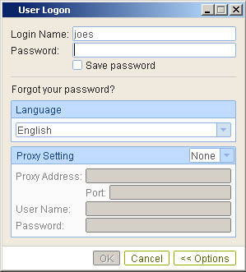
If you need to connect to the server through proxy, just enter your proxy setting in the [Proxy Setting] section. For [SOCKS] proxy, both v4 and v5 without user authentication are supported.

Language Selection
You can switch the language of the Professional Client user interface by choosing the desired language available from the [Language] drop down list. The languages available includes English, Czech, Danish, Dutch, French, Spanish, Portuguese, Icelandic, Norwegian, Finnish, Italian, German, Swedish, Chinese (Traditional and Simplified), Japanese, Lithuanian and Slovenian.

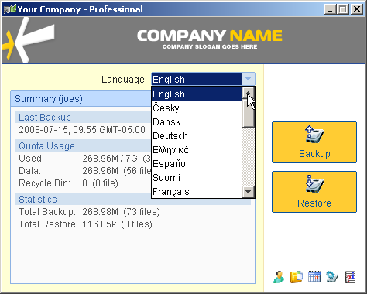

User Profile
After the backup server authenticates you successfully, the Professional Client main window appears. You can then use Professional Client to update your user profile.

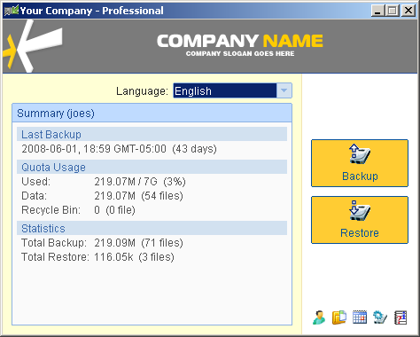

Backup Logs
All backup activities are logged to backup activity log files. They are available for reviewing from the Professional Client.

How to review backup activities?
You can review all your backup Jobs by
- Select the [Backup Log] button near the bottom right of the Professional Client
- Select the Backup Job you want to review on the [Log] dropdown in the [Backup Log] panel.
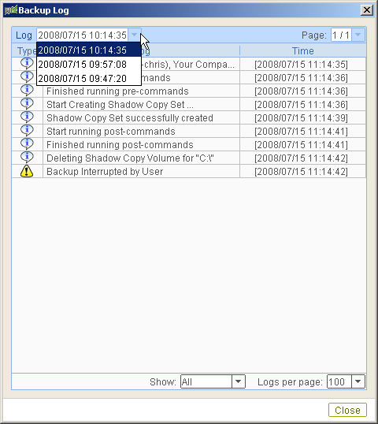

Setting Up Your Backup Set
A backup set contains all backup settings of a backup operation. This section will describe all features available within a backup set and explain how you can use each of them to achieve various backup operations.
A Professional Client account can have only one backup set. For example, instead of being able to have one directory backed up during the day and another directory to be backed up during the night, you can have one backup set that backs up all backup sources during the same operation.
  - To customize your single backup set, simply click the [Backup Source] button.
  - Choose from one of the easy one click backup sources if needed…
  - If further customization of the backup set is required you can do so by clicking the [Advanced] button and selecting the files and folders that will be included in the backup set.
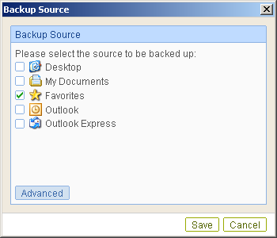
Standard Backup Source
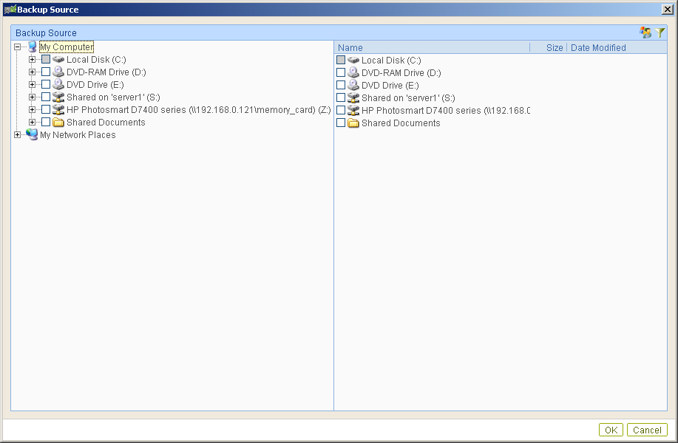
Advanced Backup Source

The checkbox next to the files/directories shown above can be in one of the following mode:
Mode | Description
 | All files/directories (recursively) under this directory will be backed up
 | All files/directories (recursively), except those explicitly excluded, under this directory will be backed up. If you add files/directories to this directory in the future, they will be backed up as well.
 | Only the checked files/directories under this directory will be backed up. If you add files/directories to this directory in the future, they will NOT be backed up.
 | Nothing under this directory will be backed up.

Backup Set Filters
A backup set can include or exclude files based on a filter you specify:
  - Open the [Backup Source] window by clicking the [Backup Source] button.
  - Click the [Advanced] button to further customize the backup source.
  - Click the [Filter] button at the top right portion of the [Advanced] backup source window.
  - Within the backup filter window, click the [Add] button to open the [Add Filter] window.
  - Click [Browse] and choose the directory you would like this filter to apply to.
  - In the [File Name Extension] enter in the extension of the files you would like to include in this filter (e.g. ‘doc’ or ‘xls’ or ‘pdf’ or ‘pst’ etc. without the quotes) then click [Add]
  - Click [OK] to close the [Add Filter] window.
  - Click [OK] to close the [Backup Filter] window.
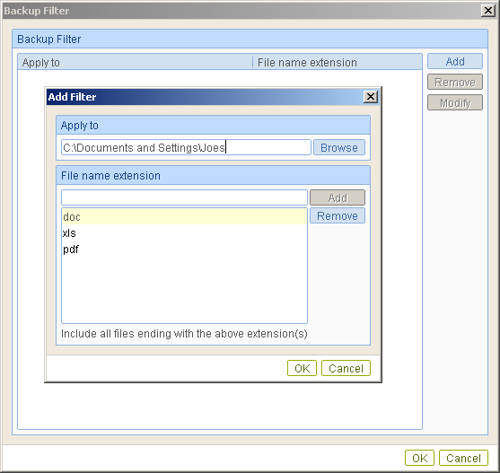

User Authentication for Windows
When performing a backup of mapped network drives within windows, or when backing up another user’s private directory, you will be required to enter the necessary administrative username and password to have the correct permissions to access the data.
- From the [Advanced] backup source window, locate and click the [User Authentication for Windows] button available at the top right of the window
- Enter in the credentials for an administrative user that has access to all network and local resources needed to be backed up.
- [Domain] should be left to the default option if you are not using Windows XP Professional or Vista Business connected to a Domain Controller
- Ensure [User Name] and [Password] are filled in correctly
- Click [OK]
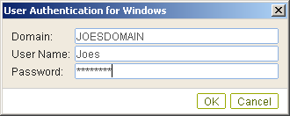
User Authentication for Windows

Backup Schedule
A “Backup Schedule” defines the frequency and the time that backups should run automatically.
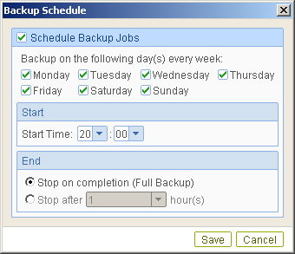
Backup schedule can be in one of the following types:
Option | Description
Schedule Backup Jobs | This Backup Schedule is enabled
Monday - Sunday | Backup Jobs will run on these specified day(s) of every week
Start | Time given in 24HR format that backup will start
Stop on completion (Full Backup) | Backup will run until completely finished. (Not Recommended for Extremely Large Backups, for Large backups use option below.)
Stop After | Backup will run for specified amount of time then exit to prevent the software from backing up continuously until finished.

Backup Setting
Within the Professional client you have access to additional backup settings to enable or disable Volume Shadow Copy, change your deleted file retention policy, set the system logout backup reminder, manage the temporary directory used for backups and whether or not to maintain file permissions.
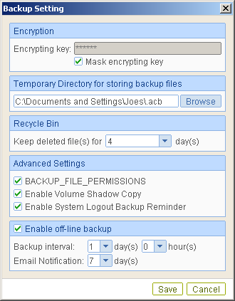
Backup Setting Options
Option | Description
Encrypting Key | View Current Encrypting Key
Temporary Directory | This is the directory that files will be copied to temporarily to compare with what is on the backup server and for generating in-file delta difference files.
Recycle Bin | Choose to keep up to two weeks worth of deleted files before completely removing them off the server
Backup File Permissions | This option will allow you to maintain the Windows Permissions or MacOSX metadata associated with the files and folders being backed up.
Enable Volume Shadow Copy | Whether or not to use Volume Shadow Copy to create backups of files. This option is REQUIRED to perform backups of open files such as Quickbooks, Outlook, Peachtree, etc. while the respective application is open.
Enable System Logout Backup Reminder | This option will prompt you on logout, shutdown, and restart of the PC if you want to perform the backup before doing so. The backup client will perform the logout, shutdown, or restart after the backup has been performed.
Enable Off-line backup | When selected the backup client will perform an off-line backup to the temporary directory during the time of the computer being disconnected from the internet. This backup occurs during each point of the backup interval specified until the computer is reconnected to the internet. Once it is connected to the internet the off-line backups are then transferred to the off-site backup server. (Recommended for Laptops or roaming PCs)
Backup Interval | This interval specifies how often the PC makes an off-line backup and checks for internet connectivity to get the data off-site.
E-Mail Notification | How often to notify the contact of the off-line backups being done. As the off-line backups can be performed on the hour every hour, getting e-mails every hour with an e-mail report can become spammish.

Microsoft’s Volume Shadow Copy Service (VSS)
Microsoft Volume Shadow Copy Service (VSS) allows you to backup files that are exclusively opened. Without VSS, you will get the error message “The process cannot access the file because another process has locked a portion of the file” if you are trying to backup a file that is exclusively opened (e.g. Outlook PST file, Quickbooks QBW).
Please note that VSS is only available on Windows XP / Vista / Server 2003 and 2008 and you must have administrative privileges to start the VSS service on a computer. Also VSS will only work if the backup source hard drives are partitioned and formatted using NTFS. VSS will not work for files source on a mapped network drive, files that are being backed up by VSS must be locally attached to the machine and not through the network.
If you are running Windows 2003, please install the Windows 2003 VSS hot fix available in http://support.microsoft.com/default.aspx?scid=kb;en-us;887827 before running VSS.
If you are running into problems with VSS running on Windows XP / Vista / Server 2003 and 2008, Microsoft's recommendation is to try re-registering the Volume Shadow Copy Service again. Simply run the script [Professional Client Install Directory]\bin\RegisterVSS.bat to do so.
For more information, please take a look at the following page for a technical introduction to Volume Shadow Copy Services (VSS):
http://technet2.microsoft.com/windowsserver/en/library/2b0d2457-b7d8-42c3-b6c9-59c145b7765f1033.mspx

Encryption
Before your files are sent to the Offsite Backup Server, all your files are compressed and encrypted using your choice of encryption key. The only Encryption options available with the Professional Client are the encryption key to be used. To be able to further customize the type of encryption and mode please use our Advanced Client.
Please Note: The Encryption Key cannot be changed once entered. It will also be required when re-installing the client and for any sort of restore procedure, whether it from the client or through our web interface. We do not store or have access to your encryption key. Please write it down and keep it in a safe place.
Please Note: The Encryption Key cannot be changed once entered. It will also be required when re-installing the client and for any sort of restore procedure, whether it from the client or through our web interface. We do not store or have access to your encryption key. Please write it down and keep it in a safe place.

Retention Policy
During backup, if Professional Client finds that you have deleted a file (or updated a file) on your computer, it will put the corresponding deleted (or updated) file already backed up on the backup server into a retention area. The retention policy setting defines how long files inside the retention area will be kept on the backup server before they are deleted automatically from the server.
Retention policy will only affect “retained” file (i.e. files that have already been deleted or updated on your computer and thus are moved to the retention area of the backup server). For those files that have not been updated on your computer, the backup of these files is kept in the data area on the backup server and won’t be affected by the setting of retention policy. These backup files of unchanged files will stay on the backup server forever until the original files are removed (or updated) from your computer.
Option | Description
Professional Client Retention Limits | 1-14 Days of Retention
Advanced Client Retention Limits | 1-365 Days of Retention

Extra Backup (Off-line backup, Logout Reminder)
Off-line backup is basically designed for notebook users who are off-line most of the time and cannot rely on the backup schedule to backup regularly. The "Backup Interval" allows notebook users to specify the interval that they would like their data to backup. When the machine is online and this interval has elapsed, backup will run automatically. The "Email Notification" setting is the number of days since the last backup that triggers the backup server to send email notification to the client to remind him to run an off-line backup.
When the “Logout Reminder” setting is enabled, a popup message box will ask the user to start a backup before logging out / shutting down Windows.

In-File Delta Technology (Configured in Web Interface)
The chapter describes what in-file delta technology is and how in-file delta can be used to backup large database files (e.g. a 10GB Outlook.pst file) without uploading the whole database file everyday.

Overview
In-file delta technology is an advanced data block matching algorithm which has the intelligence to pick up changes (delta) of file content between two files. Using this algorithm, daily backing up of large files (e.g. a 10GB Outlook.pst file) over low-speed internet connection is made possible because it requires only the changes of information (should be marginal) since the last backup to be sent over a low-speed internet connection to complete the backup of a large file (here we assume that the full backup of the file has been saved on the backup server already).
This is what will happen in the backup of a 10GB Outlook.pst file when it is backed up by Professional Client with in-file delta technology.
- The whole files (10GB), along with its checksum file, are backed up to the backup server. This can be done directly through the internet or indirectly using the seed loading utility on a removable hard disk.
- When backup runs again later (normally the next day), Professional Client will download a checksum listing of all data blocks of the full backup file (or last incremental backup file) from the backup server and use it to pick up all changes that have been made to the current Outlook.pst file.
- Changes detected are then saved in a delta file which is uploaded to the backup server. A new checksum file is generated and is also uploaded. (This delta file is assumed to be small because the content of PST files doesn’t change a lot during daily usage)
- Subsequent backups of this 10GB Outlook.pst file will go through step ii and step iii again. As explained, only a small delta file and checksum file will be uploaded to the backup server.
- With in-file delta technology, daily backing up of large file over low-speed internet connection is now possible

Incremental in-file delta type
Incremental Delta will facilitate ease of backup. The delta is generated by comparing with the latest uploaded full backup or delta files. The delta file generated is the smallest possible and uses the least bandwidth during backup. For restoration, the full file and all delta files up to the required point-in-time is required to restore the file to a specific point-in-time.
Example: If you are adding around 100MB changes to a 10G Outlook.pst everyday.
After the first full backup job, Professional Client will continue to generate and upload delta files instead of uploading the full file until either one of the following two rules are true:
- Number of deltas generated since the last full backup is greater than the [Number of Delta] setting.
- The delta ratio (the ratio of the delta file size against the full file size) is greater than the [Delta Ratio] setting
Using incremental delta, the delta generated by comparing the current file with the latest uploaded full or delta file is around 100MB.
Since the delta file size is around 100MB daily, the delta ratio (around 1%) will not trigger a full file upload. Instead Professional Client will continue to generate and upload delta files until day 102 (assuming the full file was uploaded on day 1) when the number of deltas generated exceeds the [Number of Delta] setting and triggers the upload of the full Outlook.pst file. You can disable the [Number of Delta] and [Delta Ratio] if you don’t want to upload the full file.
All delta files are generated with respect to changes made since the last incremental or full backup. This means that the last full backup file and ALL incremental delta backup files are required to restore the latest snapshot of a backup file.

Differential in-file delta type
Differential Delta will facilitate ease of restore. The delta is generated by comparing with the latest uploaded full file. The delta file generated grows daily and uses more bandwidth during backup. For restoration, the full file and a single delta file is required to restore the file to a specific point-in-time.
Example: If you are adding around 100MB changes to a 10G Outlook.pst everyday.
After the first full backup job, Professional Client will continue to generate and upload delta files instead of uploading the full file until either one of the following two rules are true:
- Number of deltas generated since the last full backup is greater than the [Number of Delta] setting.
- The delta ratio (the ratio of the delta file size against the full file size) is greater than the [Delta Ratio] setting
Using differential delta, the delta generated by comparing the current file with the latest uploaded full file is around 100MB for the 1st delta, 200MB for the 2nd delta, 300MB for the 3rd delta and so on.
Since the delta file grows by 100MB daily, the delta ratio for day 52 (delta file size is approximately 51x100= 5.1GB, assuming the full file was uploaded on day 1) being over 50% exceeds the [Delta Ratio] setting and triggers the upload of the full Outlook.pst file. You can disable the [Number of Delta] and [Delta Ratio] if you don’t want to upload the full file.
All delta files are generated with respect to changes made since the last full backup file (i.e. differential backup). This means that only last full backup file and the last delta file are required to restore the latest snapshot of a backup file. This means that other intermediate delta files are only required if you want to restore other snapshots of a backup file.
Differential in-file delta backup has the benefits that a corrupted delta file would only make one particular version of a backup file non-recoverable and all other backups created by other delta files of the same file would still be intact.

Block Size
The block size defines the size of data block being used to detect the changes between the last full or delta backup file and the file sitting on the local computer right now. In general, the smaller the block size, the more likely a matched data block can be found between the last backup file and the file on local computer. It, therefore, produces a smaller delta file but it would require more processing power to detect these changes. On the other hand, in-file delta backup running with larger block size will run faster but this will generally produce a larger delta file.
In most case, the default setting [Auto] will choose the optimal block size for each file (depending on the size of the file) for you.

Minimum File Size
The [Minimum File Size] setting defines the smallest file size a file must have before the use and application of in-file delta backup technology.
If the size of a file that is being backed up is smaller than the [Minimum File Size] setting, in-file delta backup technology won’t be applied to this file and the whole file, instead of just the delta file, will be uploaded to the backup server. It is not necessary to perform in-file delta backup on small files because backing up the whole file doesn’t take too long anyway. Backing up the whole file instead reduces the time required to restore a backup file.

Uploading full file again

No. of Delta
The [No. of delta] setting defines the maximum number of delta files from the same full backup file to be generated and backed up to the backup server before a full backup (the whole file) of this file is uploaded to the backup server instead.
For example, if you have created 100 delta files from the full backup file already and the [No. of delta] setting is set to 100, the next backup will upload a full backup file (the whole file) instead of just the delta file. However, if the [No. of delta] rule is disabled, it will keep generating delta files and uploading these delta files to the backup server until the other delta rule forces a full backup (i.e. delta ratio exceeded). This setting is here to make sure that there will always be a full backup file after a certain number of delta files have been generated.

Delta Ratio
The [Delta Ratio] setting is defined to be the size of a delta file divided by the size of its full backup file (i.e. the percentage of changes detected between the last full backup file and the current file).
If the delta ratio calculated from the size of the generated delta file and the size of the full backup file is greater than the [Delta Ratio] setting, the whole file, instead of just the delta file, will be backed up to the backup server. It is done this way because the difference between backing up the whole file and the delta file is not significant and it is better to upload the whole file instead to reduce the time required to restore the file. The default setting of [Delta Ratio] is 50%. This means that if a file changes by more than 50%, the whole file, instead of just the delta file, will be backed up and uploaded

Backing Up Files
This chapter describes how files are backed up by the Professional Client to the backup server

How files are backed up
The diagram below describes how the Professional Client will backup your files.
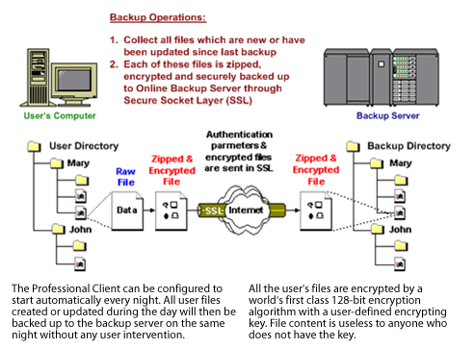

Run backup at scheduled time automatically
Once you set your backup scheduled, a backup job will be started automatically to perform backup operation for you at your absence. You can have backup running at your scheduled time as often as you want (e.g. twice a day or hourly during office hour) without requiring doing any extra work.

Incremental Backup
Unchanged files are already backed up to server and need not to be backed up again. Professional Client will pick the new or updated files from your backup set files and upload only these files to the server. It significantly reduces the time required to perform the backup operation since most users update less than 5% of their total data each day.

Compress and encrypt data automatically
Data are compressed and encrypted before they are uploaded to the server. Not only does it reduce the storage space to keep you backup files, it also ensures the privacy of your data.

File Retention Policy
The built-in file retention policy allows you to access multiple versions of the same file or even deleted files from your backup set. Backup files are put into a retention area before they are removed from the server. If you want to get back a deleted file (or you want to get back the previous versions of an updated files) within the retention period, these files will always be available in the retention area. This feature is particularly useful when you have accidentally deleted a file or incorrectly updated a file within the file retention period (file retention period is user customizable).

Restoring Files
This chapter describes different ways files can be restored from to the backup server
It is very important to write down your encrypting key on paper and keep it in a safe place because there will be no way to restore your backup files if you lose your encrypting key.

Restore backup files directly from backup server
You can use either the Professional Client or the web restore interface to restore backup files from the backup server.

Using Professional Client
You can restore your data from the backup server by following instructions below.
    - Open Professional Client from the System Tray (see previous sections for details) or icon on your desktop
    - Click the [Restore] button.
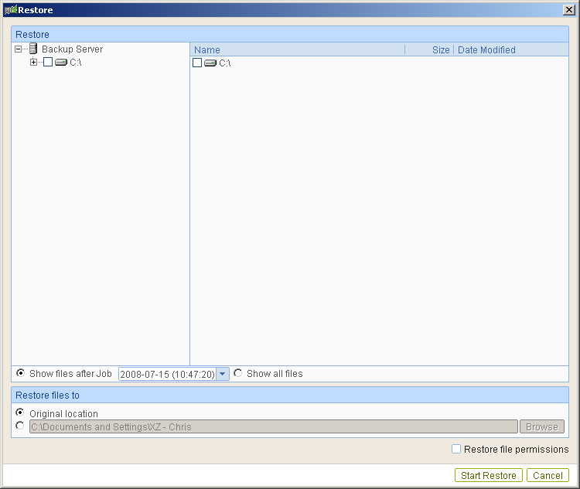
    - Select the files and directories you would like to restore by putting a check in the checkboxes next to each file or directory needed.
    - Choose whether to restore the files to their [Original Location] or by specifying an alternate directory to restore them to.
    - (Optional) Check [Restore file permissions] to restore the files with their original permissions intact.
    - Click [Start Restore]
    - 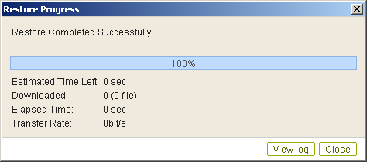

Using the web interface
You can restore your data from our website by following the instructions below.
    - Logon to your members area through our web interface ( http://www.influxpc.com/ )
    - Click the [Backup Management] tab.
    - Click the [File Explorer] link in the top menu.
    - 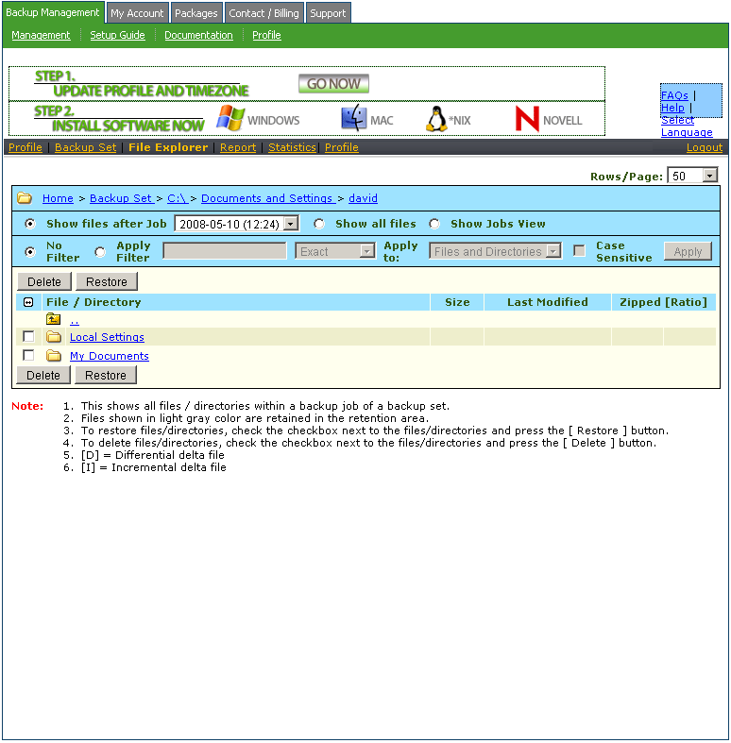
    - Click the directories that you would like to navigate through.
    - Place checkboxes next to the files or folders you would like to restore.
    - Click the [Restore] button.
    - The dialog shown below would appear.
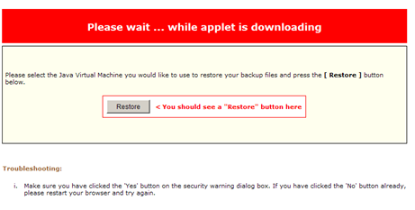
  - Press the [Restore] button
  - Enter the directory to which backup files should be restored to in the [Restore files to] textbox
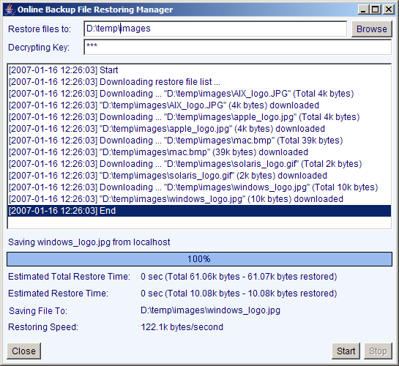
  - Enter the encrypting key which will be used to decrypt your backup files upon restoring your backup files
  - Press the [Start] button

to the backup server.

Email Reporting
Our Offsite Backup Server makes use of email to keep you informed with the status of your backup activities. Please make sure your contact information within the backup system is correct to receive the reports described in this chapter.

Backup Job Report
For each backup job you have run, a backup job report will be sent to you by email. This report contains a summary for the backup job that was run and a full listing of all files being backed up by the backup job. The backup summary report contains the following information:
Sample Backup Summary Report
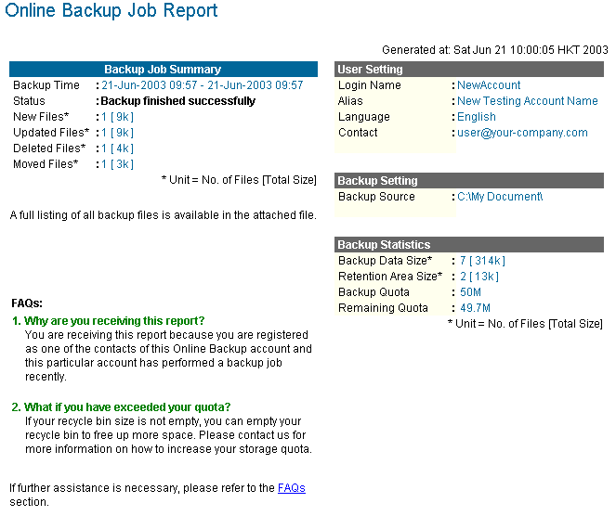

Key | Description
Backup Time | The time when the backup job ran
Backup Status | The overall status of the backup job. Normally, you should see “Backup finished successfully” in this field. If you happen to get something else, please consult the attached full report for more information.
New Files | Total number and size of backup files added to your backup set
Updated Files | Total number and size of backup files updated in your backup set
Deleted Files | Total number and size of backup files deleted from your backup set
Moved Files | Total number and size of backup files relocated in your backup set
Login Name | Login name
Alias | Alias
Language | Preferred Language for your backup report
Contact | Email Address that will be used to contact you
Backup Source | All files/directories that will be backed up
Backup Data Size | The total backup data stored in the data area
Retention Area Size | The total backup data stored in the retention area. Old copies of updated or deleted backup files are retained in the retention area for the number of days as specified by the retention policy of the backup set before they are removed from the system.
Backup Quota | Backup Quota
Remaining Quota | Remaining Quota

The full backup report, which contains a full listing of all files backed up by the backup job, is attached to the backup job report email as a zip file. You need to unzip it before you can read the full report.
Sample Report
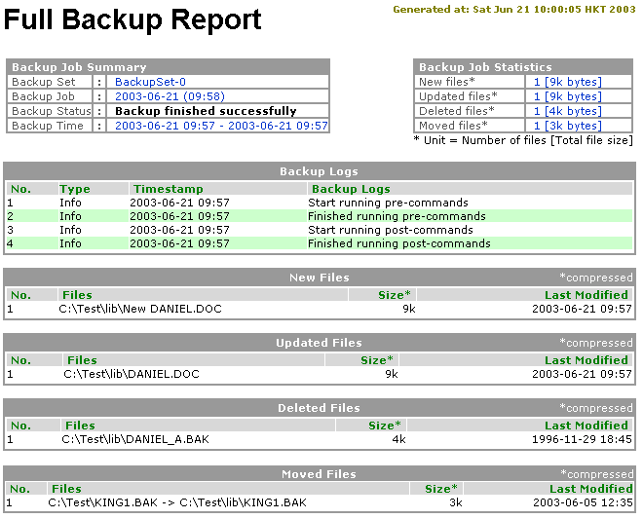

Key | Description
Backup Set | The name of the backup set
Backup Job | The name of the backup job (which is the start time of the backup job)
Backup Status | The overall status of the backup job. Normally, you should see “Backup finished successfully” in this field. If you happen to get something else, please consult the attached full report for more information.
Backup Time | The time when the backup job ran
Backup Log | All messages logged when running this backup job
New Files | Total number and size of backup files added to your backup set
Updated Files | Total number and size of backup files updated in your backup set
Deleted Files | Total number and size of backup files deleted from your backup set
Moved Files | Total number and size of backup files relocated in your backup set
New File List | Full list of all backup files added to your backup set
Updated File List | Full list of all backup files updated in your backup set
Deleted File List | Full list of all backup files deleted from your backup set
Moved File List | Full list of all backup files relocated in your backup set

Setting Change Report
After you have updated your user profile or backup setting, a setting change report will be sent to you. This report allows you to track record of the changes that have been made to your backup account.
Sample Report
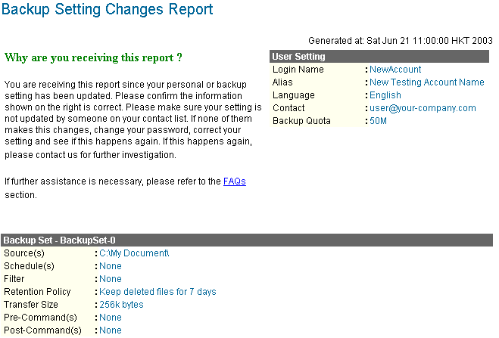

Key | Description
Login Name | Login name
Alias | Alias
Language | Preferred Language for your backup reports
Contact | Email Address that will be used to contact you
Backup Quota | Backup Quota
Backup Source(s) | All backup sources of the backup set
Backup Schedule(s) | All backup schedules of the backup set
Filter(s) | All backup filters of the backup set
Retention Policy | The retention policy of the backup set
Transfer Size | The transfer block size of the backup set
Pre-Command(s) | All Pre-Command(s) of the backup set
Post-Command(s) | All Post-Command(s) of the backup set

Inactive User Reminder
You will receive an inactive user reminder in email if your account has been left inactive for the period of 7 days (or the period specified by the system administrator). This is to remain you that you have not been running backup for more 7 days. If you are a free trial user, your account will be removed from the system automatically if the system can track no records of your backup activities in the next 30 days after receiving this report.
Sample Report
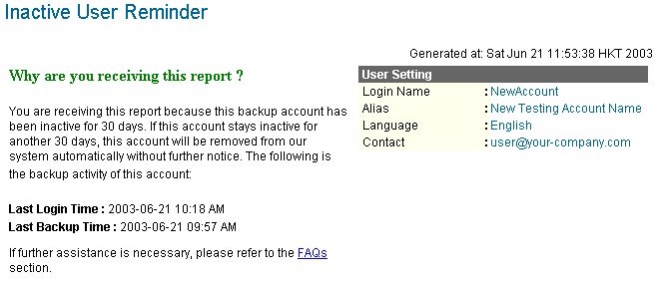

Key | Description
Login Name | Login name
Alias | Alias
Language | Preferred Language for your backup reports
Contact | Email Address that will be used to contact you
Backup Quota | Backup Quota
Last Login Time | The last time you logon to the backup system
Last Backup Time | The last time you ran a backup job

Web Features
Other than the features of Professional Client described in the previous chapter, the web interface of the offsite backup server provides you access to some additional features that are not available in Professional Client. This chapter describes each of these features in details.

Install Professional Client
Before you can use Professional Client, you have to download the Professional Client installer from the web interface of Offsite Backup Server and install Professional Client onto your computer. Please refer to the installation section (Chapter 2) for information on how to install Professional Client onto your computer.

Update User Profile
You can update your user profile by using the [Profile] panel available on the web interface. To change your profile, just make any changes to your profit on the panel shown below and press the [Update] button.
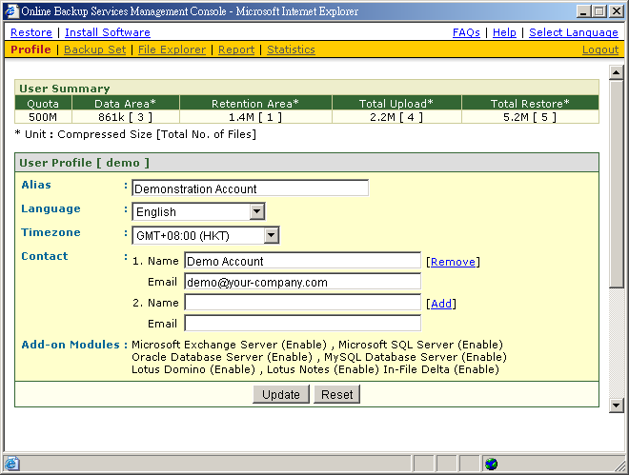
Key | Description
Quota | Backup Quota
Data Area | Total number and size backup files stored in the data area
Retention Area | Total number and size of backup files stored in the retention area
Total Upload | Total number and size of backup files uploaded to the backup server
Total Restore | Total number and size of backup files restored from the backup server
Login Name | Login name
Display Name | Alias of your backup account
Language | Preferred Language for your backup report
Time Zone | Your Time zone
Contact | Email Address that will be used to contact you

Restore/Delete/Undelete Backup Files
Using the [File Explorer], you can browse through the backup data (both current and previous versions) on OBS. You can select any current backup files to Restore or Delete. You can also select any deleted backup files (in gray) to Undelete.
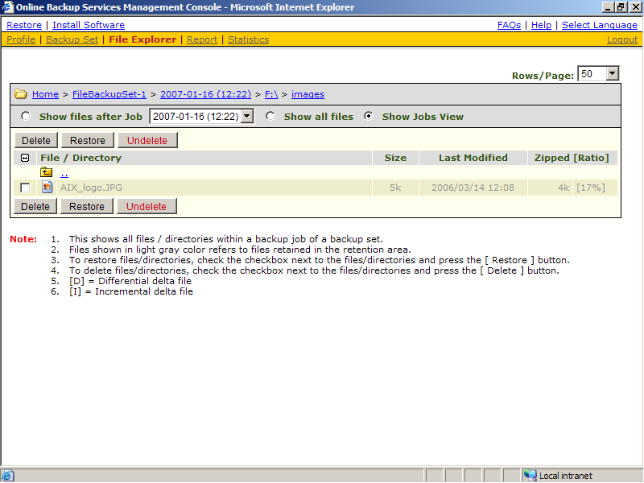

Review Backup Jobs
In addition to reviewing your backup activities from the email report and from Professional Client, you can also review any of your backup Jobs by using the [Report] panel available on the web interface. To review a backup job, just select the required backup job from the [Backup Set] and [Backup Job] drop down list.
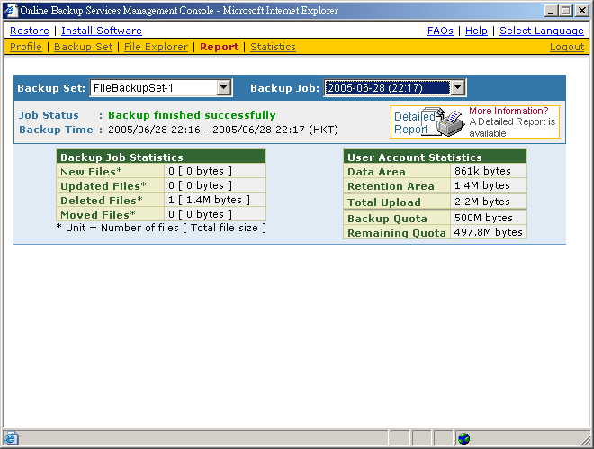
Key | Description
Job Status | The overall status of the backup job. Normally, you should see “Backup finished successfully” in this field. If you happen to get something else, please click the [Detailed Report] images on the page.
Backup Time | The time when the backup job ran
New Files | Total number and size of backup files added to your backup set
Updated Files | Total number and size of backup files updated in your backup set
Deleted Files | Total number and size of backup files deleted from your backup set
Moved Files | Total number and size of backup files relocated in your backup set
Backup Data Size | The total backup data stored in the data area
Retention Area Size | The total backup data stored in the retention area. Old copies of updated or deleted backup files are retained in the retention area for the number of days as specified by the retention policy of the backup set before they are removed from the system.
Total Upload | Total number and size of backup files uploaded to the backup server
Backup Quota | Backup Quota
Remaining Quota | Remaining Quota

You can open the [Full Backup Report] to review all information logged by a backup job by clicking the [Detailed Report] image on the [Report] panel.
Full Backup Report

Parameter | Description
Backup Set | The name of the backup set
Backup Job | The name of the backup job (which is the start time of the backup job)
Backup Status | The overall status of the backup job.
Backup Time | The time when the backup job ran
Backup Log | All messages logged when running this backup job
New Files | Total number and size of backup files added to your backup set
Updated Files | Total number and size of backup files updated in your backup set
Deleted Files | Total number and size of backup files deleted from your backup set
Moved Files | Total number and size of backup files relocated in your backup set
New File List | Full list of all backup files added to your backup set
Updated File List | Full list of all backup files updated in your backup set
Deleted File List | Full list of all backup files deleted from your backup set
Moved File List | Full list of all backup files relocated in your backup set

Review Storage Statistics
You can review the amount of data you have stored on the backup server and uploaded to the backup server on each day by opening the [Statistics] panel available on the web interface. To review your storage statistics for a different month, just select the month you are after by selecting from the [Month] drop down list.
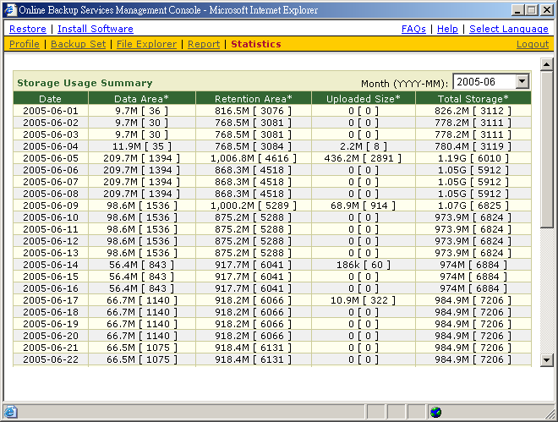
Key | Description
Date | The date the following statistics are collected
Data Area | Total number and size of backup files stored in the data area on a particular date
Retention Area | Total number and size of backup files stored in the retention area on a particular date
Uploaded Size | Total number and size of backup files uploaded to the backup server on a particular date
Total Storage | Total number and size of backup files stored under your backup account on a particular date

